Parole order
After an inmate has served their non-parole period the Parole Board will consider whether they should be released. A prisoner who is granted parole may serve the rest of their sentence in the community on conditional release, otherwise known as a parole order.

While on parole the parolee is supervised and must comply with the conditions of their parole order.

A person released to parole must:

- Follow all reasonable directions of the Probation and Parole Officer (PPO)
- Report to and receive visits from the PPO as directed
- Attend programs or counselling as directed
- Tell the PPO if they change employment or address within 2 working days
- Follow all other conditions set by the Parole Board.

A person released to parole must not:

- Break the law while on the order
- Leave the Northern Territory without permission from the PPO
- Breach the conditions of their order.

What happens after someone is granted parole?

Following the Parole Board’s decision the PPO will give the offender a copy of their Parole order that will outline the conditions the offender must comply with.

When the offender is granted Parole they will be assigned a PPO, the PPO will visit the inmate in prison to:

- Go through the order with the offender to make sure they understand it
- Explain the conditions the offender must comply with
- If the offender has a condition to attend programs or counselling the PPO will provide the details of when and where they will attend
- Help the offender develop a plan to follow the conditions of their order and stay out of trouble in the future.

What if a person can’t attend?

If an offender can’t attend a program or an appointment it is their responsibility to notify the PPO immediately. The offender will be required to provide evidence such as a doctor’s certificate or letter from their employer.
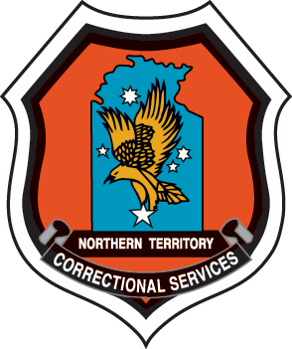

What happens if the parolee doesn’t follow the order?

If an offender doesn’t follow the conditions of the order, the PPO will investigate what has happened and provide a report to the Parole Board, the offender may be required to explain their actions to the Parole Board.

Parole Order

If an offender breaches their order, the Parole Board may decide to:

- Issue a warning letter
- Place new conditions on the parole order
- Revoke the parole order.

If the Parole Board revokes your parole, the police will arrest the offender. The offender will go back to prison and be required to serve the balance of their sentence. The time they spent on parole won’t count and they will have to serve the whole amount of time they had leftover when they were released on parole.

Why are programs included?

Programs can help offenders make changes in their life and reduce the risk of re-offending. Programs have been developed to provide help with gambling, drugs, alcohol, money problems or mental illness.

