Mineral Titles Act 2010
NOTICE OF LAND CEASING TO BE A MINERAL TITLE AREA
Title Type and Number: | Extractive Mineral Exploration Licence 33624
Area Ceased on: | 28 January 2026
Area: | 2 Blocks, 1.63 km²
Locality: | KATHERINE
Name of Applicant(s)/Holder(s): | 100% HARBROW MINING EQUIPMENT PTY LTD [ACN. 636 421 942]
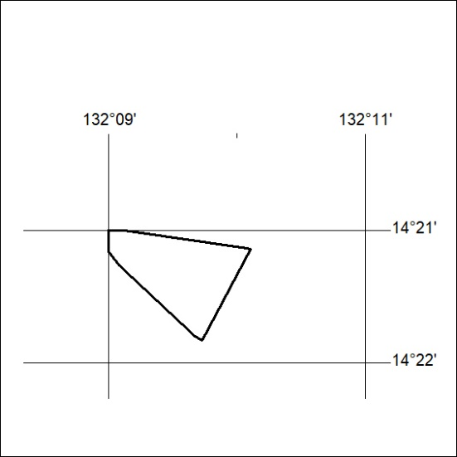

40/26

