Mineral Titles Act
NOTICE OF GRANT OF A MINERAL TITLE
Title Type and Number: | Exploration License 34143
Granted: | 24 December 2025, for a period of 6 Years
Area: | 7 Blocks, 12.70 km²
Locality: | BATCHELOR
Name of Holder/s: | 100% CHALA Alexander Joseph [ACN. 26169145643]
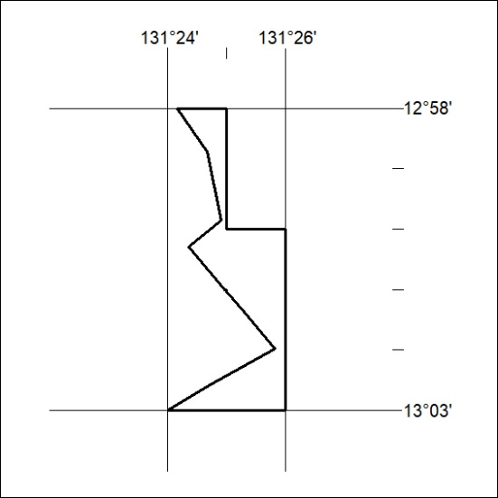
Area granted is indicated above. The titleholder is not permitted to exercise occupational rights on any land that is subject to a development title, or an application for a development title. Any land the subject of a Reserved Land gazettal under the Mineral Titles Act and all land vested in the Commonwealth of Australia is also excluded by description but not excised from the grant area.

01/26

