Mineral Titles Act 2010
NOTICE OF LAND CEASING TO BE A MINERAL TITLE APPLICATION AREA
Title Type and Number: | Exploration Licence 33945
Area Ceased on: | 06 March 2025
Area: | 246 Blocks, 806.55 km²
Locality: | MATARANKA
Name of Applicant(s)/Holder(s): | 50% ORESCOUT EXPLORATION PTY LTD [ACN. 679 171 423], 50% TWOMEY Glenn
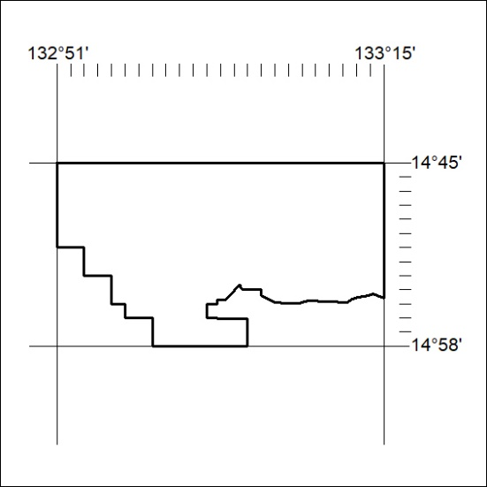
74/25

Mineral Titles Act
NOTICE OF GRANT OF A MINERAL TITLE
Title Type and Number: | Extractive Mineral Exploration Licence 33970
Granted: | 06 March 2025, for a period of 2 Years
Area: | 4 Blocks, 7.63 km²
Locality: | NOONAMAH
Name of Holder/s: | 50% OSTOJIC GROUP PTY LTD* [ACN. 009 629 805], 50% TRISTAR INDUSTRIES PTY LTD [ACN. 009 647 321]
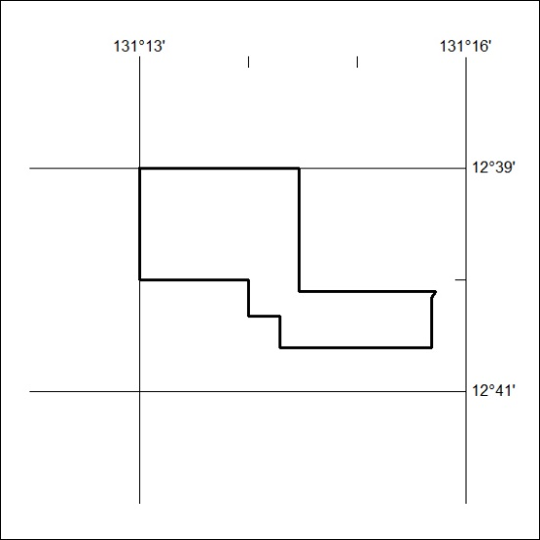
Area granted is indicated above. The titleholder is not permitted to exercise occupational rights on any land that is subject to a development title, or an application for a development title. Any land the subject of a Reserved Land gazettal under the Mineral Titles Act and all land vested in the Commonwealth of Australia is also excluded by description but not excised from the grant area.
75/25

Mineral Titles Act
NOTICE OF GRANT OF A MINERAL TITLE
Title Type and Number: | Extractive Mineral Exploration Licence 33971
Granted: | 06 March 2025, for a period of 2 Years
Area: | 2 Blocks, 3.63 km²
Locality: | NOONAMAH
Name of Holder/s: | 50% OSTOJIC GROUP PTY LTD* [ACN. 009 629 805], 50% TRISTAR INDUSTRIES PTY LTD [ACN. 009 647 321]
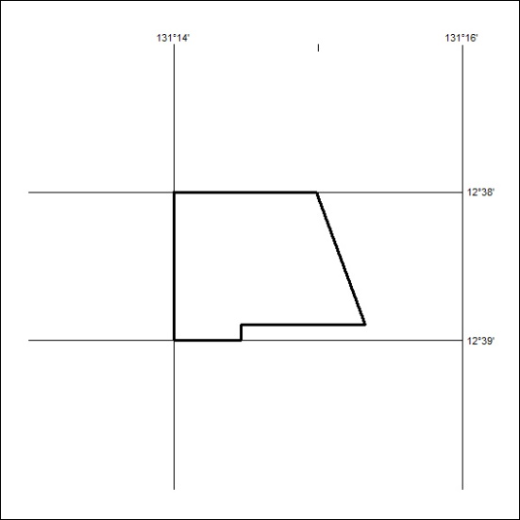
Area granted is indicated above. The titleholder is not permitted to exercise occupational rights on any land that is subject to a development title, or an application for a development title. Any land the subject of a Reserved Land gazettal under the Mineral Titles Act and all land vested in the Commonwealth of Australia is also excluded by description but not excised from the grant area.
76/25

Mineral Titles Act
NOTICE OF GRANT OF A MINERAL TITLE
Title Type and Number: | Extractive Mineral Exploration Licence 33994
Granted: | 06 March 2025, for a period of 2 Years
Area: | 4 Blocks, 12.01 km²
Locality: | AMUNGEE MUNGEE
Name of Holder/s: | 100% TAMBORAN INFRASTRUCTURE PTY LTD [ACN. 163 215 156]
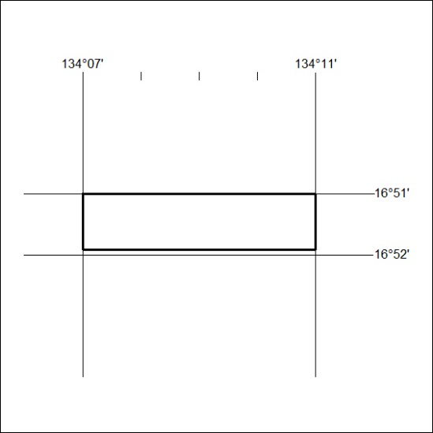
Area granted is indicated above. The titleholder is not permitted to exercise occupational rights on any land that is subject to a development title, or an application for a development title. Any land the subject of a Reserved Land gazettal under the Mineral Titles Act and all land vested in the Commonwealth of Australia is also excluded by description but not excised from the grant area.
77/25

Mineral Titles Act
NOTICE OF GRANT OF A MINERAL TITLE
Title Type and Number: | Extractive Mineral Exploration Licence 33995
Granted: | 06 March 2025, for a period of 2 Years
Area: | 4 Blocks, 13.15 km²
Locality: | AMUNGEE MUNGEE
Name of Holder/s: | 100% TAMBORAN INFRASTRUCTURE PTY LTD [ACN. 163 215 156]
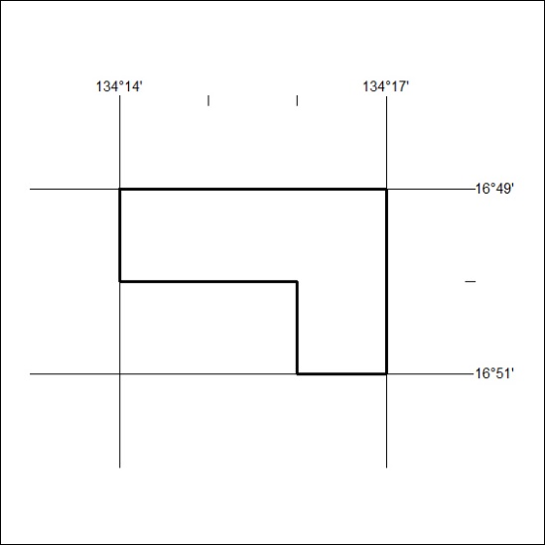
Area granted is indicated above. The titleholder is not permitted to exercise occupational rights on any land that is subject to a development title, or an application for a development title. Any land the subject of a Reserved Land gazettal under the Mineral Titles Act and all land vested in the Commonwealth of Australia is also excluded by description but not excised from the grant area.
78/25

Mineral Titles Act
NOTICE OF GRANT OF A MINERAL TITLE
Title Type and Number: | Extractive Mineral Exploration Licence 33996
Granted: | 06 March 2025, for a period of 2 Years
Area: | 4 Blocks, 13.16 km²
Locality: | WARRAMBAN
Name of Holder/s: | 100% TAMBORAN INFRASTRUCTURE PTY LTD [ACN. 163 215 156]
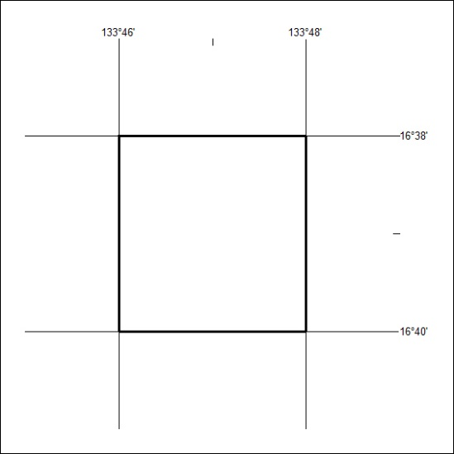
Area granted is indicated above. The titleholder is not permitted to exercise occupational rights on any land that is subject to a development title, or an application for a development title. Any land the subject of a Reserved Land gazettal under the Mineral Titles Act and all land vested in the Commonwealth of Australia is also excluded by description but not excised from the grant area.
79/25

Mineral Titles Act
NOTICE OF GRANT OF A MINERAL TITLE
Title Type and Number: | Extractive Mineral Exploration Licence 33997
Granted: | 06 March 2025, for a period of 2 Years
Area: | 4 Blocks, 13.16 km²
Locality: | WARRAMBAN
Name of Holder/s: | 100% TAMBORAN INFRASTRUCTURE PTY LTD [ACN. 163 215 156]
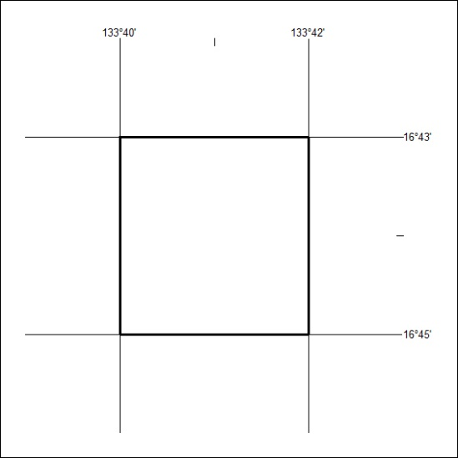
Area granted is indicated above. The titleholder is not permitted to exercise occupational rights on any land that is subject to a development title, or an application for a development title. Any land the subject of a Reserved Land gazettal under the Mineral Titles Act and all land vested in the Commonwealth of Australia is also excluded by description but not excised from the grant area.
80/25

Mineral Titles Act
NOTICE OF GRANT OF A MINERAL TITLE
Title Type and Number: | Extractive Mineral Exploration Licence 33998
Granted: | 06 March 2025, for a period of 2 Years
Area: | 4 Blocks, 13.15 km²
Locality: | WARRAMBAN
Name of Holder/s: | 100% TAMBORAN INFRASTRUCTURE PTY LTD [ACN. 163 215 156]
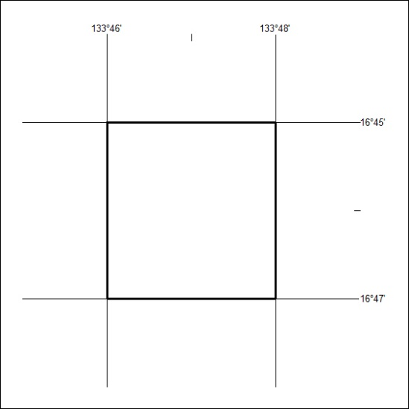
Area granted is indicated above. The titleholder is not permitted to exercise occupational rights on any land that is subject to a development title, or an application for a development title. Any land the subject of a Reserved Land gazettal under the Mineral Titles Act and all land vested in the Commonwealth of Australia is also excluded by description but not excised from the grant area.
81/25

Mineral Titles Act
NOTICE OF GRANT OF A MINERAL TITLE
Title Type and Number: | Extractive Mineral Exploration Licence 33999
Granted: | 06 March 2025, for a period of 2 Years
Area: | 4 Blocks, 13.16 km²
Locality: | WARRAMBAN
Name of Holder/s: | 100% TAMBORAN INFRASTRUCTURE PTY LTD [ACN. 163 215 156]
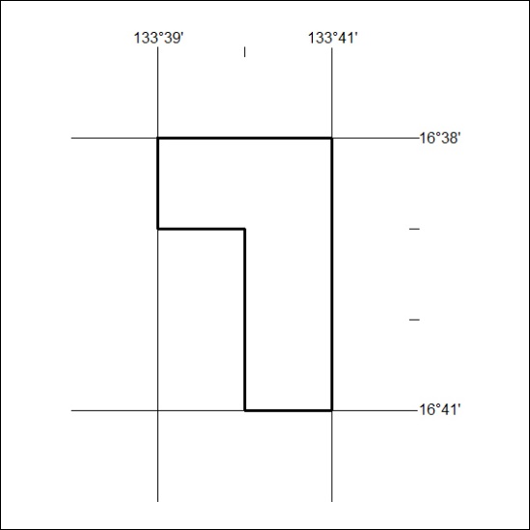
Area granted is indicated above. The titleholder is not permitted to exercise occupational rights on any land that is subject to a development title, or an application for a development title. Any land the subject of a Reserved Land gazettal under the Mineral Titles Act and all land vested in the Commonwealth of Australia is also excluded by description but not excised from the grant area.
82/25

Mineral Titles Act
NOTICE OF GRANT OF A MINERAL TITLE
Title Type and Number: | Extractive Mineral Exploration Licence 34000
Granted: | 06 March 2025, for a period of 2 Years
Area: | 4 Blocks, 9.44 km²
Locality: | NEWCASTLE WATERS
Name of Holder/s: | 100% TAMBORAN INFRASTRUCTURE PTY LTD [ACN. 163 215 156]
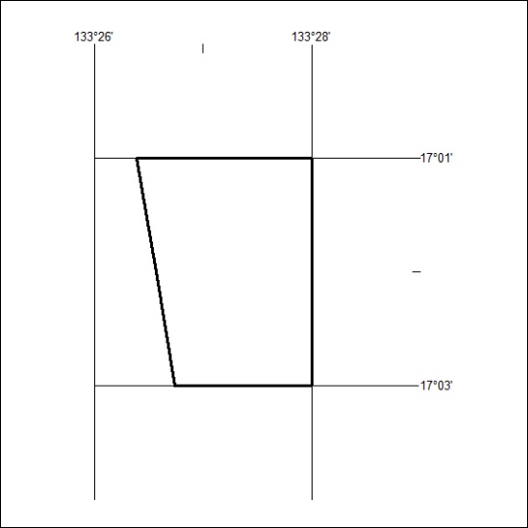
Area granted is indicated above. The titleholder is not permitted to exercise occupational rights on any land that is subject to a development title, or an application for a development title. Any land the subject of a Reserved Land gazettal under the Mineral Titles Act and all land vested in the Commonwealth of Australia is also excluded by description but not excised from the grant area.
83/25

3=Average Mineral Titles Act
NOTICE OF GRANT OF A MINERAL TITLE
Title Type and Number: | Extractive Mineral Exploration Licence 34001
Granted: | 06 March 2025, for a period of 2 Years
Area: | 4 Blocks, 12.86 km²
Locality: | WARRAMBAN
Name of Holder/s: | 100% TAMBORAN INFRASTRUCTURE PTY LTD [ACN. 163 215 156]
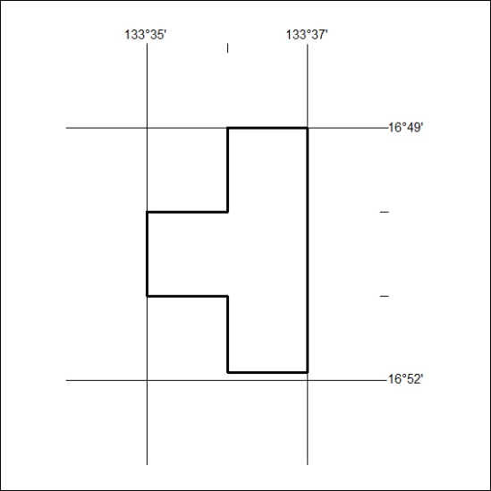
Area granted is indicated above. The titleholder is not permitted to exercise occupational rights on any land that is subject to a development title, or an application for a development title. Any land the subject of a Reserved Land gazettal under the Mineral Titles Act and all land vested in the Commonwealth of Australia is also excluded by description but not excised from the grant area.
84/25

Mineral Titles Act
NOTICE OF GRANT OF A MINERAL TITLE
Title Type and Number: | Extractive Mineral Exploration Licence 34002
Granted: | 06 March 2025, for a period of 2 Years
Area: | 4 Blocks, 12.94 km²
Locality: | WARRAMBAN
Name of Holder/s: | 100% TAMBORAN INFRASTRUCTURE PTY LTD [ACN. 163 215 156]
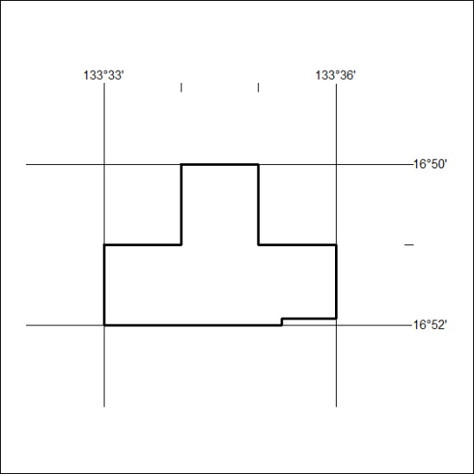
Area granted is indicated above. The titleholder is not permitted to exercise occupational rights on any land that is subject to a development title, or an application for a development title. Any land the subject of a Reserved Land gazettal under the Mineral Titles Act and all land vested in the Commonwealth of Australia is also excluded by description but not excised from the grant area.
85/25

Mineral Titles Act
NOTICE OF GRANT OF A MINERAL TITLE
Title Type and Number: | Extractive Mineral Exploration Licence 34003
Granted: | 06 March 2025, for a period of 2 Years
Area: | 4 Blocks, 13.15 km²
Locality: | WARRAMBAN
Name of Holder/s: | 100% TAMBORAN INFRASTRUCTURE PTY LTD [ACN. 163 215 156]
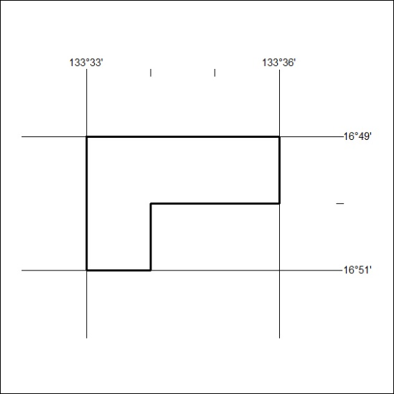
Area granted is indicated above. The titleholder is not permitted to exercise occupational rights on any land that is subject to a development title, or an application for a development title. Any land the subject of a Reserved Land gazettal under the Mineral Titles Act and all land vested in the Commonwealth of Australia is also excluded by description but not excised from the grant area.
86/25

Mineral Titles Act
NOTICE OF GRANT OF A MINERAL TITLE
Title Type and Number: | Extractive Mineral Exploration Licence 34004
Granted: | 06 March 2025, for a period of 2 Years
Area: | 4 Blocks, 13.15 km²
Locality: | WARRAMBAN
Name of Holder/s: | 100% TAMBORAN INFRASTRUCTURE PTY LTD [ACN. 163 215 156]
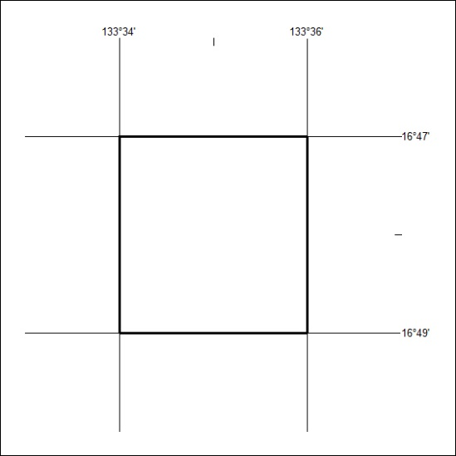
Area granted is indicated above. The titleholder is not permitted to exercise occupational rights on any land that is subject to a development title, or an application for a development title. Any land the subject of a Reserved Land gazettal under the Mineral Titles Act and all land vested in the Commonwealth of Australia is also excluded by description but not excised from the grant area.
87/25

Mineral Titles Act
NOTICE OF GRANT OF A MINERAL TITLE
Title Type and Number: | Extractive Mineral Exploration Licence 34005
Granted: | 06 March 2025, for a period of 2 Years
Area: | 4 Blocks, 13.15 km²
Locality: | WARRAMBAN
Name of Holder/s: | 100% TAMBORAN INFRASTRUCTURE PTY LTD [ACN. 163 215 156]
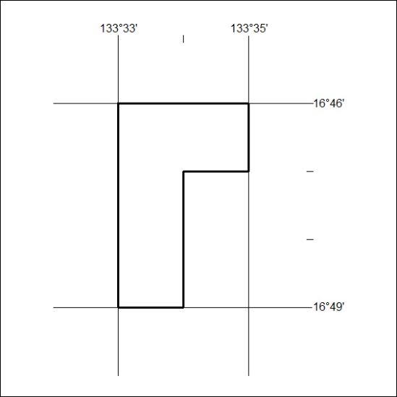
Area granted is indicated above. The titleholder is not permitted to exercise occupational rights on any land that is subject to a development title, or an application for a development title. Any land the subject of a Reserved Land gazettal under the Mineral Titles Act and all land vested in the Commonwealth of Australia is also excluded by description but not excised from the grant area.
88/25

