Mineral Titles Act 2010
NOTICE OF LAND CEASING TO BE A MINERAL TITLE AREA
Title Type and Number: | Exploration Licence 33388
Area Ceased on: | 27 June 2024
Area: | 6 Blocks, 18.95 km²
Locality: | RIDDOCH
Name of Applicant(s)/Holder(s): | 100% GEMPART (NT) PTY LTD* [ACN. 081 859 896]
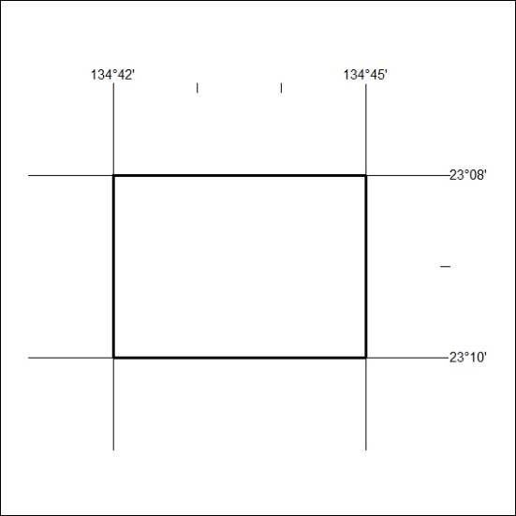
263/24

Mineral Titles Act 2010
NOTICE OF LAND CEASING TO BE A MINERAL TITLE AREA
Title Type and Number: | Exploration Licence 33492
Area Ceased on: | 27 June 2024
Area: | 16 Blocks, 37.96 km²
Locality: | QUARTZ
Name of Applicant(s)/Holder(s): | 100% GEMPART (NT) PTY LTD* [ACN. 081 859 896]
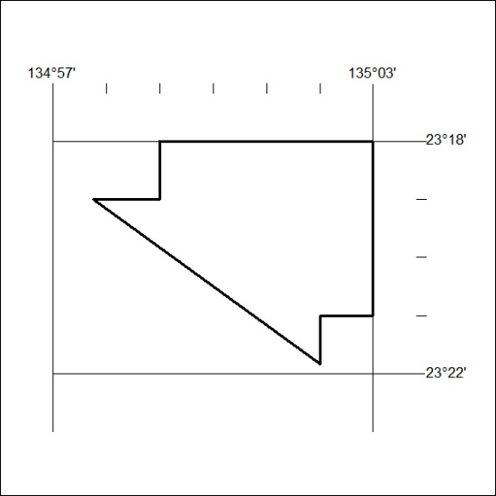
264/24

Mineral Titles Act 2010
NOTICE OF LAND CEASING TO BE A MINERAL TITLE AREA
Title Type and Number: | Exploration Licence 31354
Area Ceased on: | 27 June 2024
Area: | 10 Blocks, 33.04 km²
Locality: | TAWALLAH RANGE
Name of Applicant(s)/Holder(s): | 100% WEST ROCK RESOURCES PTY LTD [ACN. 150 296 923]
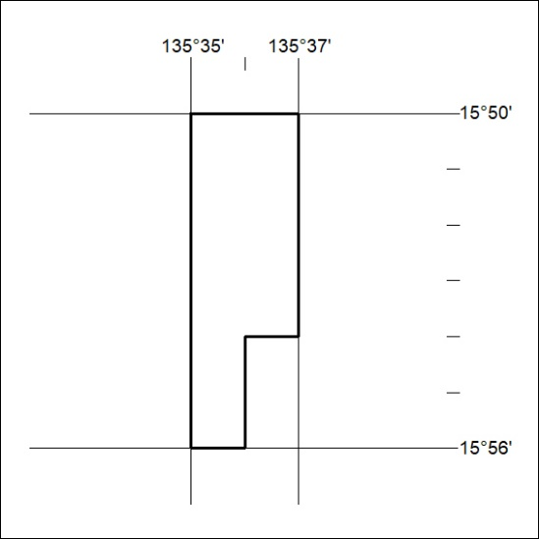
265/24

Mineral Titles Act 2010
NOTICE OF LAND CEASING TO BE A MINERAL TITLE AREA
Title Type and Number: | Exploration Licence 32261
Area Ceased on: | 27 June 2024
Area: | 50 Blocks, 163.36 km²
Locality: | BOXER
Name of Applicant(s)/Holder(s): | 100% WALHALLOW CREEK NO 2 PTY LTD [ACN. 626 076 471]
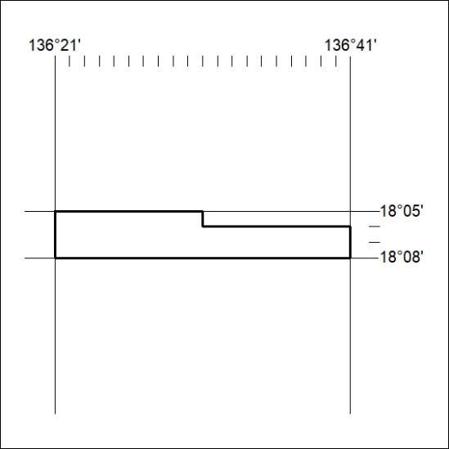
266/24

