Mineral Titles Act 2010
NOTICE OF LAND CEASING TO BE A MINERAL TITLE AREA
Title Type and Number: | Exploration Licence 32848
Area Ceased on: | 04 April 2024
Area: | 14 Blocks, 44.78 km²
Locality: | CRAWFORD
Name of Applicant(s)/Holder(s): | 100% PEGMATITE ONE PTY LTD [ACN. 652 853 391]
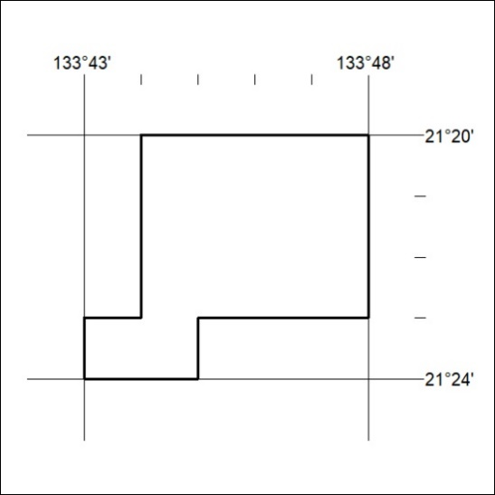

115/24

Mineral Titles Act 2010
NOTICE OF LAND CEASING TO BE A MINERAL TITLE AREA
Title Type and Number: | Exploration Licence 32851
Area Ceased on: | 04 April 2024
Area: | 34 Blocks, 108.22 km²
Locality: | DENISON
Name of Applicant(s)/Holder(s): | 100% PEGMATITE ONE PTY LTD [ACN. 652 853 391]
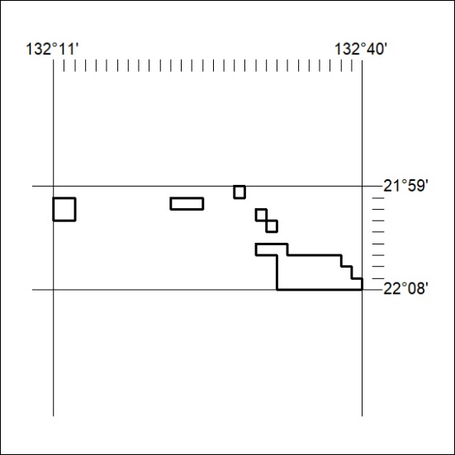

116/24
Mineral Titles Act 2010
NOTICE OF LAND CEASING TO BE A MINERAL TITLE AREA
Title Type and Number: | Exploration Licence 32852
Area Ceased on: | 04 April 2024
Area: | 9 Blocks, 28.63 km²
Locality: | DENISON
Name of Applicant(s)/Holder(s): | 100% PEGMATITE ONE PTY LTD [ACN. 652 853 391]
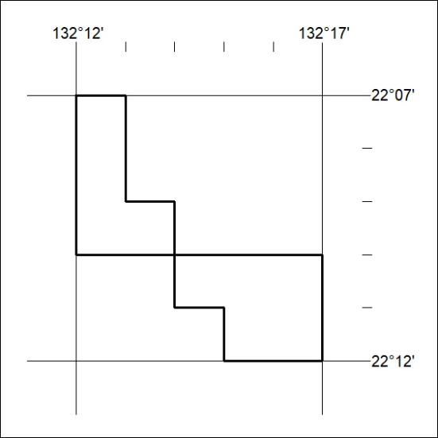

117/24

Mineral Titles Act 2010
NOTICE OF LAND CEASING TO BE A MINERAL TITLE AREA
Title Type and Number: | Exploration Licence 32854
Area Ceased on: | 04 April 2024
Area: | 147 Blocks, 455.48 km²
Locality: | LAUGHLEN
Name of Applicant(s)/Holder(s): | 100% PEGMATITE ONE PTY LTD [ACN. 652 853 391]
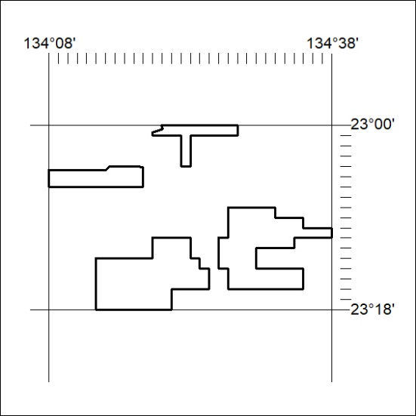

118/24

Mineral Titles Act 2010
NOTICE OF LAND CEASING TO BE A MINERAL TITLE AREA
Title Type and Number: | Exploration Licence 32855
Area Ceased on: | 04 April 2024
Area: | 57 Blocks, 179.82 km²
Locality: | RIDDOCH
Name of Applicant(s)/Holder(s): | 100% PEGMATITE ONE PTY LTD [ACN. 652 853 391]
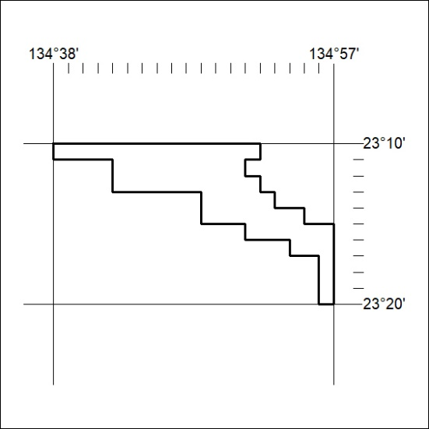

119/24

