Mineral Titles Act 2010
NOTICE OF LAND CEASING TO BE A MINERAL TITLE AREA
Title Type and Number: | Exploration Licence 32844
Area Ceased on: | 04 April 2024
Area: | 142 Blocks, 451.69 km²
Locality: | REYNOLDS RANGE
Name of Applicant(s)/Holder(s): | 100% PEGMATITE ONE PTY LTD [ACN. 652 853 391]
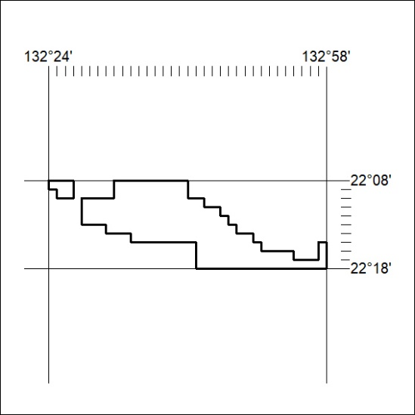

110/24

Mineral Titles Act 2010
NOTICE OF LAND CEASING TO BE A MINERAL TITLE AREA
Title Type and Number: | Exploration Licence 32845
Area Ceased on: | 04 April 2024
Area: | 127 Blocks, 401.99 km²
Locality: | REYNOLDS RANGE
Name of Applicant(s)/Holder(s): | 100% PEGMATITE ONE PTY LTD [ACN. 652 853 391]
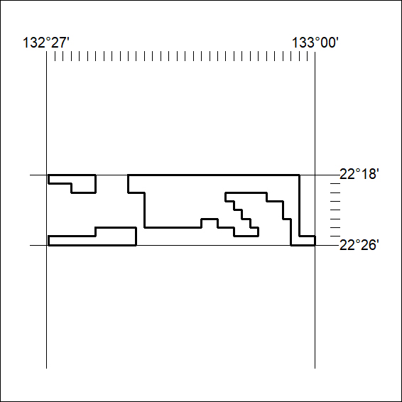

111/24
Mineral Titles Act 2010
NOTICE OF LAND CEASING TO BE A MINERAL TITLE AREA
Title Type and Number: | Exploration Licence 32846
Area Ceased on: | 04 April 2024
Area: | 73 Blocks, 231.66 km²
Locality: | REYNOLDS RANGE
Name of Applicant(s)/Holder(s): | 100% PEGMATITE ONE PTY LTD [ACN. 652 853 391]
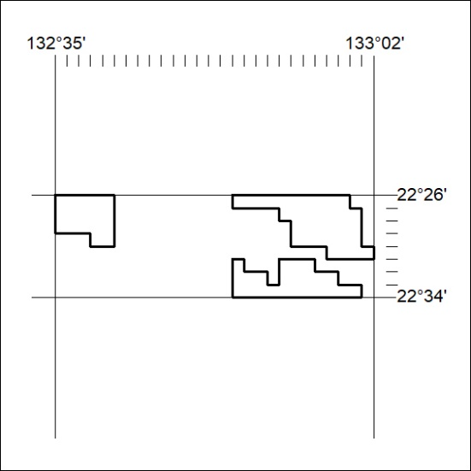

112/24

Mineral Titles Act
NOTICE OF GRANT OF A MINERAL TITLE
Title Type and Number: | Exploration Licence 33612
Granted: | 10 April 2024, for a period of 6 Years
Area: | 23 Blocks, 23.39 km²
Locality: | BENMARA
Name of Holder/s: | 100% XAVIER RESOURCES PTY LTD [ACN. 623 262 304]
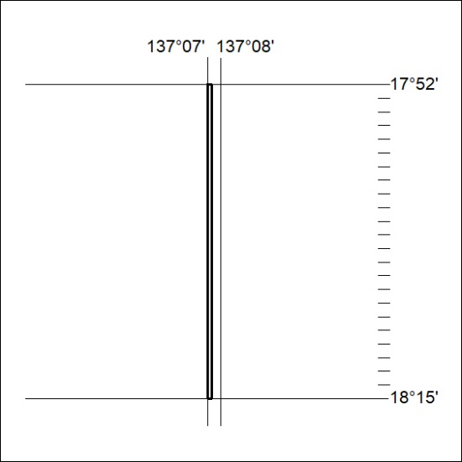
Area granted is indicated above. The titleholder is not permitted to exercise occupational rights on any land that is subject to a development title, or an application for a development title. Any land the subject of a Reserved Land gazettal under the Mineral Titles Act and all land vested in the Commonwealth of Australia is also excluded by description but not excised from the grant area.

113/24

Mineral Titles Act
NOTICE OF GRANT OF A MINERAL TITLE
Title Type and Number: | Exploration Licence 33613
Granted: | 10 April 2024, for a period of 6 Years
Area: | 118 Blocks, 384.34 km²
Locality: | BOXER
Name of Holder/s: | 100% XAVIER RESOURCES PTY LTD [ACN. 623 262 304]
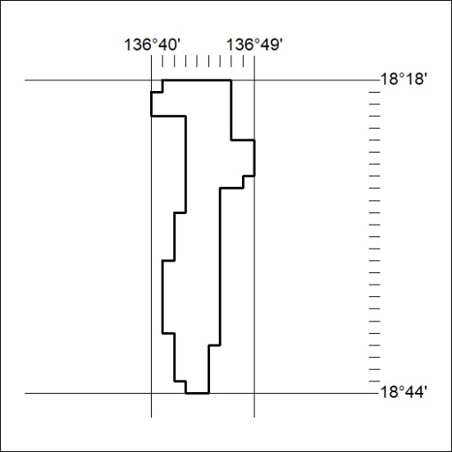
Area granted is indicated above. The titleholder is not permitted to exercise occupational rights on any land that is subject to a development title, or an application for a development title. Any land the subject of a Reserved Land gazettal under the Mineral Titles Act and all land vested in the Commonwealth of Australia is also excluded by description but not excised from the grant area.

114/24

