Mineral Titles Act 2010
NOTICE OF LAND CEASING TO BE A MINERAL TITLE APPLICATION AREA
Title Type and Number: | Mineral Lease 33371
Area ceased on: | 07 June 2023
Area: | 1847.00 Hectares
Locality: | RIDDOCH
Name of Applicants(s)Holder(s): | 100% GEMPART (NT) PTY LTD* [ACN. 081 859 896]
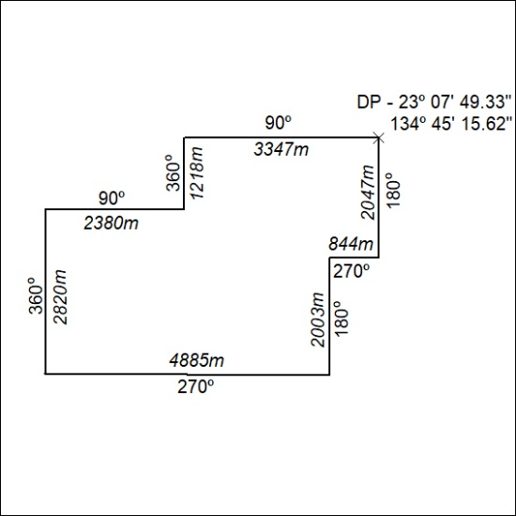

184/23

Mineral Titles Act 2010
NOTICE OF LAND CEASING TO BE A MINERAL TITLE APPLICATION AREA
Title Type and Number: | Mineral Lease 33489
Area ceased on: | 07 June 2023
Area: | 946.00 Hectares
Locality: | QUARTZ
Name of Applicants(s)Holder(s): | 100% GEMPART (NT) PTY LTD* [ACN. 081 859 896]
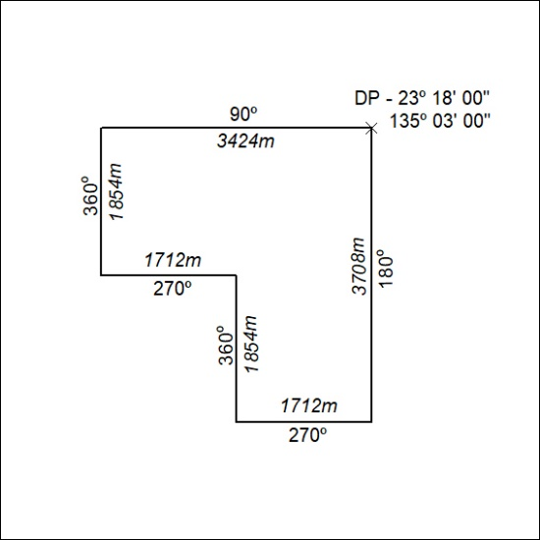

185/23

Mineral Titles Act
NOTICE OF GRANT OF A MINERAL TITLE
Title Type and Number: | Extractive Mineral Exploration Licence 33434
Granted: | 07 June 2023, for a period of 2 Years
Area: | 4 Blocks, 8.53 km²
Locality: | KOOLPINYAH
Name of Holder/s: | 100% WILGA INDIGENOUS CORPORATION
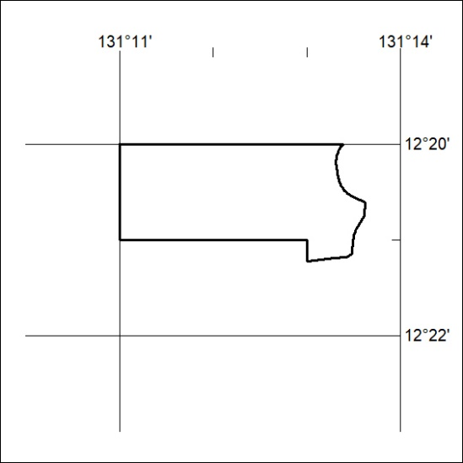
Area granted is indicated above. The titleholder is not permitted to exercise occupational rights on any land that is subject to a development title, or an application for a development title. Any land the subject of a Reserved Land gazettal under the Mineral Titles Act and all land vested in the Commonwealth of Australia is also excluded by description but not excised from the grant area.

186/23

