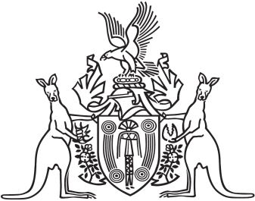
Northern Territory of Australia

Government Gazette
ISSN-0157-833X
No. S105 14 December 2018
Northern Territory of Australia

Trans-Tasman Mutual Recognition Act 1998 (NT)

Trans-Tasman Mutual Recognition Act 1997 (Cth)
Endorsement of Regulations
I, Vicki Susan O'Halloran, Administrator of the Northern Territory of Australia, acting with the advice of the Executive Council, for section 43(1) of the Trans-Tasman Recognition Act 1997 (Cth), which applies as a law of the Territory because of section 5(1) of the Trans-Tasman Mutual Recognition Act 1998 (NT), endorse the making of regulations under section 45 of the Commonwealth Act in the terms set out in the Schedule.
Dated 12 December 2018
V. S. O'Halloran
Administrator
By Her Honour's Command
N. K. Fyles
Attorney-General and Minister for Justice
