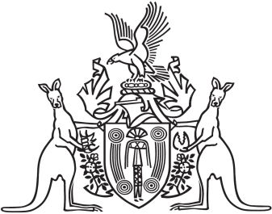

Northern Territory of Australia

Government Gazette

ISSN-0157-833X

No. S80 4 October 2018

Northern Territory of Australia

*Territory Parks and Wildlife Conservation Act*

**Application of By-laws to**

**Buffalo Creek Management Area**

The Parks and Wildlife Commission of the Northern Territory, under section 71A(2) of the *Territory Parks and Wildlife Conservation Act*, gives notice of the application of the *Territory Parks and Wildlife Conservation By‑laws* to the area of land, known as the Buffalo Creek Management Area, shown hatched on the map in the Schedule.

The Common Seal of the Commission was affixed in the presence of:

Mark Ashley

Dated 2 October 2018

**Schedule**

Application of By-laws to
Buffalo Creek Management Area
