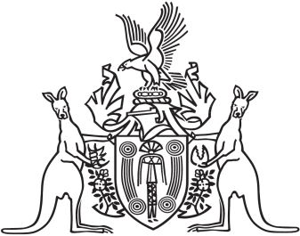
Northern Territory of Australia

Government Gazette
ISSN-0157-8324
No. G28 11 July 2018

General information
The Gazette is published by the Office of the Parliamentary Counsel.
The Gazette will be published every Wednesday, with the closing date for notices being the previous Friday at 4.00 pm.
Notices not received by the closing time will be held over until the next issue.
Notices will not be published unless a Gazette notice request form together with a copy of the signed notice and a clean copy of the notice in Word or PDF is emailed to gazettes@nt.gov.au
Notices will be published in the next issue, unless urgent publication is requested.

Availability
The Gazette will be available online at 12 Noon on the day of publication at https://nt.gov.au/about-government/gazettes
Unauthorised versions of Northern Territory Acts and Subordinate legislation are available online at https://legislation.nt.gov.au/

Northern Territory of Australia
Darwin Waterfront Corporation Act
Appointment of Members and Chairperson
I, Lauren Jane Moss, Minister for Tourism and Culture:
(a) under section 6(1) of the Darwin Waterfront Corporation Act, appoint each person named in the Schedule as a member of the Darwin Waterfront Corporation for 3 years; and
(b) under section 6(3) of the Act, appoint Tracey Louise Hayes as the chairperson of the Corporation.
Dated 1 July 2018
L. J. Moss
Minister for Tourism and Culture
Schedule
Charles Hungerford Burkitt
Kelvin John Costello
Tracey Louise Hayes
Jacqueline Anne Jennings

