DARWIN INNER CITY PACKAGED LIQUOR ACCORD

DARWIN INNER CITY

PACKAGED LIQUOR ACCORD

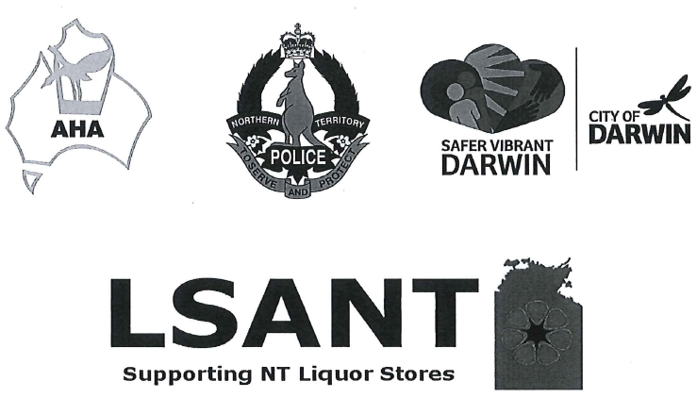
APPROVED
DATE 30 September 2016

DIRECTOR-GENERAL OF LICENSING NT
DARWIN INNER CITY PACKAGED LIQUOR ACCORD
AIM
The Darwin Inner City Packaged Liquor Accord is simply a voluntary agreement by licensees and other stakeholders to take certain actions which aim to improve safety in the Darwin community by preventing and reducing anti-social behavior and alcohol-related violence.
MEMBERS OF THE ACCORD
Members of the Darwin Inner City Packaged Liquor Accord comprise representatives from participating licensed premises within the inner Darwin City Area, industry peaks,
NT Police, City of Darwin, Licensing NT and other key stakeholders.
Initial members are set out in Schedule One.
ACCORD OBJECTIVES
In order to meet the principles of the Accord, Licensees and stakeholders are committed to:
- Harm reduction strategies towards anti-social and violent behavior in and around their licensed premises;
- The implementation of Responsible Service of Alcohol (RSA) practices in licensed premises;
- Ensuring safety and security in and around licensed premises;
- Improving the general amenity of Darwin; and
- The implementation of appropriate cross cultural learning and awareness activities.
ACCORD PERFORMANCE INDICATORS
The performance indicators for reviewing the effectiveness of the Accord each year are:
- Measurable reduction in alcohol related crime and anti-social behaviour associated with takeaway liquor consumed in the inner Darwin area;
- Dedicated commitment to maintaining appropriate RSA qualifications for staff of licensed premises;
- Measurable increase in staff of licensed premises participating in cross cultural training;
- To increase the number of people in the community who perceive Darwin to be safer; and
- An enhanced relationship between community, licensees, local police, local government and Licensing NT.
DARWIN INNER CITY PACKAGED LIQUOR ACCORD
ACCORD STRATEGIES
The Accord endeavours to promote licensees developing management policies to ensure that there is an acceptable level of consistency across the Inner Darwin City area on the comprehension and implementation of:
  - Harm minimisation measures contained in the Liquor Act concerning the service of alcohol to patrons;
  - The relevant Northern Territory Code of Practice to assist in the responsible promotion of takeaway alcohol or any other applicable codes of practice;
  - Individual liquor licence conditions relating to each premises;
  - Enhanced understanding through learning of cross-cultural issues relating to patron service;
  - Any relevant harm minimisation strategies subject to the approval of same by Licensing NT to ensure protection from and non-contravention of Australian Competition & Consumer Commission agreed to by Accord members; and
  - Accord strategies specific to the Darwin Inner City Packaged Liquor Accord are at Schedule Two and operate as agreed, from time to time by parties of the accord to enable measuring of impact.
TIMELINES
Members of the Darwin Inner City Packaged Liquor Accord will meet quarterly to review and monitor impacts of the strategies. The Accord will review continuation or otherwise of each strategy contained within Schedule 2 with the view to maintaining the Accord.
COMMUNICATIONS
Members of the Darwin Inner City Packaged Liquor Accord will develop a package of community friendly, inclusive communication tools including media releases, web site copy, posters, point of sale information and a front of premises sticker to demonstrate Accord membership.
RELATIONSHIP WITH AUTHORITIES
Licensees will closely liaise and cooperate with other licensees, NT Police, City of Darwin and Licensing NT and on measures to improve public safety and community amenity in and around licensed venues.
DARWIN INNER CITY PACKAGED LIQUOR ACCORD

COORDINATOR | ASHLEIGH WINN  HALIKOS HOSPITALITY GROUP
DEPUTY COORDINATOR | FAYE HARTLEY  LIQUOR STORES ASSOCIATION NT
DATE
DARWIN INNER CITY PACKAGED LIQUOR ACCORD
Schedule One LICENSED MEMBERS OF THIS ACCORD
VENUE | NAME | SIGNATURE
Frontier Hotel Darwin | 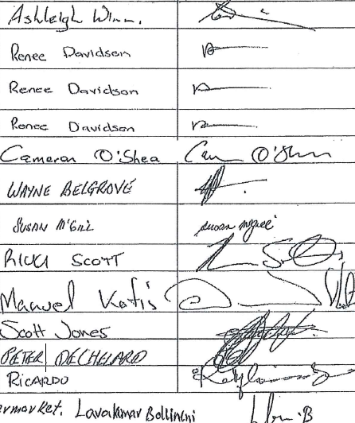
BWS Darwin City (Woolworths)
BWS Parap / Parap Tavern
BWS Stuart Park
H Hotel
Stuart Park Corner Store
IGA Supermarket Darwin
Cavanagh Hotel
Fannie Bay Supermarket
Liquorland – Coles
Vintage Cellars
Parap Road Store
Douglas Street Supermarket
ACCORD PARTNERS
NT Police | 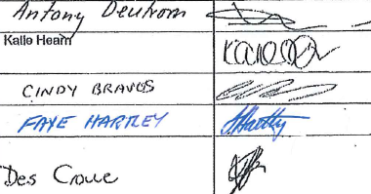
City of Darwin
Licensing NT
Liquor Stores Association NT
Australian Hotels Association (NT Branch)
DARWIN INNER CITY PACKAGED LIQUOR ACCORD

SCHEDULE 2 ACCORD STRATEGIES
The following strategies as agreed to by Accord members will continue indefinitely upon approval of Licensing NT. The Accord group will meet quarterly to monitor impact.
STRATEGY
1 cask per person per day.
Cask wine sales between 12 midday and 7:00pm only.
Recording & reporting of suspicious sales & behaviour to Licensing NT & NT Police.
No Shirt, No Service.
No credit for alcohol (Book Up).
Prominent display of ACCORD membership promotional materials.
No promotions on cask wine sales.
Commitment to improving cross cultural learning & awareness.
Provision of CPTED advice to all members
(Crime Prevention Through Environmental Design).

