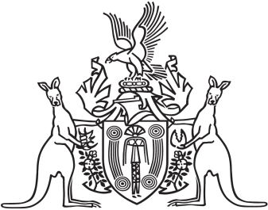
Northern Territory of Australia

Government Gazette
ISSN-0157-833X
No. S18 14 March 2018
Northern Territory of Australia

Interpretation Act
Approval and Authorisation
Part A – Approval
I, Natasha Kate Fyles, Attorney-General and Minister for Justice, under section 46(1)(b) of the Interpretation Act, approve Russell Raymond Goldflam being authorised by the Deputy Chairperson of the Northern Territory Liquor Commission to exercise the powers and perform the functions of the Deputy Chairperson under the Liquor Commission Act and the Liquor Act when either the Chairperson or Deputy Chairperson are unable, for any reason, to exercise their powers or perform their functions under those Acts.
Dated 13 March 2018
N. K. Fyles
Attorney-General and Minister for Justice
Part B – Authorisation
I, Jodi Marie Truman, Deputy Chairperson of the Northern Territory Liquor Commission, under section 46(1)(b) of the Interpretation Act, authorise Russell Raymond Goldflam to exercise my powers and perform my functions under the Liquor Commission Act and the Liquor Act when either myself or the Chairperson of the Commission are unable, for any reason, to exercise our powers or perform our functions under those Acts.
Dated 14 March 2018
J. M. Truman
Deputy Chairperson
Northern Territory Liquor Commission

