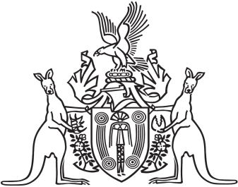
Northern Territory of Australia

Government Gazette
ISSN-0157-833X
No. S17 13 March 2018
Northern Territory of Australia

Liquor Act
Determination of Additional Conditions of Certain Licences
I, Natasha Kate Fyles, Attorney-General and Minister for Justice, being of the opinion that additional conditions of certain licences are urgently needed for the wellbeing of the Tennant Creek community, having had regard to the matters set out in Schedule 1 to this instrument and sections 3 and 6 of the Liquor Act, under section 33AA of the Liquor Act, determine for the licences specified in Schedule 2 the additional conditions specified in Schedule 3, effective from 14 March 2018 to 13 June 2018.
Dated 13 March 2018
N. K. Fyles
Attorney-General and Minister for Justice
Schedule 1
Decision Notice of the Director-General of Licensing for variation of conditions of licenses in Tennant Creek dated 27 February 2018.
Decision Notice of the Director-General of Licensing for variation of conditions of licenses in Tennant Creek dated 6 March 2018.
Letter from the Chairperson of the Northern Territory Liquor Commission dated 7 March 2018.
Schedule 2
Tennant Creek Hotel – Liquor Licence 80102044
Goldfields Hotel – Liquor Licence 80102583
Headframe Bottle Shop – Liquor Licence 81002243
Sporties Club Incorporated – Liquor Licence 81402780
Tennant Creek Golf Club Incorporated – Liquor Licence 81402752
Tennant Creek Memorial Club Incorporated – Liquor Licence 81402774
Schedule 3
Liquor for consumption away from the licensed premises (takeaway liquor) must not be sold Monday to Saturday outside the hours of 3 pm to 6 pm.
Takeaway liquor must not be sold on Sundays.
Takeaway liquor of the following products must not be sold in greater than the indicated quantity, one item per person, per day:
- Beer – light or mid-strength – 30 cans or stubbies
- Beer – full-strength – 24 cans or stubbies
- Ready to drink mixes – 12 cans or bottles
- Cask wine – one 2 litre cask
- Fortified wine – one bottle
- Green ginger wine – one bottle
- Bottled wine – 2 x 750 ml bottles
- Spirits – one 750 ml bottle
The sale of Port, wine in a glass container larger than 1 litre, and beer in bottles of 750 ml or more is prohibited.

