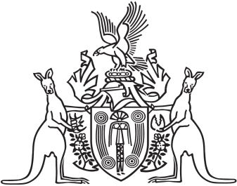
Northern Territory of Australia

Government Gazette
ISSN-0157-833X
No. S85 22 November 2017
Northern Territory of Australia

Interpretation Act
Notification of Making of Rules
Under Gaming Machine Act
I, Natasha Kate Fyles, Attorney-General and Minister for Justice, under section 63(3) of the Interpretation Act, give notice that the following rules have been made under section 89 of the Gaming Machine Act:
Subordinate Legislation No. 30 of 2017: Gaming Machine Amendment Rules 2017
Copies of the rules may be purchased from the Print Management Unit in the Department of Corporate and Information Services, by email request sent to pmu.ntg@nt.gov.au.
Dated 17 November 2017
N. K. Fyles
Attorney-General and Minister for Justice

