Northern Territory of Australia

Government Gazette
ISSN-0157-8324
No. G31 2 August 2017

General information
The Gazette is published by the Office of the Parliamentary Counsel.
The Gazette will be published every Wednesday, with the closing date for notices being the previous Friday at 4.00 pm.
Notices not received by the closing time will be held over until the next issue.
Notices will not be published unless a Gazette notice request form together with a copy of the signed notice and a clean copy of the notice in Word or PDF is emailed to gazettes@nt.gov.au
Notices will be published in the next issue, unless urgent publication is requested.

Availability
The Gazette will be available online at 12 Noon on the day of publication at http://www.nt.gov.au/ntg/gazette.shtml
Unauthorised versions of Northern Territory Acts and Subordinate legislation are available online at https://nt.gov.au/about-government/gazettes

Northern Territory of Australia
Petroleum Act

Notification of Surrender of Petroleum Exploration Permit [EP] 164

I, Vicki Lorraine Jackson, as the Delegate of the Minister for Primary Industry and Resources by virtue of an instrument of delegation dated 11 October 2016, in pursuance of Section 70(c) of the Petroleum Act, give notice that petroleum exploration permit EP164 was surrendered on 17 July 2017.

Dated 24 July 2017

V. L. Jackson

Executive Director, Energy

Northern Territory of Australia
Petroleum Act

Notification of Surrender of Petroleum Exploration Permit [EP] 165

I, Vicki Lorraine Jackson, as the Delegate of the Minister for Primary Industry and Resources by virtue of an instrument of delegation dated 11 October 2016, in pursuance of Section 70(c) of the Petroleum Act, give notice that petroleum exploration permit EP165 was surrendered on 17 July 2017.

Dated 24 July 2017

V. L. Jackson

Executive Director, Energy

Northern Territory of Australia
Petroleum Act

Notification of Surrender of Petroleum Exploration Permit [EP] 166

I, Vicki Lorraine Jackson, as the Delegate of the Minister for Primary Industry and Resources by virtue of an instrument of delegation dated 11 October 2016, in pursuance of Section 70(c) of the Petroleum Act, give notice that petroleum exploration permit EP166 was surrendered on 17 July 2017.

Dated 24 July 2017

Vicki Lorraine Jackson

Executive Director, Energy

Northern Territory of Australia
Petroleum Act

Notification of Surrender of Petroleum Exploration Permit [EP] 309

I, Vicki Lorraine Jackson, as the Delegate of the Minister for Primary Industry and Resources by virtue of an instrument of delegation dated 11 October 2016, in pursuance of Section 70(c) of the Petroleum Act, give notice that petroleum exploration permit EP309 was surrendered on 17 July 2017.

Dated 24 July 2017

V. L. Jackson

Executive Director, Energy
Northern Territory of Australia

Volatile Substance Abuse Prevention Act
Notice of Declaration of Management Area
Ali Curung Locality
I, Denise Mary Riordan, Chief Psychiatrist, as the delegate of the Minister for Health, under section 48(1) of the Volatile Substance Abuse Prevention Act, give notice that:
(a) I have declared an area in the Ali Curung locality, comprising the area of land described in Schedule 1 and shown bounded by thick black lines on the map in Schedule 2, to be a management area; and
(b) the management area is declared to enable a plan to be made for the management of the possession, supply and use of volatile substances in the management area; and
(c) the declaration take effect on the date this notice is published in the Gazette.
Dated 25 July 2017
D. M. Riordan
Chief Psychiatrist
Schedule 1
All those parcels of land in the locality of Ali Curung, Northern Territory of Australia containing a total area of 440 square kilometres more or less, being the whole of NT portions 906 and 994 within the Townsite of Ali Curung and being more particularly delineated on survey plan A/437 lodged with the Surveyor-General, Darwin, together with the whole of NT Portion 599 and being more particularly delineated on survey plan CP4198 lodged with the Surveyor-General, Darwin.
Note for Schedule 1
The address of the Surveyor-General is Level 1, Arnhemica House, 16 Parap Road, Parap NT 0820.
Schedule 2
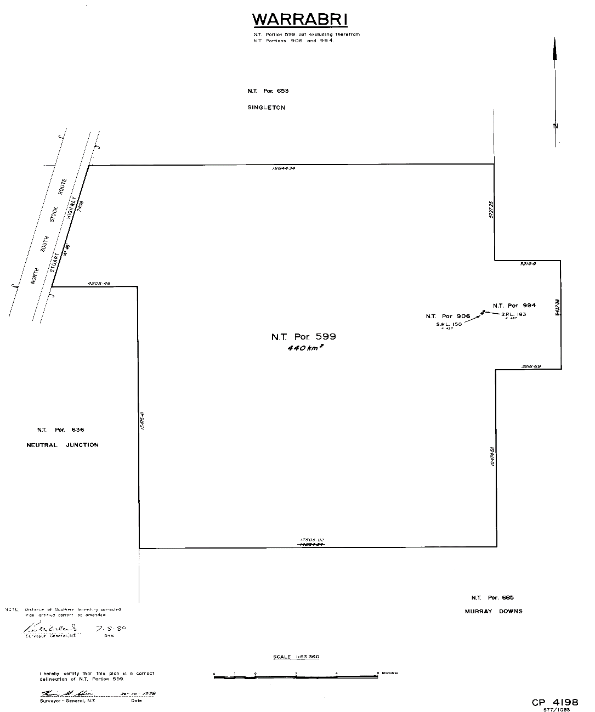

Police Administration Act

Sale of Goods
Notice is hereby given that pursuant to Section 166 of the Police Administration Act, the following property as shown on the attached schedule has been in the possession of the Officer in Charge, Police Station, Alice Springs, for a period in excess of 3 months and this property will be sold or otherwise disposed of in a manner as determined by the Commissioner of Police, if after twenty-eight (28) days from the publication of this notice the property remains unclaimed.
B. Currie
Superintendent
Alice Springs Police Station
19 July 2017
MPR Auction
483097 |  | Nikon Camera Lense AF-S 50MM 2646166 | A3
Exhibits / MPR to CRTM
477708 |  | 4455.00 | Yulara
483225 | 003 | 738.55 | Grn Safe
482197 |  | 50.00 | Grn Safe
481534 | 002 | 35.35 | Grn Safe
Exhibit/MPR Destruction
483225 | 002 | Black Lonsdale bum bag | Grn Safe
483225 | 001 | Black Telstra mobile phone | Grn Safe
483081 |  | Black bag with beige straps | A4
482911 |  | Westpac ATM card 5163610061152409 | A3
482680 |  | Raciui black backpack | A4
482634 |  | Samsung black J3 6 phone | A3
482604 |  | Telstra silver phone | A3
482367 |  | Alcatel One Touch silver B2000013c2b3cx4p | A3
482344 |  | Telstra grey phone | A3
482312 | 001 | HTC black phone | A3
482312 | 002 | Boost black / orange | A3
482216 |  | Telstra silver mobile phone | A3
482215 |  | Telstra white phone | A3
482198 |  | Iphone 4 black | A3
482014 |  | Telstra silver/white phone | A3
481944 |  | Telstra black phone | A3
481534 | 001 | Black leather wallet | Grn Safe
Bikes Auction
480287 |  | Southern Star tan white S/N SNHTC15E88333
480097 |  | Tourex Xtrain66 green purple G1508071175
483076 |  | Extreme Murray green
483075 |  | Huffy pink BB 06D30134
482875 |  | Grey ladies
482802 |  | Reid City 1 silver/gold G121000328
482754 |  | Cyclops Hyperlite silver/red J80751594
482751 |  | Kent maroon / black GS090312257
482708 |  | Cell Fitzroy 1.0 black mode150941
482643 |  | Enforcer AL12J312688
482526 |  | Southern Star Comet green / grey
482439 |  | Merida BMX yellow ACF15J006825
482423 |  | Scooter Star red/black
482358 |  | Scooter red/black
482160 |  | Repco Mystic green/white RPFJ0659111
481970 |  | Gemini Tioga black
481833 |  | Giant Aluxx black / blue C80C2103
481821 | 002 | Avanti Ridge Rider U7YK29456
481639 |  | Silver / red AH16J025210
481578 |  | Southern Star Urban cruiser G1510093120
481565 |  | Parkpre Alucomp silver 96122603
481519 |  | Tourex Xtrain66 blue / white
Firearms
472285 | #001 | Rosi Amadeo magnum S/N SM000602 | Memo | Rack 11
472285 | #002 | Winchester S/N F747900 | Memo | Rack 12
Northern Territory of Australia
Law Officers Act
Authorisation
I, Gregory John Shanahan, the Chief Executive Officer of the
Department of the Attorney-General and Justice, in pursuance of section 8(4) of the Law Officers Act, authorise Kendra Laverne Frew, Neil George von Bertouch, of the Department, each officer being a legal practitioner, to act in the name of the Solicitor for the Northern Territory.
Dated 26 July 2017
G. J. Shanahan
Chief Executive Officer
Planning Act
Adjustment to CB Zone Car Parking Contribution Rate
In accordance with Sections 5.1 Formula for Calculating Contribution and 5.2 Adjustment of Contributions of the Car Parking Contribution Plan Central Business Zone, May 2007 (first gazetted 15 August 2007), notice is hereby given that from 1 July 2017, the Developer contribution payable per parking shortfall bay in the Central Business Zone of Darwin, has decreased from $24,105 to $23,262.
Dated: 1 July 2017
C. Robson
Manager City Planning
City of Darwin
Legal Profession Act 2006
- The Law Society Northern Territory pursuant to section 375 of the Legal Profession Act 2006 (the Act) exempts local legal practitioners holding practising certificates under the Act and being principals or employees of Lawlab Pty Ltd from compliance with the section 376 of the Act.
- Pursuant to section 375 of the Act, the period of exemption shall be from 4.00pm on 30 June 2017 to 4.00pm on 30 June 2018, unless the instrument is earlier terminated by the Law Society Northern Territory.
- This exemption is subject to the following conditions:
- All legal practitioners that are covered by this exemption must maintain professional indemnity insurance with respect to their legal practice, which contains terms and conditions accepted by the Law Society Northern Territory (accepted alternative policy).
- The accepted alternative policy is Professional Indemnity Insurance Policy 2017/18 offered by Lawcover Insurance Pty Ltd.
- The legal practitioners that are covered by this exemption must provide satisfactory evidence to the Law Society Northern Territory that they are covered by the accepted alternative policy.
Dated this 27th day of July 2017
Kellie Anne Grainger
Executed by the Chief Executive Officer
Pursuant to a delegation from the Law Society Northern Territory under section 647 of the Act

Police Administration Act

Sale of Goods
Notice is hereby given that pursuant to Section 166 of the Police Administration Act, the following property as shown on the attached schedule has been in the possession of the Officer in Charge, Police Station, Peter McAulay Centre, for a period in excess of 3 months and this property will be sold or otherwise disposed of in a manner as determined by the Commissioner of Police, if after twenty-eight (28) days from the publication of this notice the property remains unclaimed.
A. S DEUTROM
for
Nouvelle Reed
SUPERINTENDENT
iCOP 2020
CIO Branch
24/07/2017
Exhibit number | Item Description
461070/001 | Black Specialized Hardrock mountain bike
481731/001 | Green Giant bicycle S/N G150600741
466377/003 | 3 x solar panels
453852/001 | 1 x men’s Casio G-shock watch- camouflage band
483134/011 | Large linked gold chain
466837/004 | 1 x yellow Trade Flame blow torch
479151/001  478151/002 | 1 x gold men’s Citizen watch  1 x men’s gold link chain (crisscross pattern)
444305/001  444305/005  444305/002 | Fishing equipment  Fishing rod  Silver hoist
481922/003  481922/004  481922/005  481922/006  481922/007  481922/008  481922/009 | Yellow bath towel  Baby shoes  Pink and brown towel sets  Assorted baby clothing  Assorted costume jewellery  Assorted clothing  Bedside table lamp
483210/002 | White Canon printer
482060/001 | Gold charm bracelet + charms
482881/001 | Silver Blaze tungsten men’s ring
482137/001 | Pearl necklace (60cm)
482088/001  482088/002 | Pink and clear frosted glass jewellery box  Assorted costume jewellery
481941/001 | Silver pendant with purple heart shaped stone
482391/002  482391/003 | Camrose and Kross jewellery box  Various jewellery pieces
482032/001 | Black Sony digital camera
481579/001 | Titleist golf driver
481561/001 | Mambo kid’s scooter
332841/001 | $5990
482728/002 | $16.85
482728/003 | 20 Pence
482518/002 | $15.95
482337/002 | $20.00
481686/001/001 | $5.10
482704/001 | $4.50
483059/002 | $5.00
483004/001/001 | $45.80
461729/004 | 2 x $1 USD
483181/001  483181/001/001  483181/002  483181/002/001 | Black Dell laptop bag  Master card  Basics card  Medicare card
483134/001  483134/002  483134/003  483143/004  483134/005  483134/006  483134/008  483134/009  483134/010  483134/012  483134/013  483134/014  483134/015  483134/016 | White ZTE mobile phone  Grey shoulder bag  Black Garmin GPS  2 x power banks (USB)  Black Dixi Onetel mobile phone  Silve/black Ipod  Black Apple I-phone  Black Samsun mobile phone  Black kindle  Apple card reader  2 x USB drives  Personal papers  Silver Toshiba laptop  Black Dell laptop
479881/001  479881/002  479881/006 | White Samsung  Portable battery charger  Portable hard drive
476101/001 | Apple I-phone 5
444176/003 | Black Huawei mobile phone
451440/003 | White/silver Samsung mobile phone
469709/001 | Black Telstra mobile phone
475710/001 | White ZTE mobile phone
486956/010 | Black/silber Telstra mobile phone
482728/001 | Wallet + contents
482518/001 | Black/red Kenworth backpack + contents
482337/001 | Black Colorado wallet + contents
481686/001 | Black Trent Nathan wallet
482704/002 | Bankcard
483059/001 | Brown/black purse
483004/001 | Black leather wallet
482977/003  482977/001  482977/002 | Black Telstra iPad  Black Telstra mobile phone  Black Telstra mobile phone
483180/001 | White Hauwei mobile phone
482939/002  482939/001 | Black Telstra ZTE mobile phone  Black Alcatel mobile phone
482869/001 | Black Samsung mobile phone
482702/001 | Black Alcatel mobile phone
482701/001 | White Samsung mobile phone
482538/001 | Silver/black OPPO mobile phone
482537/001 | Black Telstra mobile phone
482533/001 | Gold LG mobile phone
482453/050  482453/048  482453/046  482453/043  482453/038  482453/036  482453/035  482453/032  482453/029  482453/027  482453/011  482453/022 | Men’s wallet  Assorted sporting tickets  Browne Sportsgirl ladies handbag  Orange ladies wallet  Black Malebox men’s wallet  Brown Waterfield shoulderbag  Blue Sarawak shoulderbag  Assorted toiletries  Plastic bag with eye drops/cough drops  Multi-coloured purse  Assorted condoms  Black men’s belt
482391/001 | Back pack with contents
482314/001 | Black Telstra mobile phone
482121/001 | White Apple mobile phone
481796/001 | Grey Samsung mobile phone
481812/001 | Black Telstra mobile phone
481715/001  481715/002  481715/003 | Black Telstra mobile phone  Black iPhone  Black LG mobile phone
481710/001 | Purse with contents
481522/001 | Black Telstra mobile phone
475876/001 | Black iPhone
481611/003  481611/005 | Landrover keys with fob  Grey iPod shuffle
485233/001 | White Huawei mobile phone
481351/001 | Black Telstra mobile phone
470214/004 | Black HTC mobile phone
466255/042 | HP laptop computer
481922/001  481922/002 | Green singlet  Bag of assorted clothing and manchester
465835/001 | Boito SSB 410g – S/N # 124015-02
465835/002 | Lithgow RBA 25.303 – S/N# E95704
465835/003 | Ammo
465835/004 | 1 x magazine
479248/001 | Baikal SUO 12g S/N # 9651089
483194/001 | Silver BMX bike
482493/001 | Red/grey Huffy S/N # AJ014831
482493/002 | Grey/yellow Huffy S/N # AH15H033786
482249/001 | Black/red Avalanche S/N # CM15H506926
482497/001 | Red/white Thumper S/N VA05121840
482094/001 | Black Learsport Shimano S/N # PDYL02170
482456/001 | Grey/red Specialized
481688/002 | Red/white Malvern Star s/N 13K05000
482342/001 | Red Viper Diamondback S/N # RPFJ819000
481848/001 | Black/green Repco Torrent S/NRPFJ264657
482658/001 | White/purple Flight AIRX6
470811/001 | NT CC29BI – silver Ford Falcon utility

