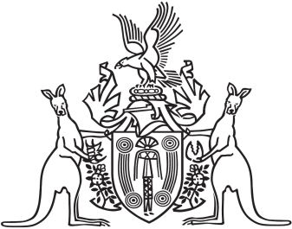
Northern Territory of Australia

Government Gazette
ISSN-0157-833X
No. S28 2 June 2017

Assent to Proposed Laws
His Honour the Administrator assented to the following proposed laws:
31 May 2017
Criminal Code Amendment (Mental Impairment and Unfitness to be Tried) Act 2017 (Act No 8 of 2017)
Justice and Other Legislation Amendment (Australian Crime Commission) Act 2017 (Act No 9 of 2017)
Limitation Amendment (Child Abuse) Act 2017 (Act No 10 of 2017)
Consumer Affairs and Fair Trading Legislation Amendment Act 2017 (Act No 11 of 2017)
Yours sincerely
Michael Tatham
Clerk of the Legislative Assembly
Date 1 June 2017

