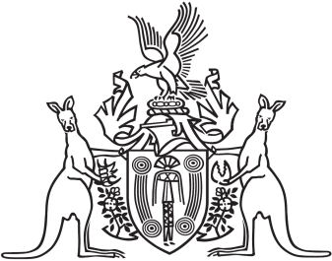
Northern Territory of Australia

Government Gazette
ISSN-0157-833X
No. S21 19 April 2017
Northern Territory of Australia

Public and Environmental Health Act
Termination and Appointment of Chief Health Officer
I, Natasha Kate Fyles, Minister for Health:
(a) under section 67(1) of the Public and Environmental Health Act and with reference to section 44(1) of the Interpretation Act, terminate the appointment of Dinesh Kumar Arya as the Chief Health Officer; and
(b) under section 67(1) of the Public and Environmental Health Act, appoint Hugh Crosbie Heggie to be the Chief Health Officer.
Dated 6 March 2017
N. K. Fyles
Minister for Health

