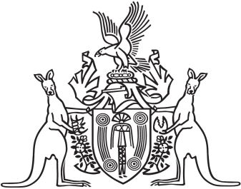
Northern Territory of Australia

Government Gazette
ISSN-0157-833X
No. S104 30 September 2016
Northern Territory of Australia

Heritage Act
Provisional Declaration of Heritage Object
I, Lauren Jane Moss, Minister for Tourism and Culture, under section 36(2) of the Heritage Act, provisionally declare the remains of the Royal Australian Air Force Spitfire A58-2 to be a heritage object.
Dated 23 September 2016
L. J. Moss
Minister for Tourism and Culture

