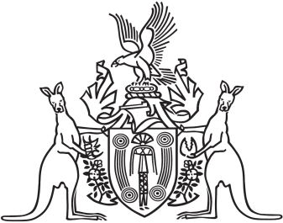
Northern Territory of Australia

Government Gazette
ISSN-0157-833X
No. S93 10 August 2016
Northern Territory of Australia

Plant Health Act
Dickeya Sp.
Declaration of Pest, Notifiable Pest And Host Plant
I, Leonie Michelle Cooper, Chief Inspector of Plant Health:
- under section 6(2)(a) of the Plant Health Act, declare Dickeya sp. (the declared pest) to be a pest; and
- under section 6(4) of the Act, specify that the declared pest is a notifiable pest; and
- under section 8(2)(a) of the Act, declare Ananas comosus (pineapple) to be a host plant for the declared pest.
Dated 5 August 2016
L. M. Cooper
Chief Inspector of Plant Health

