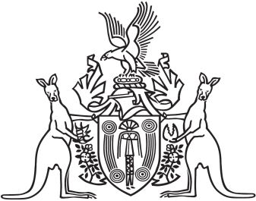
Northern Territory of Australia

Government Gazette
ISSN-0157-833X
No. S62 5 July 2016
Northern Territory of Australia

Auctioneers Act
Prescribed Fees
I, Peter Donald Styles, Minister for Racing, Gaming and Licensing:
(a) under section 3AB of the Auctioneers Act and with reference to section 43 of the Interpretation Act, revoke all instruments prescribing fees under section 3AB of the Auctioneers Act in force immediately before the date of this instrument; and
(b) under section 3AB of the Auctioneers Act and with reference to section 8 of the Interpretation Act, prescribe the fee payable in relation to a matter specified in the Schedule to be the fee specified opposite.
Dated 30 June 2016
P. D. Styles
Minister for Racing, Gaming and Licensing
Schedule
Item | Description | Fee  (Revenue units)
1 | Fee payable under section 5(3) or 8B for auctioneer's licence for period of:  (a) 1 year  (b) 3 years  (c) 5 years | 327  882  1 471
2 | Fee payable under section 6(3) or 8B for renewal of auctioneer's licence for period of:  (a) 1 year  (b) 3 years  (c) 5 years | 327  882  1 471

