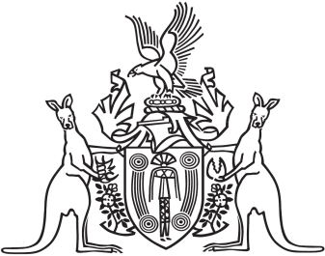
Northern Territory of Australia

Government Gazette
ISSN-0157-8324
No. G20 18 May 2016

General information
The Gazette is published by the Office of the Parliamentary Counsel.
The Gazette will be published every Wednesday, with the closing date for notices being the previous Wednesday at 4.00 pm.
Notices not received by the closing time will be held over until the next issue.
Notices will not be published unless a Gazette notice request form together with a copy of the signed notice and a clean copy of the notice in Word or PDF is emailed to gazettes@nt.gov.au
Notices will be published in the next issue, unless urgent publication is requested.

Availability
The Gazette will be available online at 12 Noon on the day of publication at http://www.nt.gov.au/ntg/gazette.shtml
Unauthorised versions of Northern Territory Acts and Subordinate legislation are available online at http://www.legislation.nt.gov.au

Northern Territory of Australia

Museum and Art Gallery of the Northern Territory Act
Appointment of Member Board of The Museum and Art Gallery of the Northern Territory
I, Gary John Higgins, Minister for Arts and Museums, under section 16(1) of the Museum and Art Gallery of the Northern Territory Act, appoint Elizabeth Anne Prell to be a member of the Board of the Museum and Art Gallery of the Northern Territory from the date of this instrument to 31 March 2019.
Dated 6 May 2016
G. J. Higgins
Minister for Arts and Museums

Northern Territory of Australia
Museum and Art Gallery of the Northern Territory Act
Appointment of Member of Board of the Museum and Art Gallery of the Northern Territory
I, Gary John Higgins, Minister for Arts and Museums, under section 16(1) of the Museum and Art Gallery of the Northern Territory Act, appoint Janet Mary Chisholm to be a member of the Board of the Museum and Art Gallery of the Northern Territory for 3 years on and from 1 April 2016.
Dated 16 March 2016
G. J. Higgins

Minister for Arts and Museums
Northern Territory of Australia

Strehlow Research Centre Act
Strehlow Research Centre Board
Appointment of Member
I, Gary John Higgins, Minister for Arts and Museums, under section 14(1)(c) of the Strehlow Research Centre Act, appoint Peter Michael Kell to be a member of the Strehlow Research Centre Board for 3 years on and from the date of this instrument.
Dated 21 April 2016
G. J. Higgins
Minister for Arts and Museums

