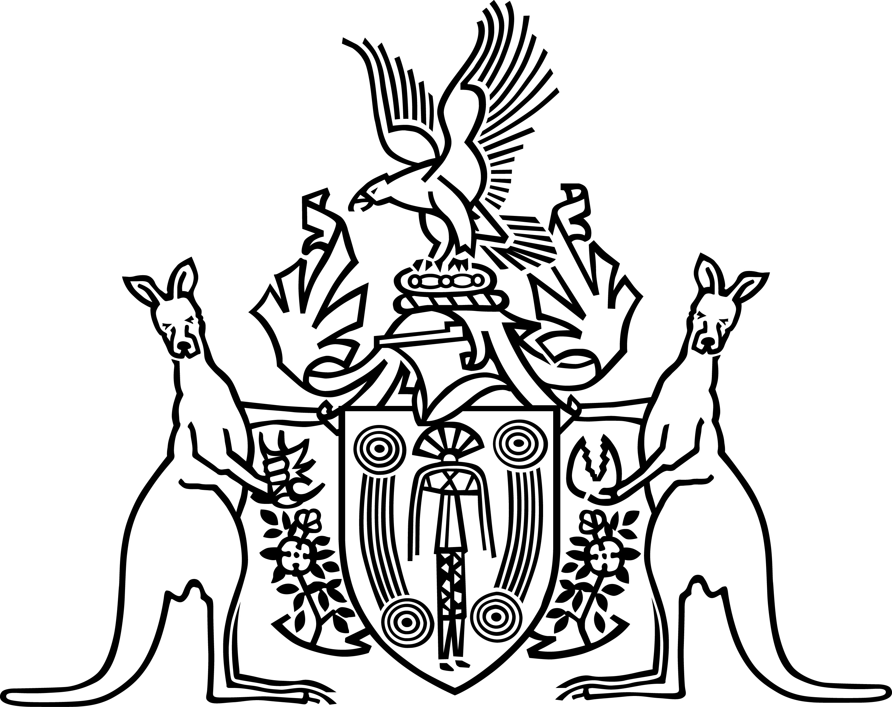
The Northern Territory of Australia

Alcohol Mandatory Treatment Tribunal
Alcohol Mandatory Treatment Act 2013
Practice Direction No. 2
President’s Nomination of Tribunal Members
In accordance with section 114(5) of the Alcohol Mandatory Treatment Act 2013 I, Tom Berkley, President of the Alcohol Mandatory Treatment Tribunal make the following Practice Direction.
- This Practice Direction shall be known as Practice Direction No.2 – President’s Nomination of Tribunal Members.
- Pursuant to section 109(1) of the Act the President must nominate 3 members of the Tribunal to exercise the powers or perform the functions of the Tribunal. Of the 3 persons nominated:
one must be the President, Deputy President or another member appointed under section 104(2)(a); and
one must be a member appointed under section 104(2)(b); and
one must be a member appointed under section 104(2)(c).
- The President’s nomination pursuant to section 109(1) will be achieved by the President approving rosters of Tribunal members covering hearings scheduled for the working week Monday to Friday.
- These rosters will be drafted by the Registrar or Deputy Registrar to cover a 6 to 8 week period in advance and emailed to the President for approval.
- Following the President’s approval the Registrar or Deputy Registrar will arrange for the roster to be circulated to all Tribunal members via their personal email addresses.
- In the event that the Tribunal is required to be convened after normal working hours or on a weekend or public holiday the President will nominate Tribunal members as and when required following recommendation by the Registrar or Deputy Registrar.
Dated this 15th day of July 2013

…………………………………………………………………..
Tom Berkley
President
Alcohol Mandatory Treatment Tribunal

