This form is for a public housing tenant who wants to have a visitor/s stay with them for more than two (2) weeks.
Only one tenant who has signed the current tenancy agreement needs to apply for approval.
Do you require an interpreter to help you complete this form? |  | ☐ Yes | ☐ No
If yes, please indicate your preferred language:
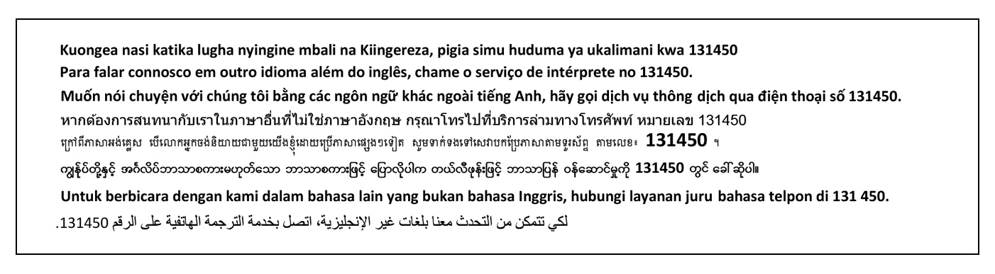
You can ask a staff member for help filling out this form.

Tenant details
Title (please circle) | Mr / Mrs / Miss / Ms / Other |  |  |  |  | Date of birth
Family name
Given names
Residential or community address
Contact number |  |  |  |  | Mobile
Email

Visitor details
Date visitors arriving |  |  |  | Number of days your visitors will stay with you
Number of visiting Adults (18 years and over) |  |  |  | Number of visiting Children (under 18years)
Why do your visitor/s need to stay longer than 14 days?
(e.g. medical appointment, visit family, to attend a sporting or cultural event, school holidays)
Only adult visitors’ details are required below. Visitors must be able to provide evidence of a permanent residence elsewhere. You can provide details of more visitors on another page, if needed.

Visitor 1 details

Full name

Current permanent residential address
Phone |  |  | Other contact

Visitor 2 details

Full name

Current permanent residential address
Phone |  |  | Other contact

Visitor 3 details

Full name

Current permanent residential address
Phone |  |  | Other contact

Visitor 4 details

Full name

Current permanent residential address
Phone |  |  | Other contact

Declaration
I, | (FULL NAME)
- Wish to apply to have the visitors detailed in this form, stay with me for an extended period of time in a public housing dwelling.
- Confirm the information contained in this application is true and correct to the best of my knowledge.
- Understand I will need to tell the Department of Local Government, Housing and Community Development of any changes about my visitors, including how long they will be staying.
- Understand that I can ask for help from the Department with managing my visitors.
Signature |  |  | Date

Disclaimer
The Department of Local Government, Housing and Community Development collects only your personal information, which is necessary to provide housing assistance under the Housing Act 1982 and its Regulations.
If you do not provide the requested information we may not be able to provide you with assistance. The information collected will not be disclosed to anyone without your consent unless it is required or authorised by law in accordance with the Information Privacy Principles at Schedule 2 of the Information Act (NT) 2002. You have a right to access and correct the information held about you.
If you have any queries or concerns please contact the Governance and Information Management Unit on 8999 8490, email infoact.DLGHCD@nt.gov.au or write to GPO Box 4621, Darwin NT 0801.
Greater Darwin | Building 5 Cas Com Centre, 13 Scaturchio Street, Casuarina NT | 8999 8814
Nhulunbuy | Shop 2 Arnhem House, Endeavour Square, Nhulunbuy NT | 8987 0533
Arafura Region | Building 4 Cas Com Centre, 13 Scaturchio Street, Casuarina NT | 8995 5122
Tennant Creek | NT Government Centre, Peko Road, Tennant Creek NT | 8962 4497
Katherine | NT Government Centre, First Street, Katherine NT | 8973 8513
Palmerston | Highway House, Chung Wah Terrace, Palmerston NT | 8999 4767
Alice Springs | Level 1, Alice Plaza, 36 Todd Mall, Alice Springs NT | 8951 5344
OFFICE USE ONLY – Assessment by Housing Officer
Group number |  |  |  | Current entitlement |  |  |  |  | bedroom(s)
Have any visitors had a past tenancy with the Department? |  | ☐ Yes  ☐ No |  | If yes, past group number/s
Have any visitors been involved in ASB complaints or incidents in the past? |  | ☐ Yes  ☐ No |  | Has the tenant had assistance to manage visitors in the past? E.g. support services |  |  |  |  |  |  | ☐ Yes  ☐ No
Is sufficient proof of residency elsewhere, for all visitors 18 years and over, attached? |  | ☐ Yes  ☐ No |  | Will visitors cause overcrowding? |  |  |  |  | ☐ Yes by people  ☐ No
OFFICE USE ONLY – Approval from delegate
Please circle | APPROVED |  |  |  | NOT APPROVED
Delegate signature |  |  | Delegate name
Position title |  |  |  |  |  |  |  | Date
Please note: Housing Officers must ensure all approved visitor applications are recorded within TMS 1.9 Client Group Request Details screen, including appropriate communication on 1.7 Communication Details.

