 | - Questions are followed by answer fields. Use the ‘Tab’ key to navigate through. Replace Y/N or Yes/No fields with your answer.
Applicant details - $48.00 per certificate. See below for postage
Name of person filling in the form
Signature of person filling the form |  |  |  |  |  |  |  |  |  |  |  |  |  |  |  |  |  |  |  |  |  |  |  |  |  |  |  |  |  |  |  |  |  |  |  |  |  |  |  |  |  |  |  |  |  |  |  |  |  |  | Date
Postal address |  |  |  |  |  |  |  |  |  |  |  |  |  |  |  |  |  |  |  |  |  |  |  |  |  |  |  |  |  |  |  |  |  |  |  |  |  |  |  |  |  |  |  |  | Post code
Day time contact number
Reason document is required
Relationship of person filling form to person in certificate. Mark with ‘X’, select one only
Self |  |  |  |  |  |  |  | Mother |  |  |  |  |  |  |  |  |  |  |  |  |  |  |  |  |  | Father |  |  |  |  |  |  |  |  |  |  |  | Authorised agent
How would you like to receive the certificate? Mark with ‘X’, select one only
Collected |  |  |  |  |  | Posted $13.30 |  |  |  |  |  |  |  |  |  |  |  |  |  |  |  |  |  |  |  |  | Laminated A4 $3.30 |  |  |  |  |  |  |  |  |  |  |  |  |  |  |  | Laminated A3 $6.05
Birth certificate details
Surname
Given names |  |  |  |  |  |  |  |  |  |  |  |  |  |  |  |  |  |  |  |  |  |  |  |  |  |  |  |  |  |  |  |  |  |  |  |  |  |  |  |  |  | Date of birth
Place of birth |  |  |  |  |  |  |  |  |  |  |  |  |  |  |  |  |  |  |  |  |  |  |  |  |  |  |  |  |  |  |  |  |  |  |  |  |  |  |  |  |  | State
Given name of parent 1
Surname of parent 1
Given name of parent 2
Surname of parent 2
Certificate request – mark with ‘X’ to indicate type and confirm quantity
Commemorative and legal certificate |  |  |  |  |  |  |  |  |  |  |  |  |  |  |  |  |  |  |  |  |  |  |  | $80.00 each |  |  |  |  |  |  |  |  |  |  |  |  |  |  |  |  |  |  |  | Quantity
Commemorative certificate |  |  |  |  |  |  |  |  |  |  |  |  |  |  |  |  |  |  |  |  |  |  |  | $45.00 each (A3 size) |  |  |  |  |  |  |  |  |  |  |  |  |  |  |  |  |  |  |  | Quantity
Legal certificate |  |  |  |  |  |  |  |  |  |  |  |  |  |  |  |  |  |  |  |  |  |  | $48.00 each (A4 size) |  |  |  |  |  |  |  |  |  |  |  |  |  |  |  |  |  |  |  |  | Quantity
Commemorative certificate theme options - mark with ‘X’, select one only
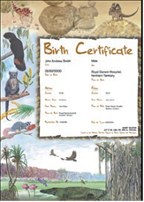 |  |  |  |  |  |  |  |  |  |  |  |  | 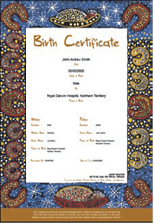 |  |  |  |  |  |  |  |  |  |  |  |  |  |  |  |  | 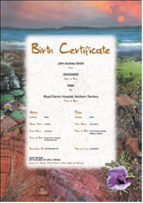 |  |  |  |  |  |  |  |  |  |  |  |  |  |  |  |  | 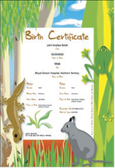
Birth certificate – portrait, wildife |  |  |  |  |  |  |  |  |  |  |  |  | Birth certificate – portrait, Indigenous |  |  |  |  |  |  |  |  |  |  |  |  |  |  |  |  | Birth certificate – portrait, Scenery |  |  |  |  |  |  |  |  |  |  |  |  |  |  |  |  | Birth certificate – portrait, Abstract
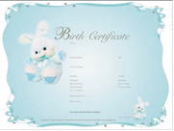 |  |  |  |  |  |  |  |  |  |  |  |  | 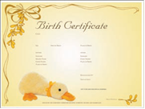 |  |  |  |  |  |  |  |  |  |  |  |  |  |  |  |  | 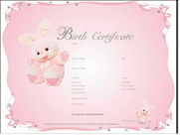 |  |  |  |  |  |  |  |  |  |  |  |  |  |  |  |  | 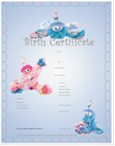
Birth certificate - landscape blue background with bunny |  |  |  |  |  |  |  |  |  |  |  |  | Birth certificate - landscape yellow background with duck |  |  |  |  |  |  |  |  |  |  |  |  |  |  |  |  | Birth certificate - landscape pink background with bunny |  |  |  |  |  |  |  |  |  |  |  |  |  |  |  |  | Birth certificate - portrait blue background with clowns
Payment details (card holder details are deleted after application is processed)
American Express/bank cards not accepted
VISA |  |  |  |  |  |  |  |  |  |  |  | MasterCard |  |  |  |  |  |  |  |  |  |  |  |  |  |  |  |  |  |  |  |  |  | Cheque/money order
Card number
Expiry date mm/yyyy |  |  |  |  |  |  |  |  |  |  |  |  |  |  |  |  |  |  |  |  |  |  |  |  |  |  |  |  |  |  |  |  |  | CCV
Card holder name in full – please print
Signature |  |  |  |  |  |  |  |  |  |  |  |  |  |  |  |  |  |  |  |  |  |  |  |  |  |  |  |  |  |  |  |  |  |  |  |  |  |  |  |  |  |  |  |  |  |  |  | Amount $
Office use only^
Registration number^ |  |  |  |  |  |  |  |  |  |  |  |  |  |  |  |  |  |  |  |  |  |  |  |  |  |  |  |  |  |  | Application number^
Date received^ |  |  |  |  |  |  |  |  |  |  |  |  |  |  | Receivers signature^ |  |  |  |  |  |  |  |  |  |  |  |  |  |  |  |  |  |  |  |  |  |  |  |  |  |  |  |  |  |  |  |  |  | ID^
Identification requirements
You must provide a minimum of three (3) types of acceptable identification from the lists below.
Identification must include at least one (1) type of photo ID from Category A and at least two (2) types of ID from Category B.
- If applying in person, you must provide original identification documents.
- If applying by post, you must provide certified photocopies of each identity document. Do not post original documents unless it is your NT birth certificate or previous change of name certificate.
Category A – provide at least one  Passport (Australian or overseas issued)  Australian drivers licence  Firearms licence  Tertiary student ID card with photo  Australian Evidence of Age Card (18+ Card)  Photographic ID issued by Larrakia Nation or Tangentyere Council  Police Service ID  Defence Force ID  NT Ochre Card  (Any other photographic ID deemed by the Registrar to be sufficient) |  |  |  |  |  |  |  |  |  |  |  |  |  |  |  |  |  |  |  |  |  |  |  |  |  |  |  |  |  | Category B – provide at least two  Australian birth certificate  Australian citizenship certificate  Immi Card  Centrelink Health Care Card  Centrelink Pension/Concession Card  Government employee ID  Overseas birth certificate with translation  Medicare Card  Credit card/debit card or passbook  Phone bill/electricity bill  Bank statement  Change of name certificate or deed poll  Tax assessment notice  ID letter from an Aboriginal community  Student letter of enrolment  NT Security ID  (Any other evidence deemed by the Registrar to be sufficient)

Contact information
Darwin/Palmerston |  |  |  |  |  |  |  |  |  |  |  |  |  |  |  |  |  |  |  |  |  |  |  |  |  |  |  |  |  | Alice Springs
Office of Births, Deaths and Marriages  Phone: 08 8999 6119  Fax: 08 8999 6324  Nichols Place, Cnr of Cavenagh and Bennett Sts, Darwin NT  GPO Box 3021, Darwin NT 0801 |  |  |  |  |  |  |  |  |  |  |  |  |  |  |  |  |  |  |  |  |  |  |  |  |  |  |  |  |  | Office of Births, Deaths and Marriages  Phone: 08 8951 5338  Ground Floor Centrepoint Building Cnr Hartley Street and Gregory Terrace Alice Springs NT  PO Box 8043, Alice Springs NT 0871
  - nd of form

