Mineral Titles Act 2010
NOTICE OF LAND CEASING TO BE A MINERAL TITLE AREA
Title Type and Number: | Exploration Licence 31356
Area Ceased on: | 13 October 2026
Area: | 83 Blocks, 261.36 km²
Locality: | PINE CREEK
Name of Applicant(s)/Holder(s): | 100% MANGUSTA MINERALS PTY LTD [ACN. 653 950 522]
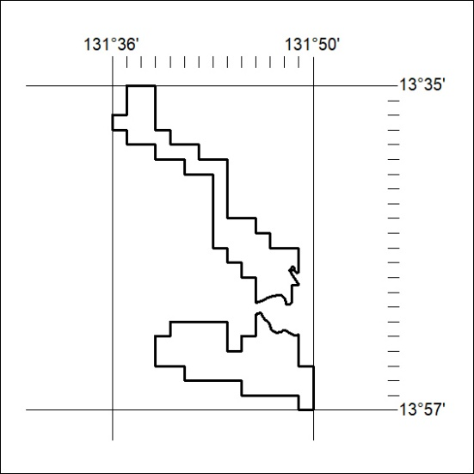

419/26

Mineral Titles Act 2010
NOTICE OF LAND CEASING TO BE A MINERAL TITLE APPLICATION AREA
Title Type and Number: | Exploration Licence 34386
Area Ceased on: | 07 October 2026
Area: | 24 Blocks, 75.98 km²
Locality: | DNEIPER
Name of Applicant(s)/Holder(s): | 100% TDM INTERNATIONAL PTY LTD [ACN. 684 939 884]
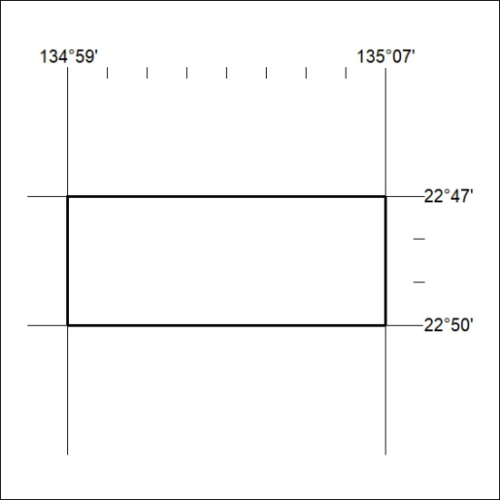

420/26

