Mineral Titles Act 2010
NOTICE OF LAND CEASING TO BE A MINERAL TITLE APPLICATION AREA
Title Type and Number: | Exploration Licence 33602
Area Ceased on: | 28 March 2025
Area: | 72 Blocks, 225.82 km²
Locality: | GILL
Name of Applicant(s)/Holder(s): | 100% TERRALITH METALS PTY LTD [ACN. 669 527 360]
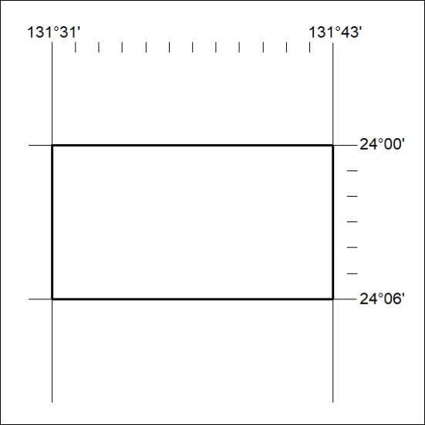

233/25

Mineral Titles Act 2010
NOTICE OF LAND CEASING TO BE A MINERAL TITLE APPLICATION AREA
Title Type and Number: | Exploration Licence 33603
Area Ceased on: | 28 March 2025
Area: | 48 Blocks, 150.97 km²
Locality: | RENNIE
Name of Applicant(s)/Holder(s): | 100% TERRALITH METALS PTY LTD [ACN. 669 527 360]
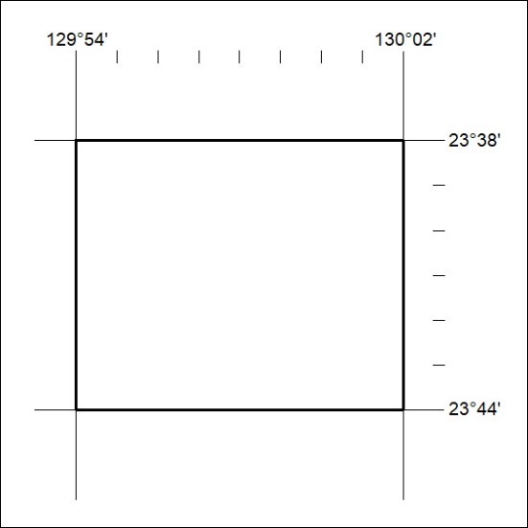

234/25

Mineral Titles Act
NOTICE OF GRANT OF A MINERAL TITLE
Title Type and Number: | Exploration Licence 33973
Granted: | 27 March 2025, for a period of 6 Years
Area: | 53 Blocks, 170.98 km²
Locality: | BREADEN
Name of Holder/s: | 100% PURE EXPLORATION PTY LTD [ACN. 669 443 636]
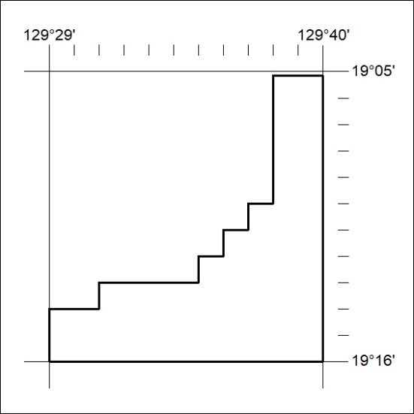
Area granted is indicated above. The titleholder is not permitted to exercise occupational rights on any land that is subject to a development title, or an application for a development title. Any land the subject of a Reserved Land gazettal under the Mineral Titles Act and all land vested in the Commonwealth of Australia is also excluded by description but not excised from the grant area.

235/25

