Mineral Titles Act 2010
NOTICE OF LAND CEASING TO BE A MINERAL TITLE AREA
Title Type and Number: | Exploration Licence 26628
Area Ceased on: | 01 March 2025
Area: | 141 Blocks, 453.82 km²
Locality: | McFARLANE
Name of Applicant(s)/Holder(s): | 90% PRODIGY GOLD NL* [ACN. 009 127 020], 10% NGUNGAJU LITHIUM OPERATIONS PTY LTD* [ACN. 095 384 491]
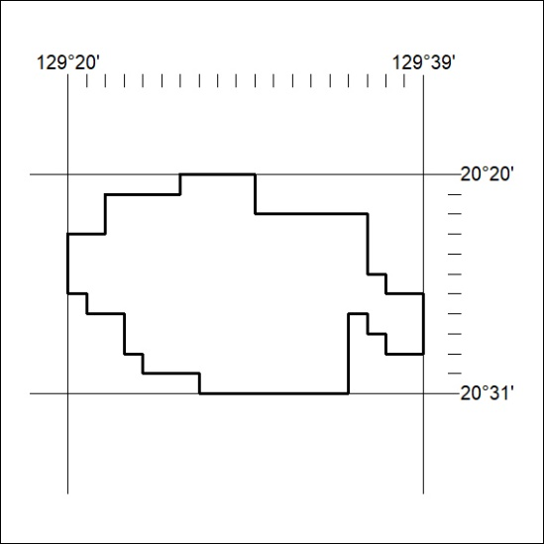

105/25

Mineral Titles Act 2010
NOTICE OF LAND CEASING TO BE A MINERAL TITLE AREA
Title Type and Number: | Exploration Licence 33263
Area Ceased on: | 14 March 2025
Area: | 158 Blocks, 502.41 km²
Locality: | ARAPUNGA
Name of Applicant(s)/Holder(s): | 100% GLYDE RIVER PTY LTD [ACN. 680 722 810]
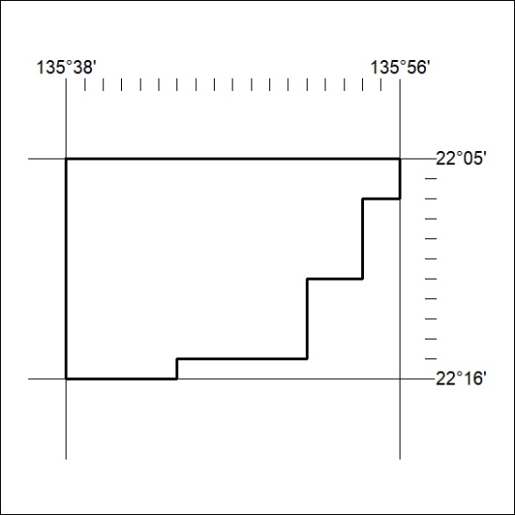

106/25

Mineral Titles Act 2010
NOTICE OF LAND CEASING TO BE A MINERAL TITLE AREA
Title Type and Number: | Exploration Licence 33267
Area Ceased on: | 14 March 2025
Area: | 202 Blocks, 625.88 km²
Locality: | ARAPUNGA
Name of Applicant(s)/Holder(s): | 100% GLYDE RIVER PTY LTD [ACN. 680 722 810]
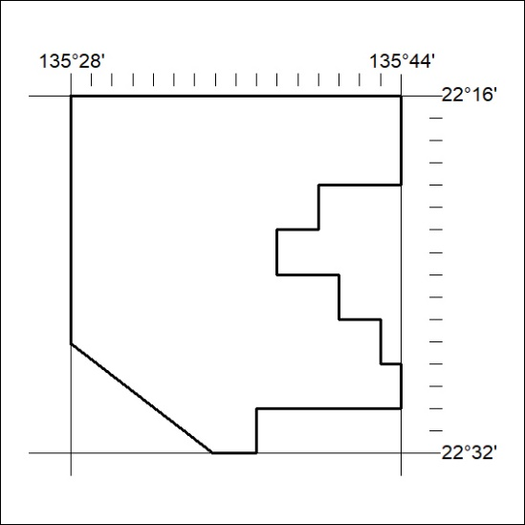

107/25

Mineral Titles Act 2010
NOTICE OF LAND CEASING TO BE A MINERAL TITLE AREA
Title Type and Number: | Exploration Licence 33272
Area Ceased on: | 17 March 2025
Area: | 64 Blocks, 201.20 km²
Locality: | JERVOIS RANGE
Name of Applicant(s)/Holder(s): | 100% GLYDE RIVER PTY LTD [ACN. 680 722 810]
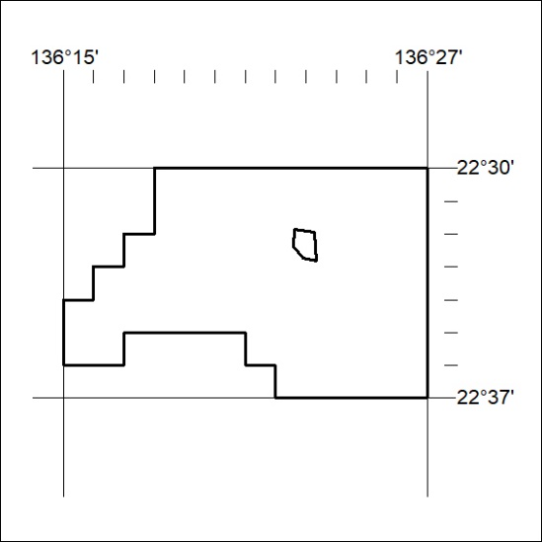

108/25

