Mineral Titles Act 2010
NOTICE OF LAND CEASING TO BE A MINERAL TITLE APPLICATION AREA
Title Type and Number: | Exploration Licence 32919
Area Ceased on: | 03 March 2025
Area: | 250 Blocks, 822.17 km²
Locality: | AMUNGEE MUNGEE
Name of Applicant(s)/Holder(s): | 100% DALY TENEMENTS PTY LTD [ACN. 658 845 786]
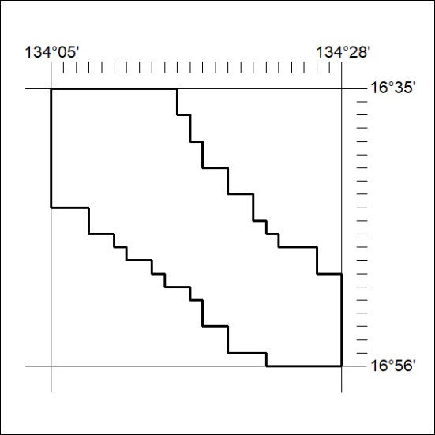

69/25

Mineral Titles Act 2010
NOTICE OF LAND CEASING TO BE A MINERAL TITLE APPLICATION AREA
Title Type and Number: | Exploration Licence 32995
Area Ceased on: | 04 March 2025
Area: | 17 Blocks, 41.11 km²
Locality: | BATCHELOR
Name of Applicant(s)/Holder(s): | 100% BIG ROCK MAGNESIUM PTY LTD [ACN. 654 855 188]
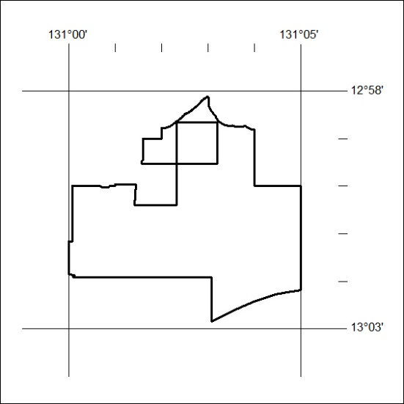

70/25

Mineral Titles Act 2010
NOTICE OF LAND CEASING TO BE A MINERAL TITLE AREA
Title Type and Number: | Exploration Licence 33138
Area Ceased on: | 04 March 2025
Area: | 14 Blocks, 45.99 km²
Locality: | MALLAPUNYAH
Name of Applicant(s)/Holder(s): | 100% MARK ALLEN AND ASSOCIATES PTY LTD [ACN. 600 069 145]
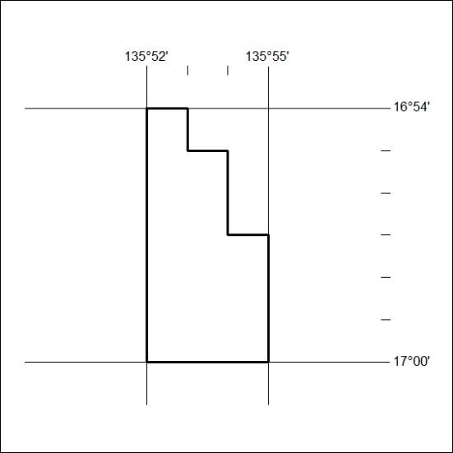

71/25

Mineral Titles Act 2010
NOTICE OF LAND CEASING TO BE A MINERAL TITLE AREA
Title Type and Number: | Exploration Licence 33375
Area Ceased on: | 21 February 2025
Area: | 73 Blocks, 227.98 km²
Locality: | DALMORE
Name of Applicant(s)/Holder(s): | 100% KNOX RESOURCES PTY LTD* [ACN. 623 480 286]
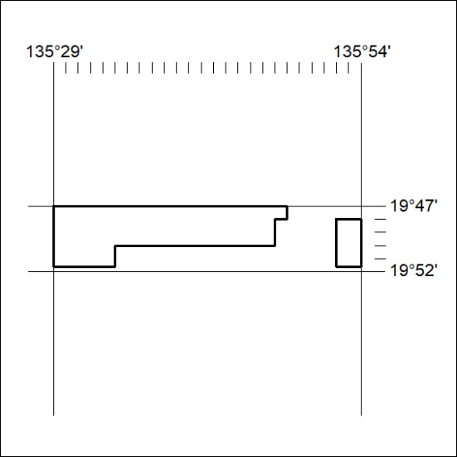

72/25

Mineral Titles Act 2010
NOTICE OF LAND CEASING TO BE A MINERAL TITLE AREA
Title Type and Number: | Exploration Licence 33376
Area Ceased on: | 23 February 2025
Area: | 91 Blocks, 280.98 km²
Locality: | EPENARRA
Name of Applicant(s)/Holder(s): | 100% KNOX RESOURCES PTY LTD* [ACN. 623 480 286]
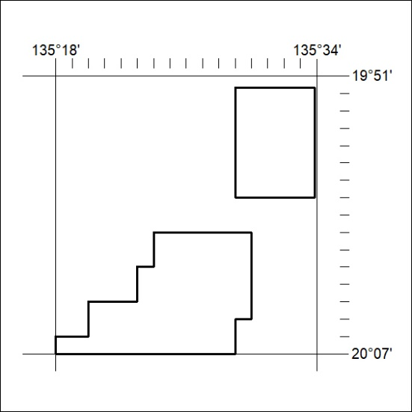

73/25

