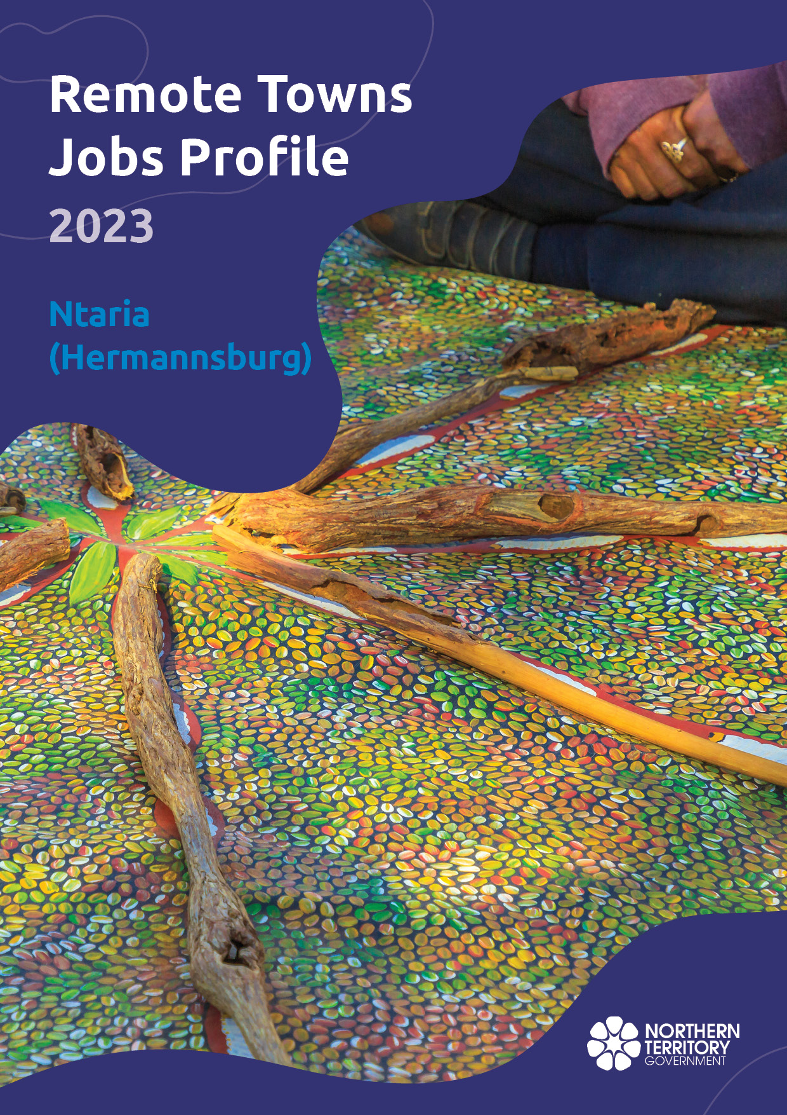

**© Northern Territory of Australia 2025**

**Preferred Reference:** Department of Trade, Business and Asian Relations, 2023 Remote Towns Jobs Profiles, Northern Territory Government, Januaryr 2025, Darwin.

**Front cover image:** Aboriginal bush painting at Karrke Aboriginal Cultural Experience.

**Disclaimer**

The data in this publication was collected by conducting a survey of businesses located in the 28 remote town boundaries. This body of work was completed in 2023 by the former Northern Territory Department of Industry, Tourism and Trade.

The collection methodology was created in accordance with Australian Bureau of Statistics data quality framework principles. Data in this publication is only reflective of those businesses reported on as operating in the town at the time of data collection (see table at the end of publication for list of businesses reported on). To comply with privacy legislation or where appropriate, some data in this publication may have been adjusted and will not reflect the actual data reported by businesses. As a result of this, combined with certain data not being reported by some businesses, some components may not add to totals. Changes over time may also reflect change in business propensity to report on certain data items rather than actual changes over time. Total figures have generally not been adjusted. Caution is advised when interpreting the comparisons made to the earlier 2011, 2014 and 2017 publications as the businesses identified and reported on and the corresponding jobs may differ between publications. The surveys have not always gathered data on training and jobs in the same years.

**Notes for each table and chart are ordered alphabetically and listed at the end of the publication.**

The Northern Territory of Australia exercised due care and skill to ensure that at the time of publication the information contained in this publication is true and correct. However, it is not intended to be relied on as professional advice or used for commercial purposes. The Territory gives no warranty or assurances as to the accuracy of the information contained in the publication and to the maximum extent permitted by law accepts no direct or indirect liability for reliance on its content.

Any use of this report for commercial purposes is not endorsed by the Department of Trade, Business and Asian Relations.

Contents

Ntaria (Hermannsburg) 4

Introduction 5

Summary 6

Jobs Overview 7

Jobs filled by Aboriginality 8

Jobs by Sector: Private and Public 11

Job Status: Permanent and Temporary 17

Job Vacancies 21

Jobs by Industry 23

Jobs by Occupation 29

Jobs by Industry by Occupation 34

Jobs by Gender 37

Jobs by Age 43

Vocational Education and Training 49

Population 55

Community Development Program 57

Businesses 58

Notes 59

Abbreviations and Acronyms 60

# Ntaria (Hermannsburg)

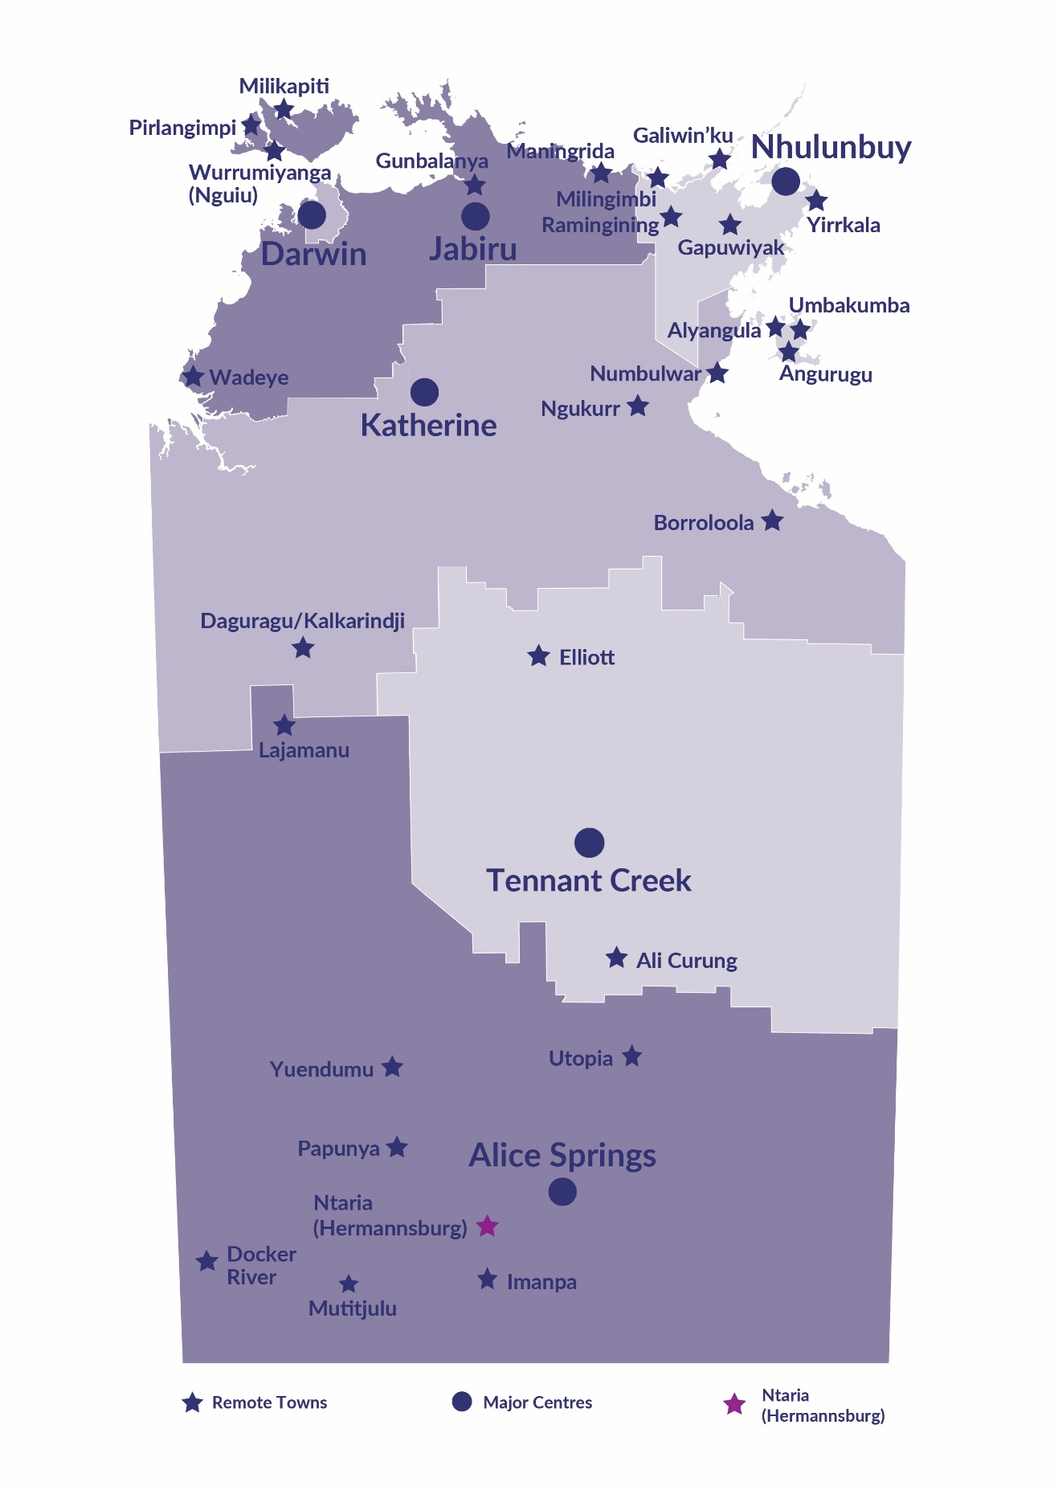Ntaria (Hermannsburg) is located in Central Australia, 125 kilometres west of Alice Springs in the traditional lands of the Western Arrernte people. With a population of 557 residents, Hermannsburg is part of the Ljirapinta Ward of the MacDonnell Regional Council. It is on a popular tourist route – Larapinta Drive - the gateway to attractions such as Gosse Bluff, Finke Gorge National Park, Kings Canyon and Palm Valley.

Source: Northern Territory Department of Industry, Tourism and Trade

# Introduction

This jobs profile provides a snapshot of jobs and the characteristics of job holders in Ntaria (Hermannsburg) as of September 2023. Trends from the surveys conducted in 2011, 2014, and 2017 are also described. Additionally, it presents data on Community Development Program activity, Population, and Vocational Education and Training.

This job profile is one of 28 profiles developed for remote towns in the Northern Territory. It is anticipated these, and subsequent profiles will contribute to a robust evidence base to inform decision making in and relating to these remote Territory towns.

This profile contains information collected by the Northern Territory Department of Industry, Tourism and Trade from businesses operating within the town and is supplemented by other administrative data sets and information.

Each profile provides up-to-date information that is intended to inform the planning and design of current and future government programs and as an evidence base to inform decision making relating to workforce development, enterprise and job opportunities.

The profile may best be understood as a point-in-time tool. The number of business surveys from which the data was drawn is significantly less than in earlier surveys, and business participation has decreased with each survey. For Ntaria (Hermannsburg), 41% fewer businesses than in 2017 are reported here.

The data collection methodology and corresponding questionnaire were created in partnership with the Australian Bureau of Statistics (ABS) and in accordance with ABS data quality framework and survey principles.

The Northern Territory Department of Industry, Tourism and Trades’ Territory Engagement and Delivery, Skills Initiative and VET data teams collaborated with the Northern Institute at Charles Darwin University to facilitate the surveys and reports.

The information collected and reported on represents a significant goodwill investment by those businesses and organisations that participated. Each business is listed at the end of this publication.

# Summary

The 2023 jobs profile was developed based on responses from 10 businesses operating within the Ntaria (Hermannsburg) town boundary, 7 less than in the 2017 survey. Of these, there were:

* 5 businesses from the Private Sector, accounting for 36 filled jobs or 46% of total filled jobs
* 5 businesses from the Public Sector, accounting for 43 filled jobs or 54% of total filled jobs
* 7 businesses participated in all four surveys (completed in 2011, 2014, 2017 and 2023).

A total of 118 filled and vacant jobs in Ntaria (Hermannsburg) were reported, a decrease of 72 jobs from 2017.[1]

The 2023 profile highlights:

* there were 79 filled jobs of which:
  + 46 jobs (58%) were filled by Aboriginal people, a decrease of 40 jobs from 2017
  + 33 jobs (42%) were filled by non-Aboriginal people, a decrease of 33 jobs from 2017
  + 29% of employed Aboriginal people are working in the public and Private Sectors
  + Aboriginal people accounted for 58% of job holders in the town compared to 57% in 2017
  + Aboriginal females made up 70% of filled Aboriginal jobs in the town compared to 65% in 2017
* there were 39 vacant jobs, of which:
  + job vacancies as a percentage of jobs increased to 33.1% in 2023 from 20.0% in 2017 (1 in 3 jobs vacant)
  + 12 of the vacancies were in Community and Personal Service Worker areas, including Aboriginal and Torres Strait Islander Education Worker and Aboriginal and Torres Strait Islander Health Worker jobs
* Education and Training industry was the largest industry employer in 2023, with an increase of 12 jobs from 2017
* Training increased in student numbers between 2016 and 2023
* Business and Clerical was the largest training activity sector in 2023 with the most students followed by Tourism and Hospitality
* Food Processing had the highest decreases in student numbers between 2023 and 2016 of 12.

The overall population in Ntaria (Hermannsburg) decreased by 70 people (-11.2%) between 2011 and 2021 to 557 people.

In comparison, the overall Northern Territory population increased by 9.7% between 2011 and 2021.

In 2021, the working age population (15 years and over) in Ntaria (Hermannsburg) was an estimated 394 people compared to 429 in 2011, a decrease of 8.2%.

There were 0.3 jobs in Ntaria (Hermannsburg) per working age person compared to 0.3 jobs per working age person across the 28 remote towns in the Northern Territory.

# Jobs Overview

Table 1: Count of filled jobs and vacancies, 2011, 2014, 2017 & 2023 (a)(b)

|  |  |  |  |  |  |  |  |
| --- | --- | --- | --- | --- | --- | --- | --- |
|  | **2011** | **2014** | **2017** | **2023** | **Change 2011-2014** | **Change 2014-2017** | **Change 2017-2023** |
| **Total All Jobs** | **269** | **236** | **190** | **118** | **-33** | **-46** | **-72** |
| **Vacancies** | **42** | **22** | **38** | **39** | **-20** | **16** | **1** |
| Vacancies as % of Total All Jobs | 15.6% | 9.3% | 20.0% | 33.1% | - 6.3 ppt | 10.7 ppt | 13.1 ppt |
| **Filled Jobs** | **227** | **214** | **152** | **79** | **-13** | **-62** | **-73** |
| Full-time | 136 | 127 | 102 | 54 | -9 | -25 | -48 |
| Part-time | 91 | 87 | 50 | 25 | -4 | -37 | -25 |

Source: Northern Territory Department of Industry, Tourism and Trade

Chart 1: Count of vacant jobs and filled jobs by full-time/part-time status, 2011, 2014, 2017 & 2023 (a)(b)

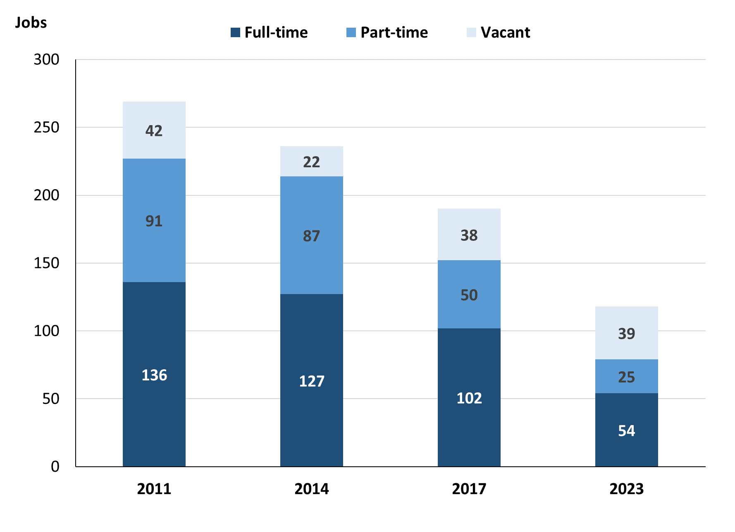

Source: Northern Territory Department of Industry, Tourism and Trade

In 2023 in Ntaria (Hermannsburg):

* there was a total of 79 **filled jobs**, a decrease of 73 jobs from 2017 and a decrease of 135 jobs from 2014
* of the 79 **filled jobs** in 2023:
  + 54 were full-time jobs, a decrease of 48 jobs from 2017 and a decrease of 73 jobs from 2014
  + 25 were part-time jobs, a decrease of 25 jobs from 2017 and a decrease of 62 jobs from 2014
* there were 39 total **job vacancies** in 2023, an increase of 1 vacancy from 2017 and an increase of 17 vacancies from 2014.

# Jobs filled by Aboriginality

Chart 2: Count of filled jobs by Aboriginality, 2011, 2014, 2017 & 2023 (a)(c)

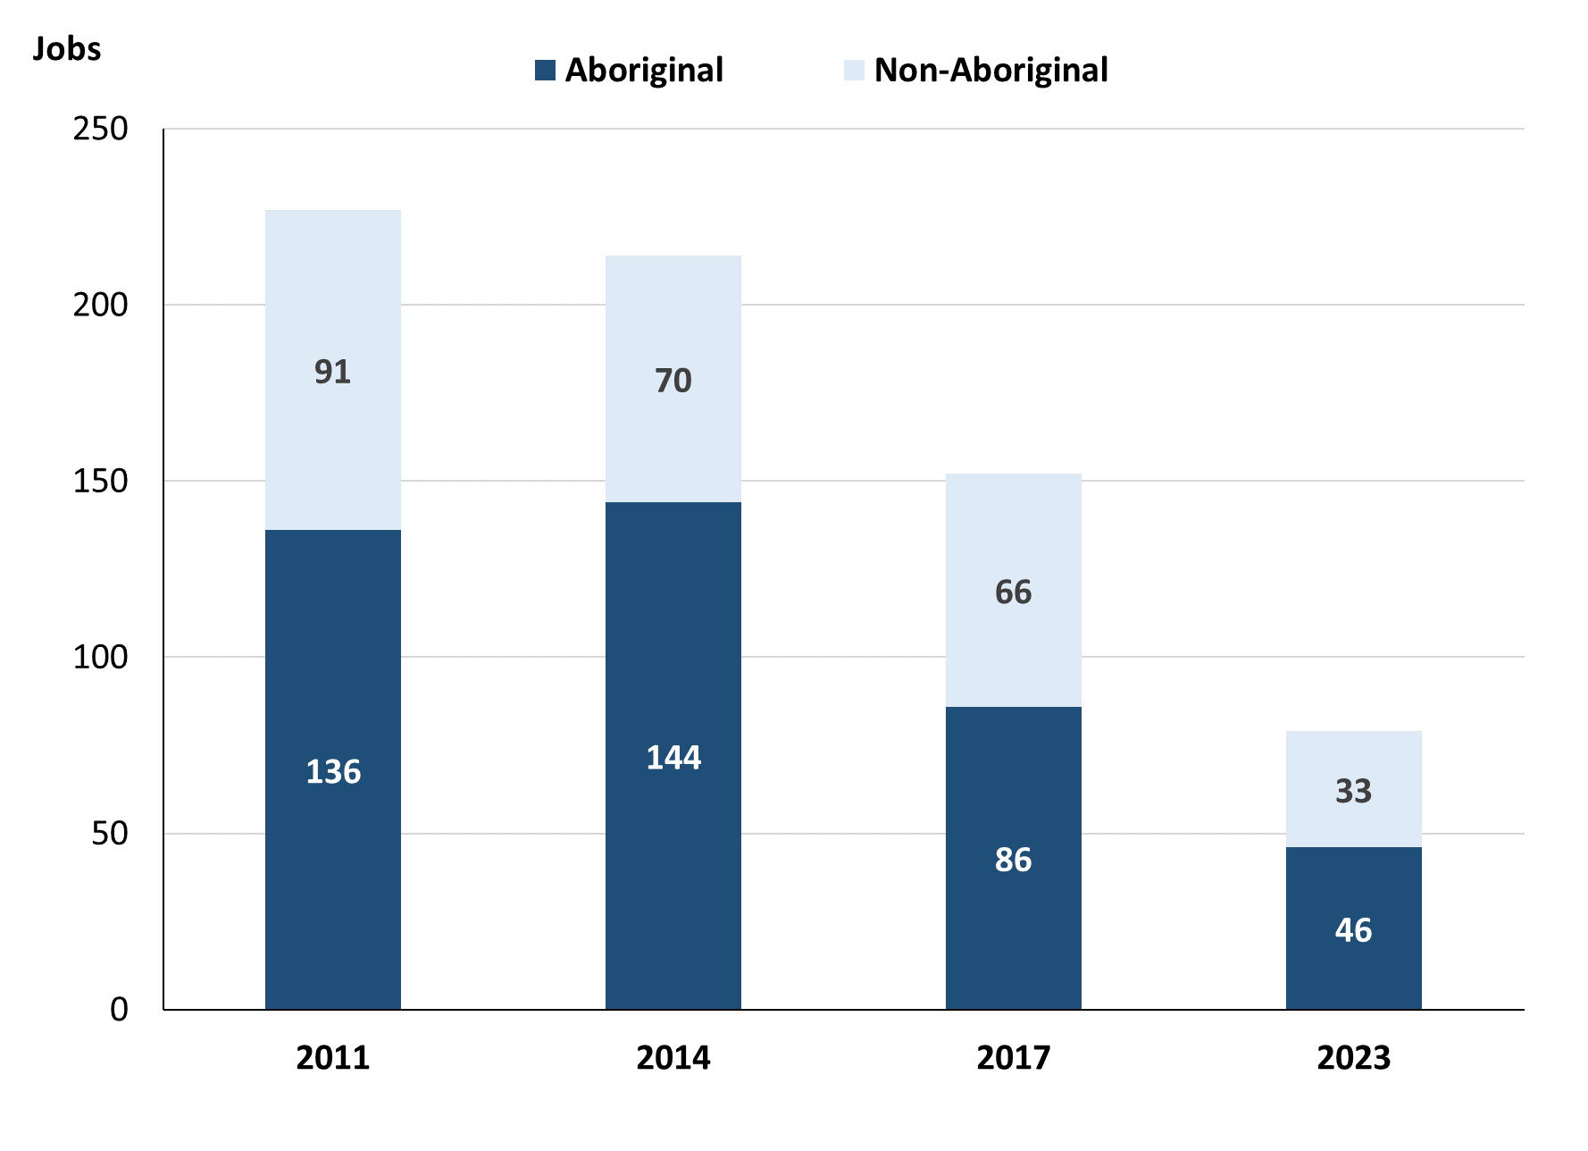

Source: Northern Territory Department of Industry, Tourism and Trade

In 2023 in Ntaria (Hermannsburg):

* of the 79 **filled jobs**:
  + **Aboriginal** people filled 46 jobs, a decrease of 40 jobs from 2017 and a decrease of 98 jobs from 2014
  + **non-Aboriginal** people filled 33 jobs, a decrease of 33 jobs from 2017 and a decrease of 37 jobs from 2014
* **Aboriginal** people accounted for 58% of job holders compared to 57% in 2017 and 67% in 2014.

Table 2a: Count of filled jobs by full-time/part-time status, 2011, 2014, 2017 & 2023 (a)(b)(c)

| **Indicator** | **2011** | | | **2014** | | | **2017** | | | **2023** | | |
| --- | --- | --- | --- | --- | --- | --- | --- | --- | --- | --- | --- | --- |
| **Aboriginal** | **Non-Aboriginal** | **Total** | **Aboriginal** | **Non-Aboriginal** | **Total** | **Aboriginal** | **Non-Aboriginal** | **Total** | **Aboriginal** | **Non-Aboriginal** | **Total** |
| Full-time | 54 | 82 | **136** | 60 | 67 | **127** | 40 | 62 | **102** | 26 | 28 | **54** |
| Part-time | 82 | 9 | **91** | 84 | 3 | **87** | 46 | 4 | **50** | 20 | 5 | **25** |
| **Total** | **136** | **91** | **227** | **144** | **70** | **214** | **86** | **66** | **152** | **46** | **33** | **79** |

Source: Northern Territory Department of Industry, Tourism and Trade

Table 2b: Count of filled jobs by full-time/part-time status, 2011-2014, 2014-2017 & 2017-2023 (a)(b)(c)

| **Indicator** | **Change 2011-2014** | | | **Change 2014-2017** | | | **Change 2017-2023** | | |
| --- | --- | --- | --- | --- | --- | --- | --- | --- | --- |
| **Aboriginal** | **Non-Aboriginal** | **Total** | **Aboriginal** | **Non-Aboriginal** | **Total** | **Aboriginal** | **Non-Aboriginal** | **Total** |
| Full-time | 6 | -15 | **-9** | -20 | -5 | **-25** | -14 | -34 | **-48** |
| Part-time | 2 | -6 | **-4** | -38 | 1 | **-37** | -26 | 1 | **-25** |
| **Total** | **8** | **-21** | **-13** | **-58** | **-4** | **-62** | **-40** | **-33** | **-73** |

Source: Northern Territory Department of Industry, Tourism and Trade

Chart 3: Count of filled jobs by full-time/part-time status, 2011, 2014, 2017 & 2023 (a)(b)(c)

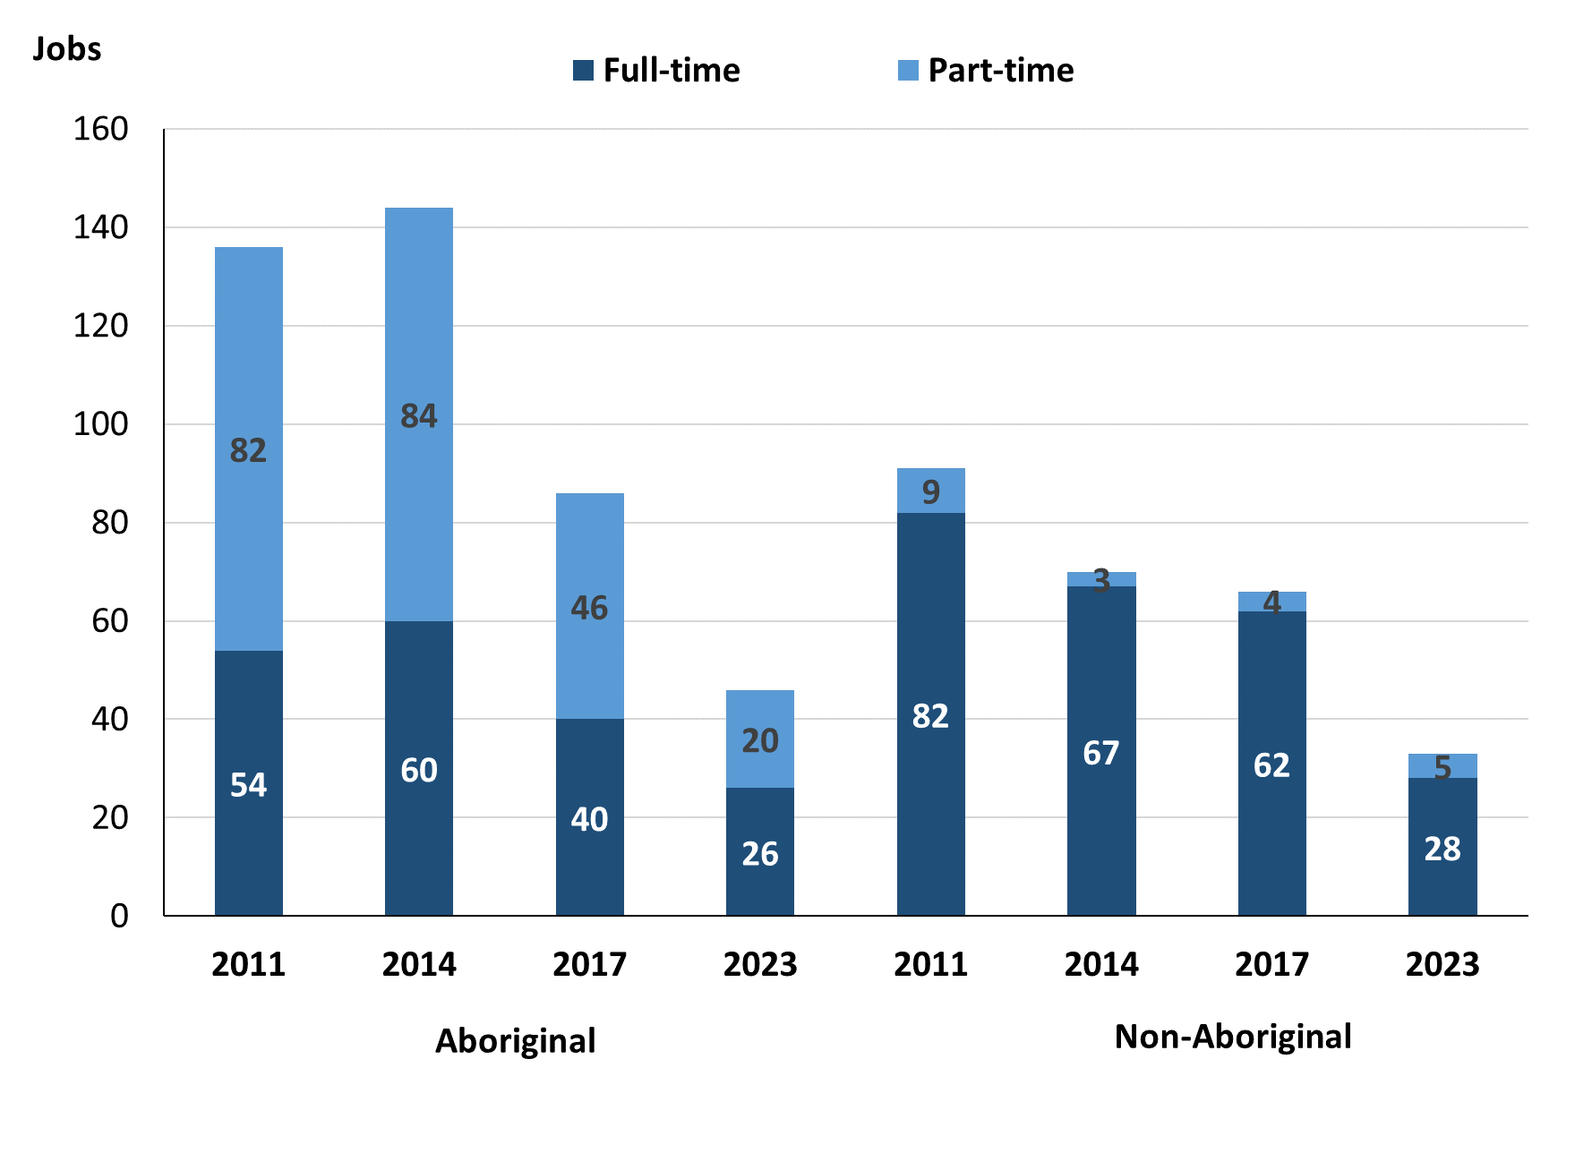

Source: Northern Territory Department of Industry, Tourism and Trade

In 2023 in Ntaria (Hermannsburg):

* of the 79 **filled jobs**:
  + 26 were **full-time** jobs filled by **Aboriginal** people, a decrease of 14 jobs from 2017 and a decrease of 34 jobs from 2014
  + 20 were **part-time** jobs filled by **Aboriginal** people, a decrease of 26 jobs from 2017 and a decrease of 64 jobs from 2014
  + 28 were **full-time** jobs filled by **non-Aboriginal** people, a decrease of 34 jobs from 2017 and a decrease of 39 jobs from 2014
  + 5 were **part-time** jobs filled by **non-Aboriginal** people, an increase of 1 job from 2017 and an increase of 2 jobs from 2014.

# Jobs by Sector: Private and Public

Table 3a: Count of filled jobs by sector of business, 2011, 2014, 2017 & 2023 (a)(b)(c)

| **Indicator** | **2011** | | | | **2014** | | | | **2017** | | | | **2023** | | |
| --- | --- | --- | --- | --- | --- | --- | --- | --- | --- | --- | --- | --- | --- | --- | --- |
| **Aboriginal** | **Non-Aboriginal** | **Total** | **Aboriginal** | | **Non-Aboriginal** | **Total** | **Aboriginal** | | **Non-Aboriginal** | **Total** | **Aboriginal** | | **Non-Aboriginal** | **Total** |
| **Public Sector** | 60 | 47 | **107** | 62 | | 34 | **96** | 26 | | 21 | **47** | 23 | | 20 | **43** |
| Australian Government | 4 | 1 | **5** | 5 | | 1 | **6** | 3 | | 1 | **4** | 0 | | 0 | **0** |
| Territory Government | 21 | 41 | **62** | 19 | | 29 | **48** | 22 | | 20 | **42** | 23 | | 20 | **43** |
| Local Government | 35 | 5 | **40** | 38 | | 4 | **42** | 1 | | 0 | **1** | 0 | | 0 | **0** |
| **Private Sector** | 76 | 44 | **120** | 82 | | 36 | **118** | 60 | | 45 | **105** | 23 | | 13 | **36** |
| **Total** | **136** | **91** | **227** | **144** | | **70** | **214** | **86** | | **66** | **152** | **46** | | **33** | **79** |

Source: Northern Territory Department of Industry, Tourism and Trade

Table 3b: Count of filled jobs by sector of business, 2011-2014, 2014-2017 & 2017-2023 (a)(b)(c)

| **Indicator** | **Change 2011-2014** | | | **Change 2014-2017** | | | **Change 2017-2023** | | |
| --- | --- | --- | --- | --- | --- | --- | --- | --- | --- |
| **Aboriginal** | **Non-Aboriginal** | **Total** | **Aboriginal** | **Non-Aboriginal** | **Total** | **Aboriginal** | **Non-Aboriginal** | **Total** |
| **Public Sector** | 2 | -13 | **-11** | -36 | -13 | **-49** | -3 | -1 | **-4** |
| Australian Government | 1 | 0 | **1** | -2 | 0 | **-2** | -3 | -1 | **-4** |
| Territory Government | -2 | -12 | **-14** | 3 | -9 | **-6** | 1 | 0 | **1** |
| Local Government | 3 | -1 | **2** | -37 | -4 | **-41** | -1 | 0 | **-1** |
| **Private Sector** | 6 | -8 | **-2** | -22 | 9 | **-13** | -37 | -32 | **-69** |
| **Total** | **8** | **-21** | **-13** | **-58** | **-4** | **-62** | **-40** | **-33** | **-73** |

Source: Northern Territory Department of Industry, Tourism and Trade

Chart 4: Count of filled jobs by sector, 2011, 2014, 2017 & 2023 (a)(d)

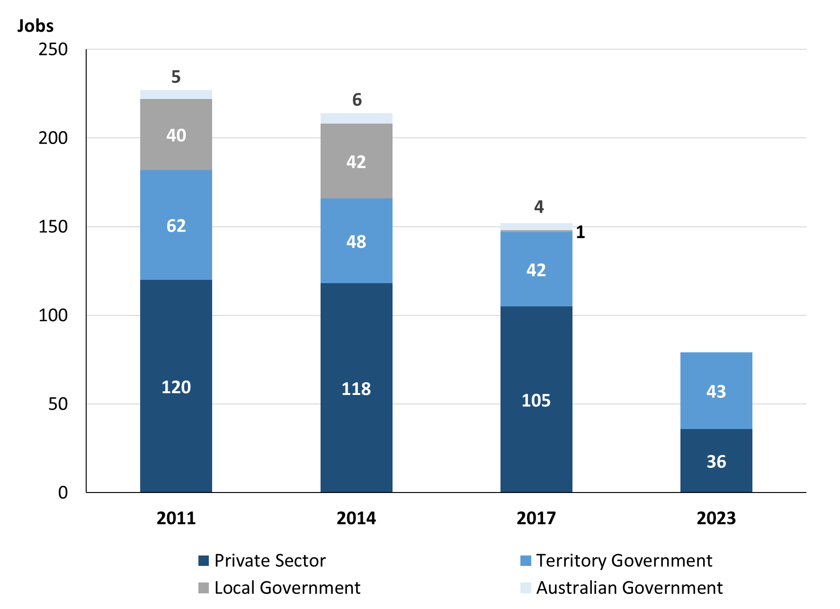

Source: Northern Territory Department of Industry, Tourism and Trade

Chart 5: Percentage of filled jobs by sector in 2023 (a)(d)

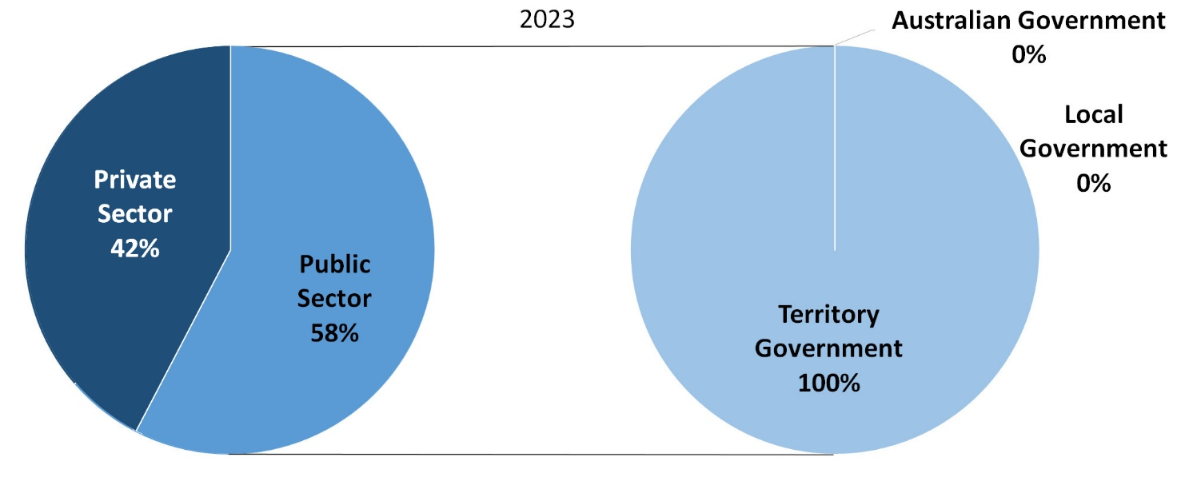

Source: Northern Territory Department of Industry, Tourism and Trade

In 2023 in Ntaria (Hermannsburg):

* there were 43 jobs in the **Public Sector**, a decrease of 4 jobs from 2017 and a decrease of 53 jobs from 2014
* of the 43 jobs in the **Public Sector**:
  + none were in the Australian Government, a decrease of 4 jobs from 2017 and a decrease of 6 jobs from 2014
  + 43 jobs were in the Territory Government, an increase of 1 job from 2017 and a decrease of 5 jobs from 2014
  + none were in the Local Government, a decrease of 1 job from 2017 and a decrease of 42 jobs from 2014
* there were 36 jobs in the **Private Sector**, a decrease of 69 jobs from 2017 and a decrease of 82 jobs from 2014.

Chart 6: Count of filled jobs by sector, 2011, 2014, 2017 & 2023 (a)(c)(d)

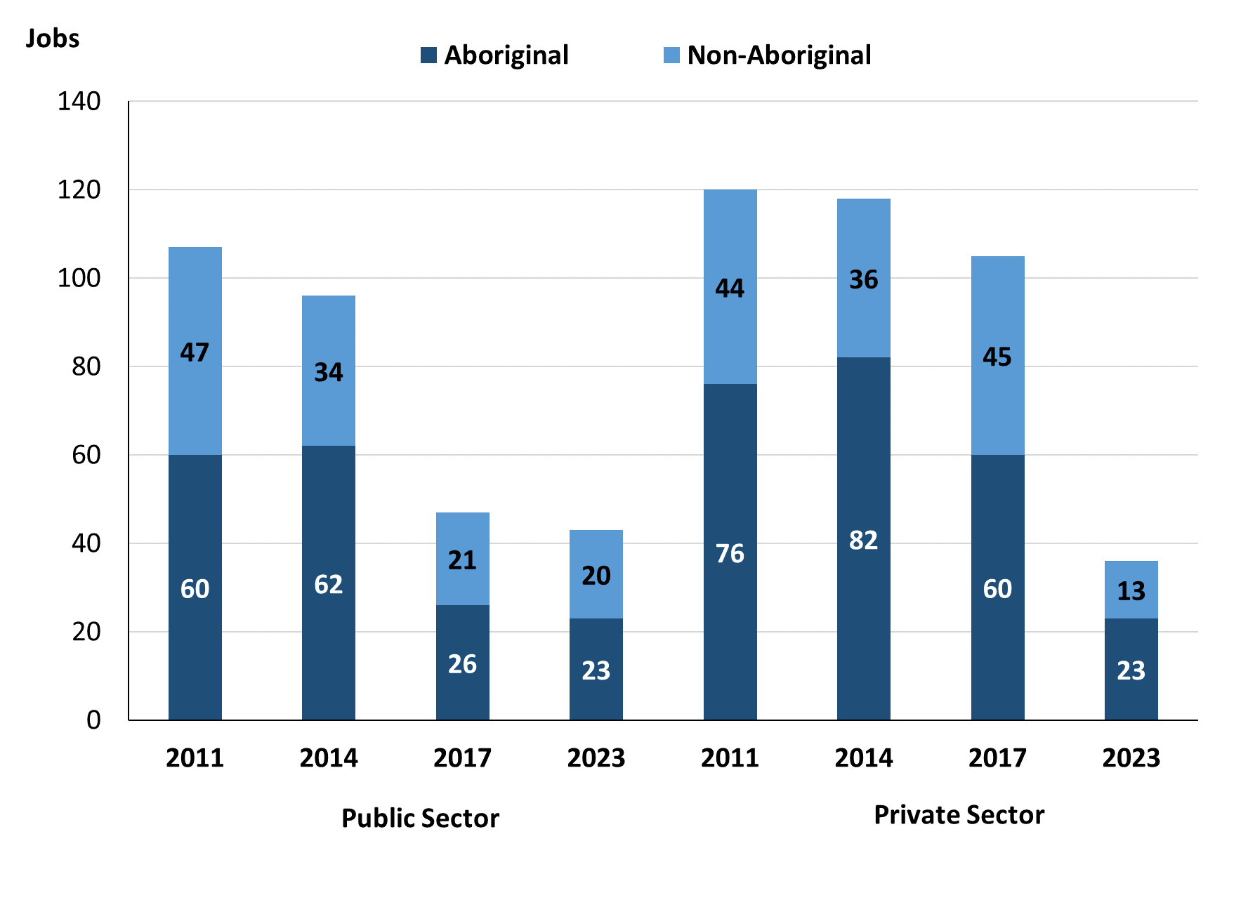

Source: Northern Territory Department of Industry, Tourism and Trade

In 2023 in Ntaria (Hermannsburg):

* of the 43 jobs in the **Public Sector**:
  + **Aboriginal** people filled 23 jobs, a decrease of 3 jobs from 2017 and a decrease of 39 jobs from 2014
  + **non-Aboriginal** people filled 20 jobs, a decrease of 1 job from 2017 and a decrease of 14 jobs from 2014
* of the 36 jobs in the **Private Sector**:
  + **Aboriginal** people filled 23 jobs, a decrease of 37 jobs from 2017 and a decrease of 59 jobs from 2014
  + **non-Aboriginal** people filled 13 jobs, a decrease of 32 jobs from 2017 and a decrease of 23 jobs from 2014.

Chart 7: Count of filled jobs by sector and full-time/part-time status, 2011, 2014, 2017 & 2023 (a)(b)(d)

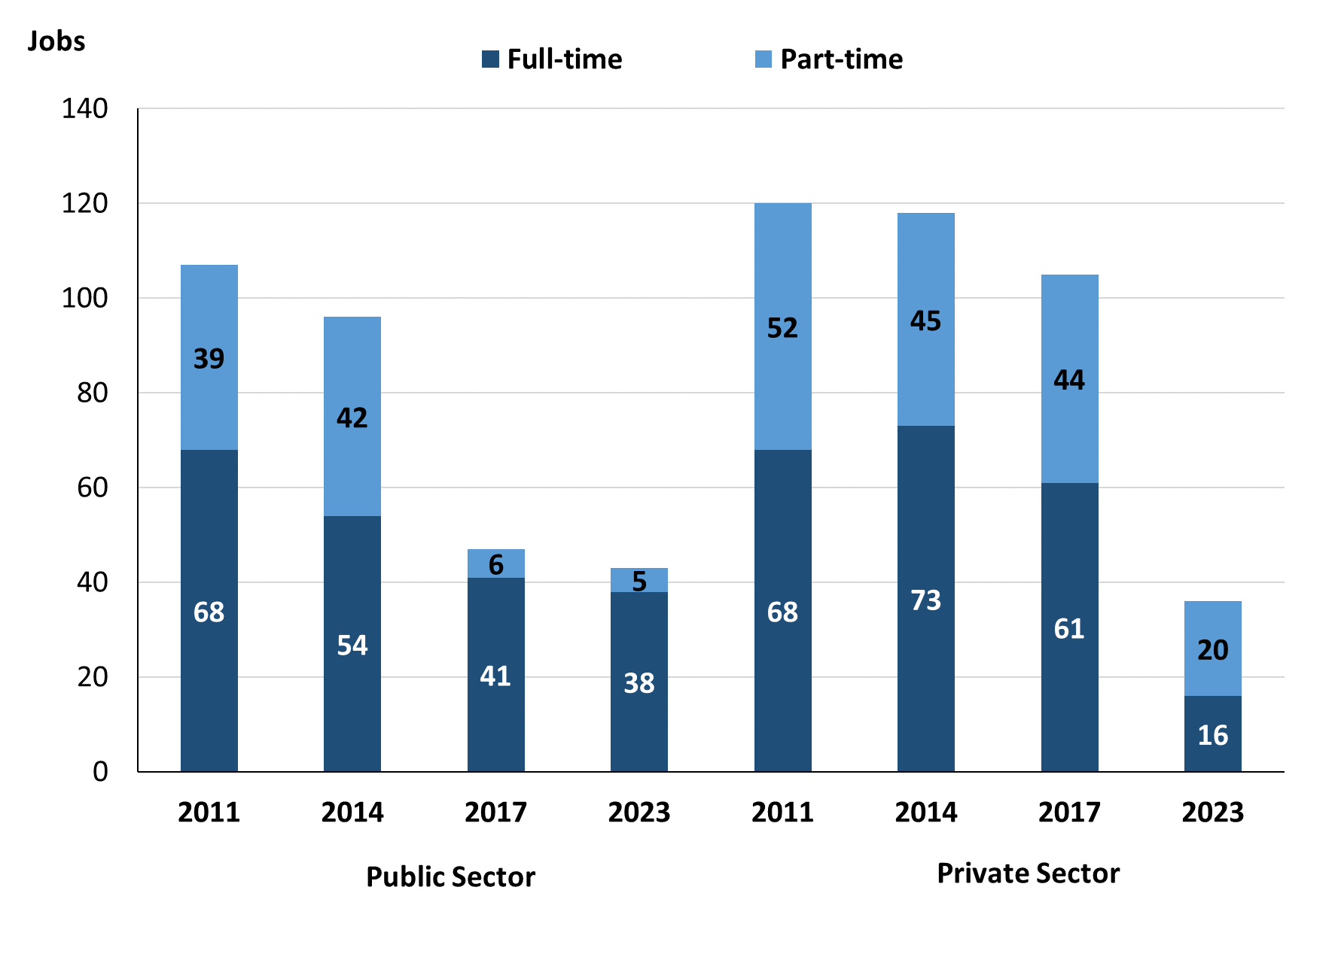

Source: Northern Territory Department of Industry, Tourism and Trade

In 2023 in Ntaria (Hermannsburg):

* of the 43 jobs in the **Public Sector**:
  + 38 were **full-time** jobs, a decrease of 3 jobs from 2017 and a decrease of 16 jobs from 2014
  + 5 were **part-time** jobs, a decrease of 1 job from 2017 and a decrease of 37 jobs from 2014
* of the 36 jobs in the **Private Sector**:
  + 16 were **full-time** jobs, a decrease of 45 jobs from 2017 and a decrease of 57 jobs from 2014
  + 20 were **part-time** jobs, a decrease of 24 jobs from 2017 and a decrease of 25 jobs from 2014.

Table 4: Count of filled jobs by full-time/part-time status by sector, 2011, 2014, 2017 & 2023 (a)(b)(c)(d)

| **Indicator** | **2011** | | | | | | | | | |
| --- | --- | --- | --- | --- | --- | --- | --- | --- | --- | --- |
| **Aboriginal** | | | **Non-Aboriginal** | | | **Total** | | | |
| **Full-time** | **Part-time** | **Total** | **Full-time** | **Part-time** | **Total** | **Full-time** | **Part-time** | **Total** |
| Public Sector | 23 | 37 | **60** | 45 | 2 | **47** | 68 | 39 | **107** |
| Private Sector | 31 | 45 | **76** | 37 | 7 | **44** | 68 | 52 | **120** |
| Total | **54** | **82** | **136** | **82** | **9** | **91** | **136** | **91** | **227** |

| **Indicator** | **2014** | | | | | | | | |
| --- | --- | --- | --- | --- | --- | --- | --- | --- | --- |
| **Aboriginal** | | | **Non-Aboriginal** | | | **Total** | | |
| **Full-time** | **Part-time** | **Total** | **Full-time** | **Part-time** | **Total** | **Full-time** | **Part-time** | **Total** |
| Public Sector | 21 | 41 | **62** | 33 | 1 | **34** | 54 | 42 | **96** |
| Private Sector | 39 | 43 | **82** | 34 | 2 | **36** | 73 | 45 | **118** |
| Total | **60** | **84** | **144** | **67** | **3** | **70** | **127** | **87** | **214** |

| **Indicator** | **2017** | | | | | | | | | |
| --- | --- | --- | --- | --- | --- | --- | --- | --- | --- | --- |
| **Aboriginal** | | | **Non-Aboriginal** | | | **Total** | | | |
| **Full-time** | **Part-time** | **Total** | **Full-time** | **Part-time** | **Total** | **Full-time** | **Part-time** | **Total** |
| Public Sector | 20 | 6 | **26** | 21 | 0 | **21** | 41 | 6 | **47** |
| Private Sector | 20 | 40 | **60** | 41 | 4 | **45** | 61 | 44 | **105** |
| Total | **60** | **84** | **86** | **62** | **4** | **66** | **102** | **50** | **152** |

| **Indicator** | **2023** | | | | | | | | | |
| --- | --- | --- | --- | --- | --- | --- | --- | --- | --- | --- |
| **Aboriginal** | | | **Non-Aboriginal** | | | **Total** | | | |
| **Full-time** | **Part-time** | **Total** | **Full-time** | **Part-time** | **Total** | **Full-time** | **Part-time** | **Total** |
| Public Sector | 20 | 3 | **23** | 18 | 2 | **20** | 38 | 5 | **43** |
| Private Sector | 6 | 17 | **23** | 10 | 3 | **13** | 16 | 20 | **36** |
| Total | **26** | **20** | **46** | **28** | **5** | **33** | **54** | **25** | **79** |

Source: Northern Territory Department of Industry, Tourism and Trade

In 2023 in Ntaria (Hermannsburg) there were:

* 23 jobs in the **Public Sector** filled by **Aboriginal** people, a decrease of 3 jobs from 2017 and a decrease of 39 jobs from 2014, of which:
  + 20 were **full-time** jobs, unchanged from 2017 and a decrease of 1 job from 2014
  + 3 were **part-time** jobs, a decrease of 3 jobs from 2017 and a decrease of 38 jobs from 2014
* 23 jobs in the **Private Sector** filled by **Aboriginal** people, a decrease of 37 jobs from 2017 and a decrease of 59 jobs from 2014, of which:
  + 6 were **full-time** jobs, a decrease of 14 jobs from 2017 and a decrease of 33 jobs from 2014
  + 17 were **part-time** jobs, a decrease of 23 jobs from 2017 and a decrease of 26 jobs from 2014
* 20 jobs in the **Public Sector** filled by **non-Aboriginal** people, a decrease of 1 job from 2017 and a decrease of 14 jobs from 2014, of which:
  + 18 were **full-time** jobs, a decrease of 3 jobs from 2017 and a decrease of 15 jobs from 2014
  + 2 were **part-time** jobs, an increase of 2 jobs from 2017 and an increase of 1 job from 2014
* 13 jobs in the **Private Sector** filled by **non-Aboriginal** people, a decrease of 32 jobs from 2017 and a decrease of 23 jobs from 2014, of which:
  + 10 were **full-time** jobs, a decrease of 31 jobs from 2017 and a decrease of 24 jobs from 2014
  + 3 were **part-time** jobs, a decrease of 1 job from 2017 and an increase of 1 job from 2014.

# Job Status: Permanent and Temporary

Table 5a: Count of filled jobs by employment status, 2011, 2014, 2017 & 2023 (a)(c)(e)

| **Indicator** | **2011** | | | **2014** | | | **2017** | | | **2023** | | |
| --- | --- | --- | --- | --- | --- | --- | --- | --- | --- | --- | --- | --- |
| **Aboriginal** | **Non-Aboriginal** | **Total** | **Aboriginal** | **Non-Aboriginal** | **Total** | **Aboriginal** | **Non-Aboriginal** | **Total** | **Aboriginal** | **Non-Aboriginal** | **Total** |
| Permanent | 32 | 23 | **55** | 53 | 39 | **92** | 34 | 34 | **68** | 19 | 19 | **38** |
| Temporary | 104 | 68 | **172** | 91 | 31 | **122** | 52 | 32 | **84** | 27 | 14 | **41** |
| Total | **136** | **91** | **227** | **144** | **70** | **214** | **86** | **66** | **152** | **46** | **33** | **79** |

Source: Northern Territory Department of Industry, Tourism and Trade

Table 5b: Count of filled jobs by employment status, 2011-2014, 2014-2017 & 2017-2023 (a)(c)(e)

| **Indicator** | **Change 2011-2014** | | | **Change 2014-2017** | | | **Change 2017-2023** | | | |
| --- | --- | --- | --- | --- | --- | --- | --- | --- | --- | --- |
| **Aboriginal** | **Non-Aboriginal** | **Total** | **Aboriginal** | **Non-Aboriginal** | **Total** | **Aboriginal** | **Non-Aboriginal** | **Total** |
| Permanent | 21 | 16 | **37** | -19 | -5 | **-24** | -15 | -15 | **-30** |
| Temporary | -13 | -37 | **-50** | -39 | 1 | **-38** | -25 | -18 | **-43** |
| Total | **8** | **-21** | **-13** | **-58** | **-4** | **-62** | **-40** | **-33** | **-73** |

Source: Northern Territory Department of Industry, Tourism and Trade

Chart 8: Count of filled jobs by employment status, 2011, 2014, 2017 & 2023 (a)(c)(e)

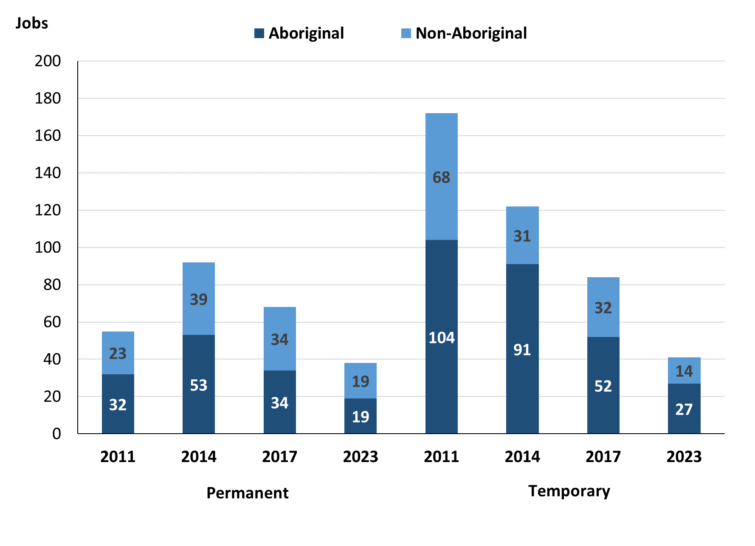

Source: Northern Territory Department of Industry, Tourism and Trade

In 2023 in Ntaria (Hermannsburg):

* there were 38 **permanent jobs**, a decrease of 30 jobs from 2017, and a decrease of 54 jobs from 2014, of which:
  + **Aboriginal** people filled 19 jobs, a decrease of 15 jobs from 2017 and a decrease of 34 jobs from 2014
  + **non-Aboriginal** people filled 19 jobs, a decrease of 15 jobs from 2017 and a decrease of 20 jobs from 2014
* there were 41 **temporary jobs**, a decrease of 43 jobs from 2017 and a decrease of 81 jobs from 2014, of which:
  + **Aboriginal** people filled 27 jobs, a decrease of 25 jobs from 2017 and a decrease of 64 jobs from 2014
  + **non-Aboriginal** people filled 14 jobs, a decrease of 18 job from 2017 and a decrease of 17 jobs from 2014.

Table 6: Count of filled jobs by sector and employment status, 2011, 2014, 2017 & 2023 (a)(c)(d)(e)

| **Indicator** | **2011** | | | | | | | | | |
| --- | --- | --- | --- | --- | --- | --- | --- | --- | --- | --- |
| **Aboriginal** | | | **Non-Aboriginal** | | | **Total** | | | |
| **Perm** | **Temp** | **Total** | **Perm** | **Temp** | **Total** | **Perm** | **Temp** | **Total** |
| Public Sector | 6 | 54 | **60** | 11 | 36 | **47** | 17 | 90 | **107** |
| Private Sector | 26 | 50 | **76** | 12 | 32 | **44** | 38 | 82 | **120** |
| Total | **32** | **104** | **136** | **23** | **68** | **91** | **55** | **172** | **227** |

| **Indicator** | **2014** | | | | | | | | |
| --- | --- | --- | --- | --- | --- | --- | --- | --- | --- |
| **Aboriginal** | | | **Non-Aboriginal** | | | **Total** | | |
| **Perm** | **Temp** | **Total** | **Perm** | **Temp** | **Total** | **Perm** | **Temp** | **Total** |
| Public Sector | 47 | 15 | **62** | 25 | 9 | **34** | 72 | 24 | **96** |
| Private Sector | 6 | 76 | **82** | 14 | 22 | **36** | 20 | 98 | **118** |
| Total | **53** | **91** | **144** | **39** | **31** | **70** | **92** | **122** | **214** |

| **Indicator** | **2017** | | | | | | | | | |
| --- | --- | --- | --- | --- | --- | --- | --- | --- | --- | --- |
| **Aboriginal** | | | **Non-Aboriginal** | | | **Total** | | | |
| **Perm** | **Temp** | **Total** | **Perm** | **Temp** | **Total** | **Perm** | **Temp** | **Total** |
| Public Sector | 16 | 10 | **26** | 12 | 9 | **21** | 28 | 19 | **47** |
| Private Sector | 18 | 42 | **60** | 22 | 23 | **45** | 40 | 65 | **105** |
| Total | **34** | **52** | **86** | **34** | **32** | **66** | **68** | **84** | **152** |

| **Indicator** | **2023** | | | | | | | | | |
| --- | --- | --- | --- | --- | --- | --- | --- | --- | --- | --- |
| **Aboriginal** | | | **Non-Aboriginal** | | | **Total** | | | |
| **Perm** | **Temp** | **Total** | **Perm** | **Temp** | **Total** | **Perm** | **Temp** | **Total** |
| Public Sector | 8 | 15 | **23** | 9 | 11 | **20** | 17 | 26 | **43** |
| Private Sector | 11 | 12 | **23** | 10 | 3 | **13** | 21 | 15 | **36** |
| Total | **19** | **27** | **46** | **19** | **14** | **33** | **38** | **41** | **79** |

Source: Northern Territory Department of Industry, Tourism and Trade

In 2023 in Ntaria (Hermannsburg) there were:

* 43 jobs in the **Public Sector**, a decrease of 4 jobs from 2017 and a decrease of 53 jobs from 2014, of which:
  + 17 jobs were **permanent**, a decrease of 11 jobs from 2017 and a decrease of 55 jobs from 2014, of which:
    - **Aboriginal** people filled 8 jobs, a decrease of 8 jobs from 2017 and a decrease of 39 jobs from 2014
    - **non-Aboriginal** people filled 9 jobs, a decrease of 3 jobs from 2017 and a decrease of 16 jobs from 2014
  + 26 jobs were **temporary**, an increase of 7 jobs from 2017 and an increase of 2 jobs from 2014, of which:
    - **Aboriginal** people filled 15 jobs, an increase of 5 jobs from 2017 and unchanged from 2014
    - **non-Aboriginal** people filled 11 jobs, an increase of 2 jobs from 2017 and an increase of 2 jobs from 2014
* 36 jobs in the **Private Sector**, a decrease of 69 jobs from 2017 and a decrease of 82 jobs from 2014, of which:
  + 21 jobs were **permanent**, a decrease of 19 jobs from 2017 and an increase of 1 job from 2014, of which:
    - **Aboriginal** people filled 11 jobs, a decrease of 7 jobs from 2017 and an increase of 5 jobs from 2014
    - **non-Aboriginal** people filled 10 jobs, a decrease of 12 jobs from 2017 and a decrease of 4 jobs from 2014
  + 15 jobs were **temporary**, a decrease of 50 jobs from 2017 and a decrease of 83 jobs from 2014, of which:
    - **Aboriginal** people filled 12 jobs, a decrease of 30 jobs from 2017 and a decrease of 64 jobs from 2014
    - **non-Aboriginal** people filled 3 jobs, a decrease of 20 jobs from 2017 and a decrease of 19 jobs from 2014.

# Job Vacancies

Table 7: Job vacancies, 2011, 2014, 2017 & 2023

| **Indicator** | **2011** | **2014** | **2017** | **2023** | **Change 2011-2014** | **Change 2014-2017** | **Change 2017-2023** |
| --- | --- | --- | --- | --- | --- | --- | --- |
| Job vacancies | 42 | 22 | 38 | 39 | -20 | 16 | 1 |

Source: Northern Territory Department of Industry, Tourism and Trade

Table 8a: Job vacancies by occupation, 2011, 2014, 2017 & 2023 (f)(g)

| **Occupation (ANZSCO major group)** | **2011** | **2014** | **2017** | **2023** | |
| --- | --- | --- | --- | --- | --- |
| Clerical and Administrative Workers | 1 | 1 | 3 | 6 | |
| Community and Personal Service Workers | 32 | 8 | 21 | 12 | |
| Labourers | 1 | 1 | 4 | 5 | |
| Machinery Operators and Drivers | 0 | 0 | 0 | 0 | |
| Managers | 0 | 1 | 1 | 3 | |
| Professionals | 5 | 7 | 9 | 9 | |
| Sales Workers | 3 | 2 | 0 | 1 | |
| Technicians and Trades Workers | 0 | 2 | 0 | 2 | |
| Other | 0 | 0 | 0 | 1 |
| Total | **42** | **22** | **38** | **39** | |

Source: Northern Territory Department of Industry, Tourism and Trade

Table 8b: Job vacancies by occupation, 2011-2014, 2014-2017 & 2017-2023 (f)(g)

| **Occupation (ANZSCO major group)** | **Change 2011-2014** | **Change 2014-2017** | **Change 2017-2023** | |
| --- | --- | --- | --- | --- |
| Clerical and Administrative Workers | 0 | 2 | 3 | |
| Community and Personal Service Workers | -24 | 13 | -9 | |
| Labourers | 0 | 3 | 1 | |
| Machinery Operators and Drivers | 0 | 0 | 0 | |
| Managers | 1 | 0 | 2 | |
| Professionals | 2 | 2 | 0 | |
| Sales Workers | -1 | -2 | 1 | |
| Technicians and Trades Workers | 2 | -2 | 2 | |
| Other | 0 | 0 | 1 |
| Total | **-20** | **16** | **1** | |

Source: Northern Territory Department of Industry, Tourism and Trade

Table 9: Job vacancies by job title, 2023 profile (f)

| **Job Vacancy** | **No** |
| --- | --- |
| Aboriginal and Torres Strait Islander Education Worker | 7 |
| Aboriginal and Torres Strait Islander Health Worker | 4 |
| Aboriginal and Torres Strait Islander land and Sea Ranger | 5 |
| Assistant Manager | 1 |
| Baker | 1 |
| Café or Restaurant Manager | 1 |
| Classroom Teacher | 2 |
| Construction and Mining Labourer | 1 |
| Construction Trade Worker | 2 |
| General Clerk | 4 |
| Handyperson | 3 |
| Hospitality Worker | 1 |
| Kitchenhand | 1 |
| Primary Health Care Manager | 1 |
| Program or Project Administrator | 2 |
| Registered Nurse nec | 2 |
| Sales Assistant (General) | 1 |
| Other (inadequately described) | 1 |
| **Total** | **39** |

Source: Northern Territory Department of Industry, Tourism and Trade

In 2023 in Ntaria (Hermannsburg):

* there were 39 **vacancies** reported, an increase of 1 vacancy from 2017 and an increase of 17 vacancies from 2014
* of the 39 reported **vacancies**, the largest requirements were for:
  + 12 Community and Personal Service Workers, the majority of which are in the following jobs:
    - Aboriginal and Torres Strait Islander Education Worker
    - Aboriginal and Torres Strait Islander Health Worker
  + 9 Professionals, the majority of which are in the following jobs:
    - Aboriginal and Torres Strait Islander land and Sea Ranger
    - Classroom Teacher
    - Registered Nurse nec
  + 6 Clerical and Administrative Workers in the following jobs:
    - General Clerk
    - Program or Project Administrator.

# Jobs by Industry

Table 10: Count of filled jobs by industry of business, 2011, 2014, 2017, 2023 and change in count of filled jobs by industry 2011-2014, 2014-2017 & 2017-2023 (a)(h)

| **Industry (ANZSIC Division)** | **2011** | | **2014** | | **2017** | | **2023** | | **Change 2011-2014** | **Change 2014-2017** | **Change 2017-2023** |
| --- | --- | --- | --- | --- | --- | --- | --- | --- | --- | --- | --- |
| **Total** | **% of Total** | **Total** | **% of Total** | **Total** | **% of Total** | **Total** | **% of Total** | **Total** | **Total** | **Total** |
| Accommodation and Food Services | 0 | 0.0% | 4 | 1.9% | 0 | 0.0% | 0 | 0.0% | 4 | -4 | 0 |
| Administrative and Support Services | 4 | 1.8% | 0 | 0.0% | 0 | 0.0% | 8 | 10.1% | -4 | 0 | 8 |
| Arts and Recreation Services | 10 | 4.4% | 25 | 11.7% | 16 | 10.5% | 9 | 11.4% | 15 | -9 | -7 |
| Education and Training | 41 | 18.1% | 29 | 13.6% | 24 | 15.8% | 36 | 45.6% | -12 | -5 | 12 |
| Health Care and Social Assistance | 37 | 16.3% | 24 | 11.2% | 27 | 17.8% | 5 | 6.3% | -13 | 3 | -22 |
| Other Services | 2 | 0.9% | 0 | 0.0% | 0 | 0.0% | 0 | 0.0% | -2 | 0 | 0 |
| Professional, Scientific and Technical Services | 10 | 4.4% | 0 | 0.0% | 0 | 0.0% | 0 | 0.0% | -10 | 0 | 0 |
| Public Administration and Safety | 89 | 39.2% | 112 | 52.3% | 59 | 38.8% | 8 | 10.1% | 23 | -53 | -51 |
| Retail Trade | 34 | 15.0% | 20 | 9.3% | 26 | 17.1% | 13 | 16.5% | -14 | 6 | -13 |
| Total | **227** | **100.0%** | **214** | **100.0%** | **152** | **100.0%** | **79** | **100.0%** | **-13** | **-62** | **-73** |

Source: Northern Territory Department of Industry, Tourism and Trade

In 2023 in Ntaria (Hermannsburg):

* the Education and Training industry was the **largest industry employer**, with 36 filled jobs or 45.6% of filled jobs, an increase of 12 jobs from 2017 and an increase of 7 jobs from 2014
* **other significant** industry employers were:
  + Retail Trade with 13 jobs (or 16.5% of filled jobs), a decrease of 13 jobs from 2017 and a decrease of 7 jobs from 2014
  + Arts and Recreation Services with 9 jobs (or 11.4% of filled jobs), a decrease of 7 jobs from 2017 and a decrease of 16 jobs from 2014
  + Public Administration and Safety with 8 jobs (or 10.1% of filled jobs), a decrease of 51 jobs from 2017 and a decrease of 104 jobs from 2014
  + Administrative and Support Services with 8 jobs (or 10.1% of filled jobs), an increase of 8 jobs from 2017 and an increase of 8 jobs from 2014.

Table 11a: Count of filled jobs by industry of business, 2011, 2014, 2017 & 2023 (a)(c)(h)

|  |  |  |  |  |  |  |  |  |  |  |  |  |
| --- | --- | --- | --- | --- | --- | --- | --- | --- | --- | --- | --- | --- |
| **Industry (ANZSIC division)** | **2011** | | | **2014** | | | **2017** | | | **2023** | | |
| **Aboriginal** | **Non-Aboriginal** | **Total** | **Aboriginal** | **Non-Aboriginal** | **Total** | **Aboriginal** | **Non-Aboriginal** | **Total** | **Aboriginal** | **Non-Aboriginal** | **Total** |
| Accommodation and Food Services | 0 | 0 | **0** | 4 | 0 | **4** | 0 | 0 | **0** | 0 | 0 | **0** |
| Administrative and Support Services | 4 | 0 | **4** | 0 | 0 | **0** | 0 | 0 | **0** | 7 | 1 | **8** |
| Arts and Recreation Services | 9 | 1 | **10** | 19 | 6 | **25** | 12 | 4 | **16** | 6 | 3 | **9** |
| Education and Training | 9 | 32 | **41** | 10 | 19 | **29** | 14 | 10 | **24** | 22 | 14 | **36** |
| Health Care and Social Assistance | 25 | 12 | **37** | 11 | 13 | **24** | 11 | 16 | **27** | 2 | 3 | **5** |
| Public Administration and Safety | 70 | 19 | **89** | 90 | 22 | **112** | 37 | 22 | **59** | 4 | 4 | **8** |
| Retail Trade | 9 | 25 | **34** | 10 | 10 | **20** | 12 | 14 | **26** | 5 | 8 | **13** |
| Total | **136** | **91** | **227** | **144** | **70** | **214** | **86** | **66** | **152** | **46** | **33** | **79** |

Source: Northern Territory Department of Industry, Tourism and Trade

Table 11b: Count of filled jobs by industry of business, 2011-2014, 2014-2017 & 2017-2023 (a)(c)(h)

|  |  |  |  |  |  |  |  |  |  |
| --- | --- | --- | --- | --- | --- | --- | --- | --- | --- |
| **Industry (ANZSIC division)** | **Change 2011-2014** | | | **Change  2014-2017** | | | **Change  2017-2023** | | |
| **Aboriginal** | **Non-Aboriginal** | **Total** | **Aboriginal** | **Non-Aboriginal** | **Total** | **Aboriginal** | **Non-Aboriginal** | **Total** |
| Accommodation and Food Services | 4 | 0 | **4** | -4 | 0 | **-4** | 0 | 0 | **0** |
| Administrative and Support Services | -4 | 0 | **-4** | 0 | 0 | **0** | 7 | 1 | **8** |
| Arts and Recreation Services | 10 | 5 | **15** | -7 | -2 | **-9** | -6 | -1 | **-7** |
| Education and Training | 1 | -13 | **-12** | 4 | -9 | **-5** | 8 | 4 | **12** |
| Health Care and Social Assistance | -14 | 1 | **-13** | 0 | 3 | **3** | -9 | -13 | **-22** |
| Public Administration and Safety | 20 | 3 | **23** | -53 | 0 | **-53** | -33 | -18 | **-51** |
| Retail Trade | 1 | -15 | **-14** | 2 | 4 | **6** | -7 | -6 | **-13** |
| Total | **8** | **-21** | **-13** | **-58** | **-4** | **-62** | **-40** | **-33** | **-73** |

Source: Northern Territory Department of Industry, Tourism and Trade

Chart 9: Count of filled jobs by top 5 industries, 2023 (a)(c)(h)

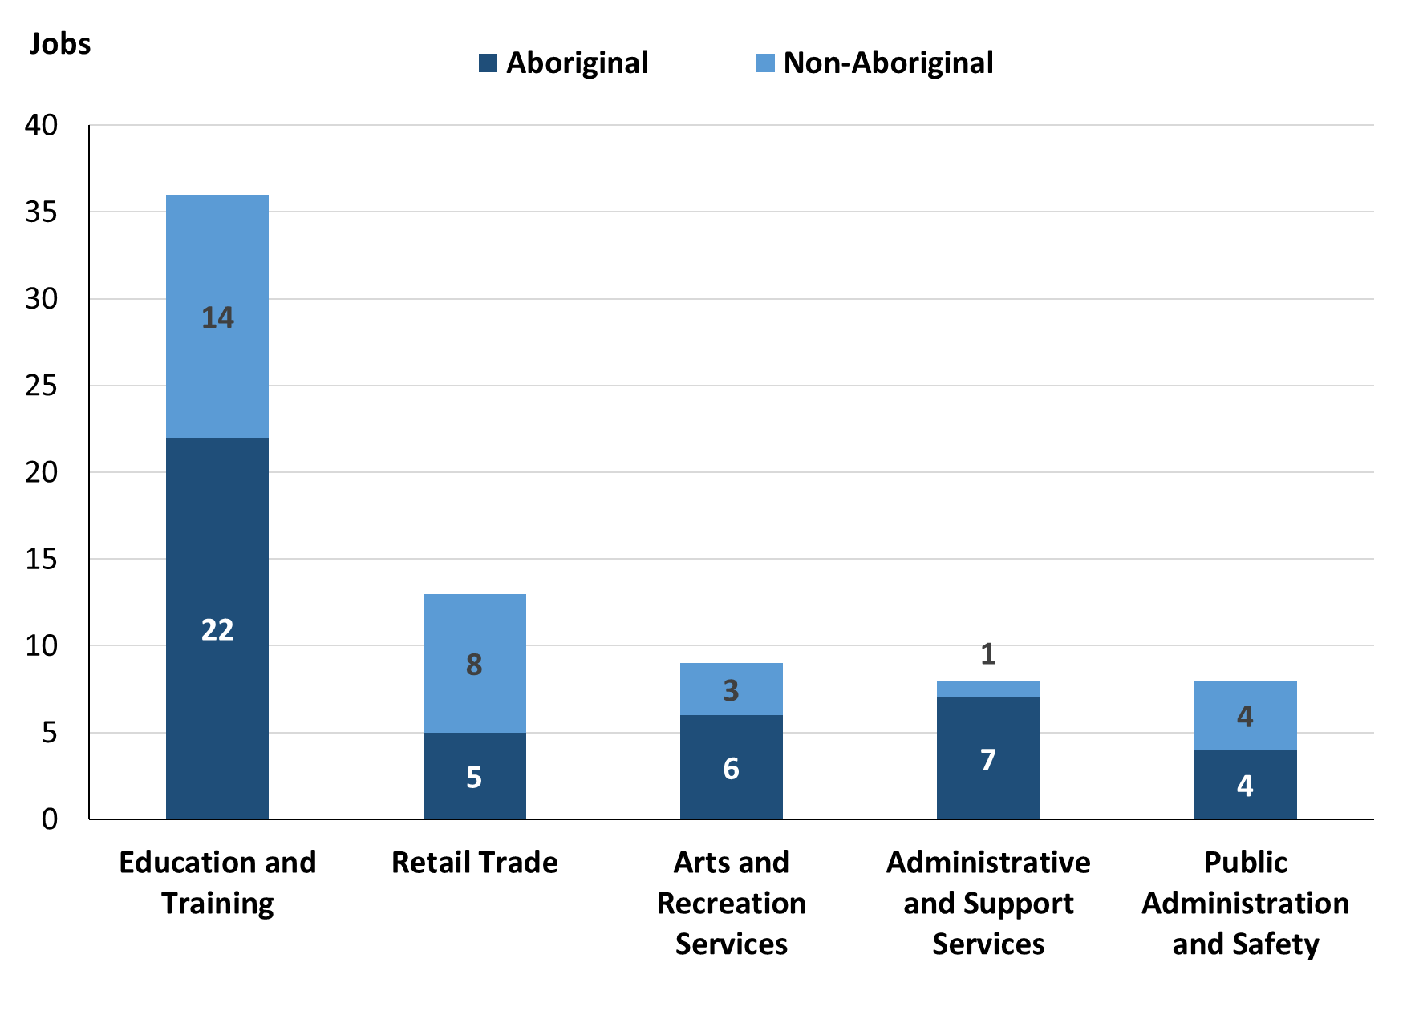

Source: Northern Territory Department of Industry, Tourism and Trade

In 2023 in Ntaria (Hermannsburg):

* of the 46 **jobs filled** by **Aboriginal** people, there were:
  + 22 jobs in Education and Training, an increase of 8 jobs from 2017 and an increase of 12 jobs from 2014
  + 7 jobs in Administrative and Support Services, an increase of 7 jobs from 2017 and an increase of 7 jobs from 2014
  + 6 jobs in Arts and Recreation Services, a decrease of 6 jobs from 2017 and a decrease of 13 jobs from 2014
* of the 33 **jobs filled** by **non-Aboriginal** people, there were:
  + 14 jobs in Education and Training, an increase of 4 jobs from 2017 and a decrease of 5 jobs from 2014
  + 8 jobs in Retail Trade, a decrease of 6 jobs from 2017 and a decrease of 2 jobs from 2014
  + 4 jobs in Public Administration and Safety, a decrease of 18 jobs from 2017 and a decrease of 18 jobs from 2014.

Table 12: Count of filled jobs by industry and employment status, 2011 (a)(c)(e)(h)

| **Industry (ANZSIC division)** | **2011** | | | | | | | | |
| --- | --- | --- | --- | --- | --- | --- | --- | --- | --- |
| **Aboriginal** | | | **Non-Aboriginal** | | | **Total** | | |
| **Perm** | **Temp** | **Total** | **Perm** | **Temp** | **Total** | **Perm** | **Temp** | **Total** |
| Administrative and Support Services | 0 | 4 | **4** | 0 | 0 | **0** | 0 | 4 | **4** |
| Arts and Recreation Services | 6 | 3 | **9** | 0 | 1 | **1** | 6 | 4 | **10** |
| Education and Training | 2 | 7 | **9** | 9 | 23 | **32** | 11 | 30 | **41** |
| Health Care and Social Assistance | 12 | 13 | **25** | 4 | 8 | **12** | 16 | 21 | **37** |
| Other Services | 0 | 1 | **1** | 1 | 0 | **1** | 1 | 1 | **2** |
| Professional, Scientific and Technical Services | 0 | 9 | **9** | 1 | 0 | **1** | 1 | 9 | **10** |
| Public Administration and Safety | 12 | 58 | **70** | 3 | 16 | **19** | 15 | 74 | **89** |
| Retail Trade | 0 | 9 | **9** | 5 | 20 | **25** | 5 | 29 | **34** |
| Total | **32** | **104** | **136** | **23** | **68** | **91** | **55** | **172** | **227** |

Source: Northern Territory Department of Industry, Tourism and Trade

Table 13: Count of filled jobs by industry and employment status, 2014 (a)(c)(e)(h)

| **Industry (ANZSIC division)** | **2014** | | | | | | | | |
| --- | --- | --- | --- | --- | --- | --- | --- | --- | --- |
| **Aboriginal** | | | **Non-Aboriginal** | | | **Total** | | |
| **Perm** | **Temp** | **Total** | **Perm** | **Temp** | **Total** | **Perm** | **Temp** | **Total** |
| Accommodation and Food Services | 4 | 0 | **4** | 0 | 0 | **0** | 4 | 0 | **4** |
| Arts and Recreation Services | 0 | 19 | **19** | 2 | 4 | **6** | 2 | 23 | **25** |
| Education and Training | 7 | 3 | **10** | 10 | 9 | **19** | 17 | 12 | **29** |
| Health Care and Social Assistance | 9 | 2 | **11** | 11 | 2 | **13** | 20 | 4 | **24** |
| Public Administration and Safety | 30 | 60 | **90** | 8 | 14 | **22** | 38 | 74 | **112** |
| Retail Trade | 3 | 7 | **10** | 8 | 2 | **10** | 11 | 9 | **20** |
| Total | **53** | **91** | **144** | **39** | **31** | **70** | **92** | **122** | **214** |

Source: Northern Territory Department of Industry, Tourism and Trade

Table 14: Count of filled jobs by industry and employment status, 2017 (a)(c)(e)(h)

| **Industry (ANZSIC division)** | **2017** | | | | | | | | |
| --- | --- | --- | --- | --- | --- | --- | --- | --- | --- |
| **Aboriginal** | | | **Non-Aboriginal** | | | **Total** | | |
| **Perm** | **Temp** | **Total** | **Perm** | **Temp** | **Total** | **Perm** | **Temp** | **Total** |
| Arts and Recreation Services | 8 | 4 | **12** | 4 | 0 | **4** | 12 | 4 | **16** |
| Education and Training | 8 | 6 | **14** | 2 | 8 | **10** | 10 | 14 | **24** |
| Health Care and Social Assistance | 11 | 0 | **11** | 15 | 1 | **16** | 26 | 1 | **27** |
| Public Administration and Safety | 3 | 34 | **37** | 4 | 18 | **22** | 7 | 52 | **59** |
| Retail Trade | 4 | 8 | **12** | 9 | 5 | **14** | 13 | 13 | **26** |
| Total | **34** | **52** | **86** | **34** | **32** | **66** | **68** | **84** | **152** |

Source: Northern Territory Department of Industry, Tourism and Trade

Table 15: Count of filled jobs by industry and employment status, 2023 (a)(c)(e)(h)

| **Industry (ANZSIC division)** | **2023** | | | | | | | | |
| --- | --- | --- | --- | --- | --- | --- | --- | --- | --- |
| **Aboriginal** | | | **Non-Aboriginal** | | | **Total** | | |
| **Perm** | **Temp** | **Total** | **Perm** | **Temp** | **Total** | **Perm** | **Temp** | **Total** |
| Administrative and Support Services | 0 | 7 | **7** | 0 | 1 | **1** | 0 | 8 | **8** |
| Arts and Recreation Services | 6 | 0 | **6** | 2 | 1 | **3** | 8 | 1 | **9** |
| Education and Training | 4 | 18 | **22** | 2 | 12 | **14** | 6 | 30 | **36** |
| Health Care and Social Assistance | 2 | 0 | **2** | 3 | 0 | **3** | 5 | 0 | **5** |
| Public Administration and Safety | 3 | 1 | **4** | 4 | 0 | **4** | 7 | 1 | **8** |
| Retail Trade | 4 | 1 | **5** | 8 | 0 | **8** | 12 | 1 | **13** |
| Total | **19** | **27** | **46** | **19** | **14** | **33** | **38** | **41** | **79** |

Source: Northern Territory Department of Industry, Tourism and Trade

In 2023 in Ntaria (Hermannsburg):

* of the 38 **permanent jobs,** there were:
  + 12 jobs in Retail Trade, a decrease of 1 job from 2017 and an increase of 1 job from 2014, including:
    - **Aboriginal** people filled 4 jobs, unchanged from 2017 and an increase of 1 job from 2014
    - **non-Aboriginal** people filled 8 jobs, a decrease of 1 job from 2017 and unchanged from 2014
  + 8 jobs in Arts and Recreation Services, a decrease of 4 jobs from 2017 and an increase of 6 jobs from 2014, including:
    - **Aboriginal** people filled 6 jobs, a decrease of 2 jobs from 2017 and an increase of 6 jobs from 2014
    - **non-Aboriginal** people filled 2 jobs, a decrease of 2 jobs from 2017 and unchanged from 2014
  + 7 jobs in Public Administration and Safety, unchanged from 2017 and a decrease of 31 jobs from 2014, including:
    - **Aboriginal** people filled 3 jobs, unchanged from 2017 and a decrease of 27 jobs from 2014
    - **non-Aboriginal** people filled 4 jobs, unchanged from 2017 and a decrease of 4 jobs from 2014
* of the 41 **temporary jobs,** there were:
  + 30 jobs in Education and Training, an increase of 16 jobs from 2017 and an increase of 18 jobs from 2014, including:
    - **Aboriginal** people filled 18 jobs, an increase of 12 jobs from 2017 and an increase of 15 jobs from 2014
    - **non-Aboriginal** people filled 12 jobs, an increase of 4 jobs from 2017 and an increase of 3 jobs from 2014
  + 8 jobs in Administrative and support services, an increase of 8 jobs from 2017 and an increase of 8 jobs from 2014, including
    - **Aboriginal** people filled 7 jobs, an increase of 7 jobs from 2017 and an increase of 7 jobs from 2014
    - a **non-Aboriginal** person filled 1 job, an increase of 1 job from 2017 and an increase of 1 job from 2014.

# Jobs by Occupation

Table 16a: Count of filled jobs by occupation, 2011, 2014, 2017 & 2023 (a)(f)(g)

| **Occupation (ANZSCO major group)** | **2011** | | **2014** | | **2017** | | **2023** | |
| --- | --- | --- | --- | --- | --- | --- | --- | --- |
| **Total** | **% of Total** | **Total** | **% of Total** | **Total** | **% of Total** | **Total** | **% of Total** |
| Clerical and Administrative Workers | 14 | 6.2% | 26 | 12.1% | 31 | 20.4% | 13 | 16.5% |
| Community and Personal Service Workers | 73 | 32.2% | 64 | 29.9% | 26 | 17.1% | 27 | 34.2% |
| Labourers | 28 | 12.3% | 37 | 17.3% | 24 | 15.8% | 2 | 2.5% |
| Machinery Operators and Drivers | 4 | 1.8% | 7 | 3.3% | 7 | 4.6% | 2 | 2.5% |
| Managers | 12 | 5.3% | 10 | 4.7% | 10 | 6.6% | 4 | 5.1% |
| Professionals | 70 | 30.8% | 60 | 28.0% | 41 | 27.0% | 25 | 31.6% |
| Sales Workers | 24 | 10.6% | 8 | 3.7% | 11 | 7.2% | 3 | 3.8% |
| Technicians and Trades Workers | 0 | 0.0% | 2 | 0.9% | 2 | 1.3% | 3 | 3.8% |
| Other Occupations | 2 | 0.9% | 0 | 0.0% | 0 | 0.0% | 0 | 0.0% |
| Total | **227** | **100.0%** | **214** | **100.0%** | **152** | **100.0%** | **79** | **100.0%** |

Source: Northern Territory Department of Industry, Tourism and Trade

Table 16b: Count of filled jobs by occupation, 2011-2014, 2014-2017 & 2017-2023 (a)(f)(g)

| **Occupation (ANZSCO major group)** | **Change 2011-2014** | **Change 2014-2017** | **Change 2017-2023** |
| --- | --- | --- | --- |
| **Total** | **Total** | **Total** |
| Clerical and Administrative Workers | 12 | 5 | -18 |
| Community and Personal Service Workers | -9 | -38 | 1 |
| Labourers | 9 | -13 | -22 |
| Machinery Operators and Drivers | 3 | 0 | -5 |
| Managers | -2 | 0 | -6 |
| Professionals | -10 | -19 | -16 |
| Sales Workers | -16 | 3 | -8 |
| Technicians and Trades Workers | 2 | 0 | 1 |
| Other Occupations | -2 | 0 | 0 |
| Total | **-13** | **-62** | **-73** |

Source: Northern Territory Department of Industry, Tourism and Trade

Chart 10: Percentage and count of top 6 filled jobs by occupation, 2011, 2014, 2017 & 2023 (a)(f)(g)

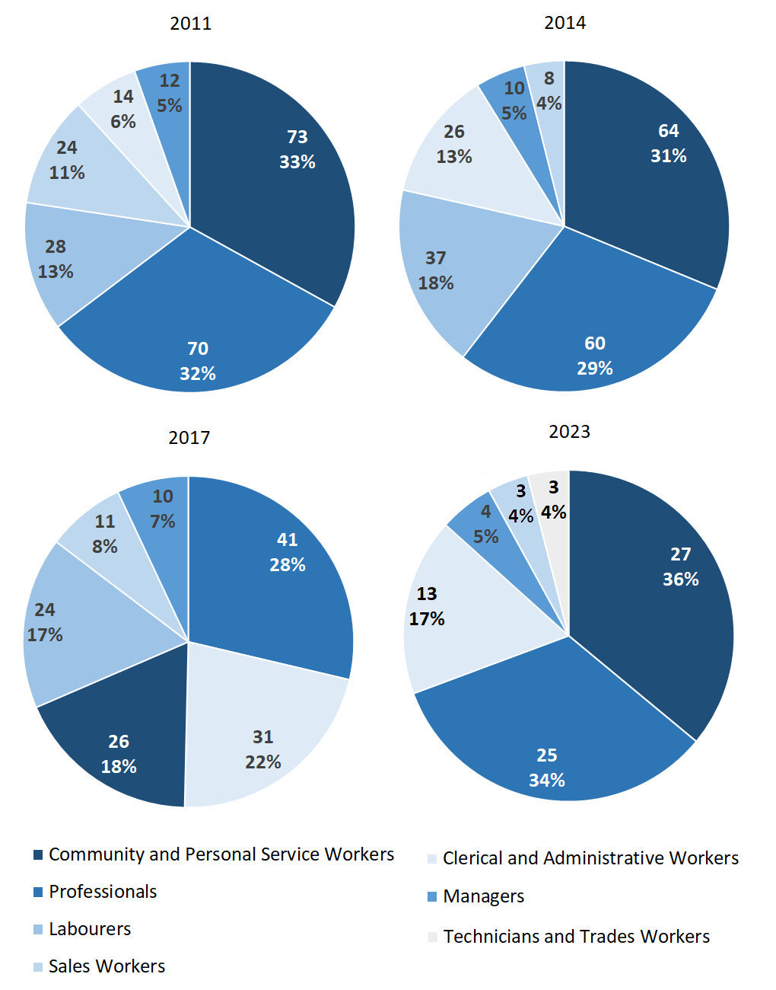Source: Northern Territory Department of Industry, Tourism and Trade

In 2023 in Ntaria (Hermannsburg):

* Community and Personal Service Workers was the **largest occupation classification** in terms of filled jobs, accounting for 27 jobs (34.2% of total filled jobs), an increase of 1 job from 2017 and a decrease of 37 jobs from 2014
* **other significant** occupation classifications were:
  + Professionals accounting for 25 jobs or 31.6% of total jobs a decrease of 16 jobs from 2017 and a decrease of 35 jobs from 2014
  + Clerical and Administrative Workers accounting for 13 jobs or 16.5% of total jobs a decrease of 18 jobs from 2017 and a decrease of 13 jobs from 2014
  + Managers accounting for 4 jobs or 5.1% of total jobs a decrease of 6 jobs from 2017 and a decrease of 6 jobs from 2014.

Table 17a: Count of filled jobs by ANZSCO occupation, 2011, 2014, 2017 & 2023 (a)(c)(f)(g)

| **Occupation (ANZSCO major group)** | **2011** | | | **2014** | | | **2017** | | | | **2023** | | | |
| --- | --- | --- | --- | --- | --- | --- | --- | --- | --- | --- | --- | --- | --- | --- |
| **Aboriginal** | **Non-Aboriginal** | **Total** | **Aboriginal** | **Non-Aboriginal** | **Total** | **Aboriginal** | **Non-Aboriginal** | **Total** | **Aboriginal** | | **Non-Aboriginal** | **Total** |
| Clerical and Administrative Workers | 10 | 4 | **14** | 16 | 10 | **26** | 14 | 17 | **31** | 5 | | 8 | **13** |
| Community and Personal Service Workers | 48 | 25 | **73** | 51 | 13 | **64** | 20 | 6 | **26** | 22 | | 5 | **27** |
| Labourers | 23 | 5 | **28** | 32 | 5 | **37** | 17 | 7 | **24** | 2 | | 0 | **2** |
| Machinery Operators and Drivers | 3 | 1 | **4** | 6 | 1 | **7** | 3 | 4 | **7** | 2 | | 0 | **2** |
| Managers | 3 | 9 | **12** | 1 | 9 | **10** | 1 | 9 | **10** | 1 | | 3 | **4** |
| Professionals | 41 | 29 | **70** | 32 | 28 | **60** | 20 | 21 | **41** | 12 | | 13 | **25** |
| Sales Workers | 6 | 18 | **24** | 5 | 3 | **8** | 10 | 1 | **11** | 2 | | 1 | **3** |
| Technicians and Trades Workers | 0 | 0 | **0** | 1 | 1 | **2** | 1 | 1 | **2** | 0 | | 3 | **3** |
| Other Occupations | 2 | 0 | **2** | 0 | 0 | **0** | 0 | 0 | **0** | 0 | | 0 | **0** |
| **Total** | **136** | **91** | **227** | **144** | **70** | **214** | **86** | **66** | **152** | **46** | | **33** | **79** |

Source: Northern Territory Department of Industry, Tourism and Trade

Table 17b: Count of filled jobs by ANZSCO occupation, 2011-2014, 2014-2017 & 2017-2023 (a)(c)(f)(g)

| **Occupation (ANZSCO major group)** | **Change 2011-2014** | | | **Change 2014-2017** | | | **Change 2017-2023** | | | |
| --- | --- | --- | --- | --- | --- | --- | --- | --- | --- | --- |
| **Aboriginal** | **Non-Aboriginal** | **Total** | **Aboriginal** | **Non-Aboriginal** | **Total** | **Aboriginal** | **Non-Aboriginal** | **Total** |
| Clerical and Administrative Workers | 6 | 6 | **12** | -2 | 7 | **5** | -9 | -9 | **-18** |
| Community and Personal Service Workers | 3 | -12 | **-9** | -31 | -7 | **-38** | 2 | -1 | **1** |
| Labourers | 9 | 0 | **9** | -15 | 2 | **-13** | -15 | -7 | **-22** |
| Machinery Operators and Drivers | 3 | 0 | **3** | -3 | 3 | **0** | -1 | -4 | **-5** |
| Managers | -2 | 0 | **-2** | 0 | 0 | **0** | 0 | -6 | **-6** |
| Professionals | -9 | -1 | **-10** | -12 | -7 | **-19** | -8 | -8 | **-16** |
| Sales Workers | -1 | -15 | **-16** | 5 | -2 | **3** | -8 | 0 | **-8** |
| Technicians and Trades Workers | 1 | 1 | **2** | 0 | 0 | **0** | -1 | 2 | **1** |
| Other Occupations | -2 | 0 | **-2** | 0 | 0 | **0** | 0 | 0 | **0** |
| **Total** | **8** | **-21** | **-13** | **-58** | **-4** | **-62** | **-40** | **-33** | **-73** |

Source: Northern Territory Department of Industry, Tourism and Trade

In 2023 in Ntaria (Hermannsburg):

* of the 46 **jobs filled by Aboriginal** people, there were:
  + 22 Community and Personal Service Workers, an increase of 2 jobs from 2017 and a decrease of 29 jobs from 2014
  + 12 Professionals, a decrease of 8 jobs from 2017 and a decrease of 20 jobs from 2014
  + 5 Clerical and Administrative Workers, a decrease of 9 jobs from 2017 and a decrease of 11 jobs from 2014
* of the 33 **jobs filled by** **non-Aboriginal** people, there were:
  + 13 Professionals, a decrease of 8 jobs from 2017 and a decrease of 15 jobs from 2014
  + 8 Clerical and Administrative Workers, a decrease of 9 jobs from 2017 and a decrease of 2 jobs from 2014
  + 5 Community and Personal Service Workers, a decrease of 1 job from 2017 and a decrease of 8 jobs from 2014.

# Jobs by Industry by Occupation

Table 18: Count of filled jobs by industry by occupation, 2011 (a)(f)(g)(h)

| **2011** | | | | | | | | | | |
| --- | --- | --- | --- | --- | --- | --- | --- | --- | --- | --- |
| **Industry (ANZSIC Division)** |  | **Occupation (ANZSCO major group)** | | | | | | | | |
| **Clerical and Administrative Workers** | **Community and Personal Service Workers** | **Labourers** | **Machinery Operators and Drivers** | **Managers** | **Professionals** | **Sales Workers** | **Technicians and Trades Workers** | **Other Occupations** | **Total** |
| Administrative and Support Services | 0 | 0 | 2 | 0 | 2 | 0 | 0 | 0 | 0 | **4** |
| Arts and Recreation Services | 0 | 4 | 0 | 0 | 0 | 6 | 0 | 0 | 0 | **10** |
| Education and Training | 2 | 23 | 1 | 0 | 1 | 14 | 0 | 0 | 0 | **41** |
| Health Care and Social Assistance | 1 | 14 | 7 | 2 | 2 | 9 | 0 | 0 | 2 | **37** |
| Other Services | 0 | 1 | 0 | 0 | 0 | 1 | 0 | 0 | 0 | **2** |
| Professional, Scientific and Technical Services | 0 | 0 | 0 | 0 | 0 | 10 | 0 | 0 | 0 | **10** |
| Public Administration and Safety | 11 | 24 | 18 | 2 | 2 | 30 | 2 | 0 | 0 | **89** |
| Retail Trade | 0 | 7 | 0 | 0 | 5 | 0 | 22 | 0 | 0 | **34** |
| Total | **14** | **73** | **28** | **4** | **12** | **70** | **24** | **0** | **2** | **227** |

Source: Northern Territory Department of Industry, Tourism and Trade

Table 19: Count of filled jobs by industry by occupation, 2014 (a)(f)(g)(h)

| **2014** | | | | | | | | | | |
| --- | --- | --- | --- | --- | --- | --- | --- | --- | --- | --- |
| **Industry (ANZSIC Division)** |  | **Occupation (ANZSCO major group)** | | | | | | | | |
| **Clerical and Administrative Workers** | **Community and Personal Service Workers** | **Labourers** | **Machinery Operators and Drivers** | **Managers** | **Professionals** | **Sales Workers** | **Technicians and Trades Workers** | **Other Occupations** | **Total** |
| Accommodation and Food Services | 1 | 1 | 1 | 0 | 1 | 0 | 0 | 0 | 0 | **4** |
| Arts and Recreation Services | 2 | 2 | 6 | 0 | 1 | 13 | 0 | 1 | 0 | **25** |
| Education and Training | 1 | 8 | 1 | 0 | 2 | 17 | 0 | 0 | 0 | **29** |
| Health Care and Social Assistance | 2 | 9 | 1 | 2 | 2 | 8 | 0 | 0 | 0 | **24** |
| Public Administration and Safety | 19 | 43 | 22 | 4 | 2 | 22 | 0 | 0 | 0 | **112** |
| Retail Trade | 1 | 1 | 6 | 1 | 2 | 0 | 8 | 1 | 0 | **20** |
| Total | **26** | **64** | **37** | **7** | **10** | **60** | **8** | **2** | **0** | **214** |

Source: Northern Territory Department of Industry, Tourism and Trade

Table 20: Count of filled jobs by occupation and by industry, 2017 (a)(f)(g)(h)

| **2017** | | | | | | | | | | |
| --- | --- | --- | --- | --- | --- | --- | --- | --- | --- | --- |
| **Industry (ANZSIC Division)** |  | **Occupation (ANZSCO major group)** | | | | | | | | |
| **Clerical and Administrative Workers** | **Community and Personal Service Workers** | **Labourers** | **Machinery Operators and Drivers** | **Managers** | **Professionals** | **Sales Workers** | **Technicians and Trades Workers** | **Other Occupations** | **Total** |
| Arts and Recreation Services | 1 | 1 | 1 | 0 | 3 | 10 | 0 | 0 | 0 | **16** |
| Education and Training | 1 | 10 | 1 | 0 | 2 | 10 | 0 | 0 | 0 | **24** |
| Health Care and Social Assistance | 2 | 8 | 3 | 2 | 1 | 10 | 0 | 1 | 0 | **27** |
| Public Administration and Safety | 24 | 7 | 14 | 1 | 2 | 11 | 0 | 0 | 0 | **59** |
| Retail Trade | 3 | 0 | 5 | 4 | 2 | 0 | 11 | 1 | 0 | **26** |
| Total | **31** | **26** | **24** | **7** | **10** | **41** | **11** | **2** | **0** | **152** |

Source: Northern Territory Department of Industry, Tourism and Trade

Table 21: Count of filled jobs by occupation and by industry, 2023 (a)(f)(g)(h)

| **2023** | | | | | | | | | | |
| --- | --- | --- | --- | --- | --- | --- | --- | --- | --- | --- |
| **Industry (ANZSIC Division)** |  | **Occupation (ANZSCO major group)** | | | | | | | | |
| **Clerical and Administrative Workers** | **Community and Personal Service Workers** | **Labourers** | **Machinery Operators and Drivers** | **Managers** | **Professionals** | **Sales Workers** | **Technicians and Trades Workers** | **Other Occupations** | **Total** |
| Administrative and Support Services | 1 | 7 | 0 | 0 | 0 | 0 | 0 | 0 | 0 | **8** |
| Arts and Recreation Services | 2 | 0 | 1 | 0 | 1 | 5 | 0 | 0 | 0 | **9** |
| Education and Training | 6 | 14 | 0 | 0 | 2 | 14 | 0 | 0 | 0 | **36** |
| Health Care and Social Assistance | 1 | 2 | 0 | 0 | 0 | 2 | 0 | 0 | 0 | **5** |
| Public Administration and Safety | 1 | 3 | 0 | 0 | 0 | 4 | 0 | 0 | 0 | **8** |
| Retail Trade | 2 | 1 | 1 | 2 | 1 | 0 | 3 | 3 | 0 | **13** |
| Total | **13** | **27** | **2** | **2** | **4** | **25** | **3** | **3** | **0** | **79** |

Source: Northern Territory Department of Industry, Tourism and Trade

In 2023 in Ntaria (Hermannsburg):

* Community and Personal Service Workers held the majority 27 jobs (the largest occupation group) were shared across the Education and Training with 14 jobs, Administrative and Support Services had 7 jobs, Public Administration and Safety had 3 jobs, and Health Care and Social Assistance industries had 2 jobs,
* Professionals (the second largest occupation group) held the majority of jobs, and these were in the Education and Training industry accounting for 14 filled jobs,
* Education and Training (the largest industry), there were 14 filled jobs each for Community and Personal Service Workers and Professionals, an increase of 4 jobs each from 2017,
* Public Administration and Safety showed a decrease of 51 jobs between 2023 and 2017, and a decrease of 104 jobs between 2023 and 2014.

# Jobs by Gender

Table 22a: Count of filled jobs by gender, 2011, 2014, 2017 & 2023 (a)(c)(i)

| **Indicator** | **2011** | | | **2014** | | | **2017** | | | **2023** | | |
| --- | --- | --- | --- | --- | --- | --- | --- | --- | --- | --- | --- | --- |
| **Aboriginal** | **Non-Aboriginal** | **Total** | **Aboriginal** | **Non-Aboriginal** | **Total** | **Aboriginal** | **Non-Aboriginal** | **Total** | **Aboriginal** | **Non-Aboriginal** | **Total** |
| Male | 48 | 34 | **82** | 61 | 29 | **90** | 30 | 23 | **53** | 14 | 10 | **24** |
| Female | 87 | 57 | **144** | 83 | 41 | **124** | 56 | 43 | **99** | 32 | 22 | **54** |
| Total | **136** | **91** | **227** | **144** | **70** | **214** | **86** | **66** | **152** | **46** | **33** | **79** |

Source: Northern Territory Department of Industry, Tourism and Trade

Table 22b: Count of filled jobs by gender, 2011-2014, 2014-2017 & 2017-2023 (a)(c)(i)

| **Indicator** | **2011-2014 Change** | | | **2014-2017 Change** | | | **2017-2023 Change** | | | |
| --- | --- | --- | --- | --- | --- | --- | --- | --- | --- | --- |
| **Aboriginal** | **Non-Aboriginal** | **Total** | **Aboriginal** | **Non-Aboriginal** | **Total** | **Aboriginal** | **Non-Aboriginal** | **Total** |
| Male | 13 | -5 | **8** | -31 | -6 | **-37** | -16 | -13 | **-29** |
| Female | -4 | -16 | **-20** | -27 | 2 | **-25** | -24 | -21 | **-45** |
| Total | **8** | **-21** | **-13** | **-58** | **-4** | **-62** | **-40** | **-33** | **-73** |

Source: Northern Territory Department of Industry, Tourism and Trade

Chart 11: Count of filled jobs by gender, 2011, 2014, 2017 & 2023 (a)(c)(i)

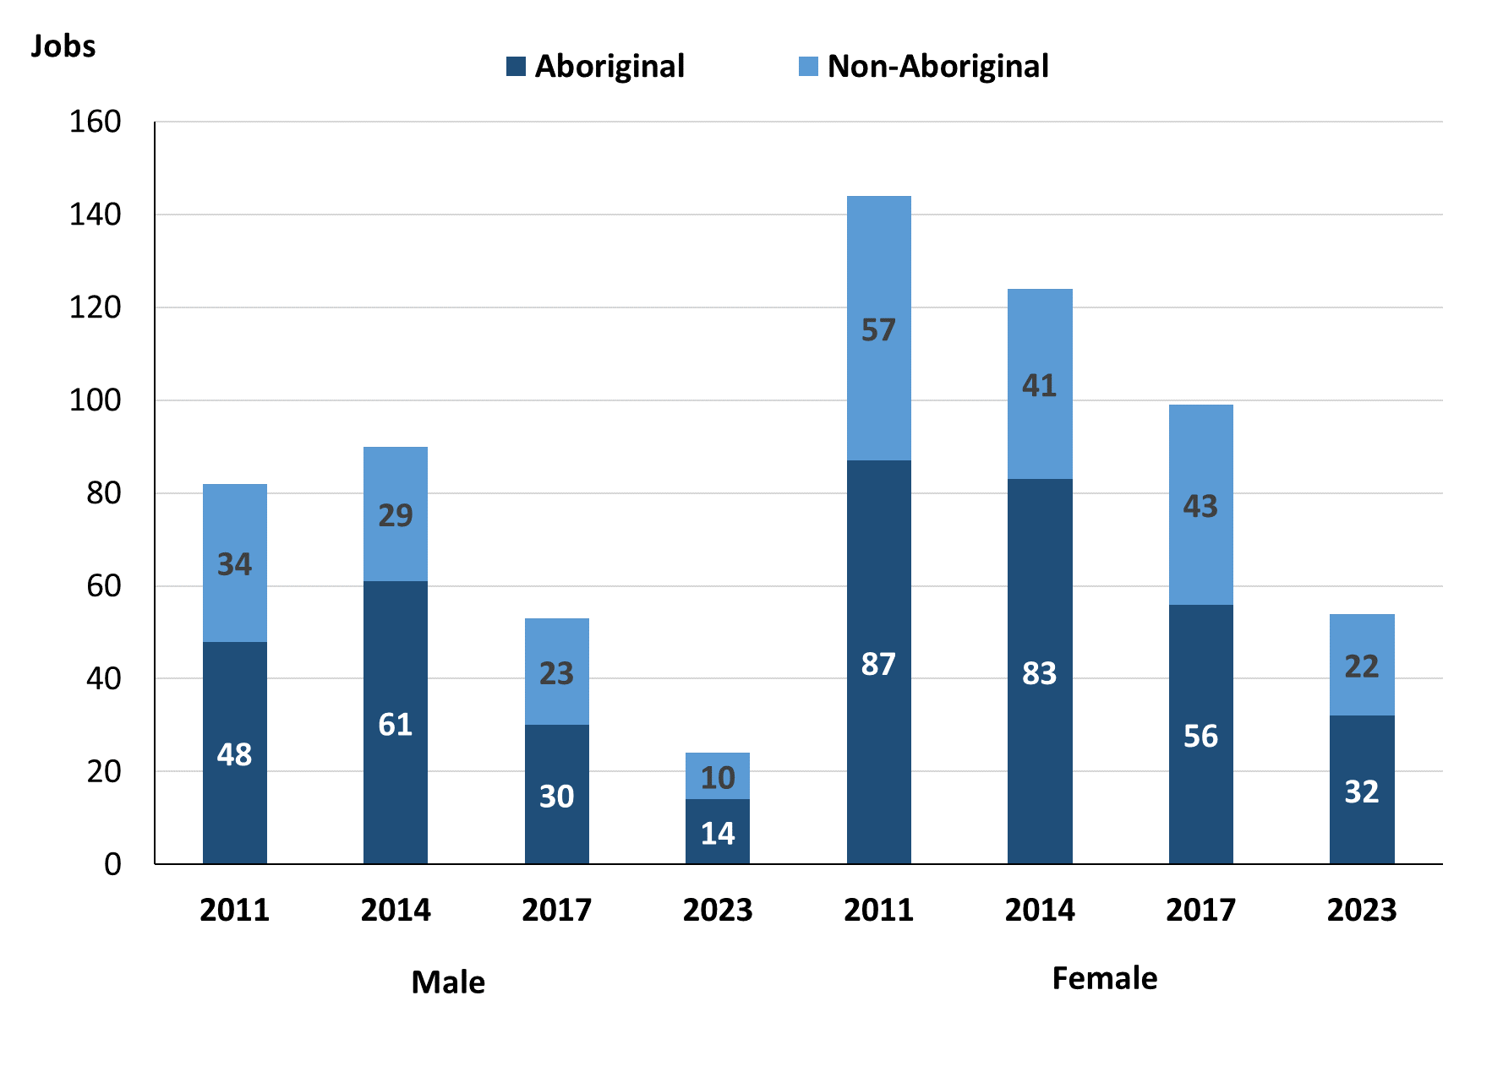

Source: Northern Territory Department of Industry, Tourism and Trade

In 2023 in Ntaria (Hermannsburg):

* there were 24 jobs **filled** by **males**, a decrease of 29 jobs from 2017 and a decrease of 66 jobs from 2014
* of the 24 jobs **filled by males**:
  + 14 were **Aboriginal**, a decrease of 16 jobs from 2017 and a decrease of 47 jobs from 2014
  + 10 were **non-Aboriginal**, a decrease of 13 jobs from 2017 and a decrease of 19 jobs from 2014
* there were 54 jobs **filled by females**, a decrease of 45 jobs from 2017 and a decrease of 70 jobs from 2014
* of the 54 jobs **filled by females**:
  + 32 were **Aborigina**l, a decrease of 24 jobs from 2017 and a decrease of 51 jobs from 2014
  + 22 were **non-Aboriginal**, a decrease of 21 jobs from 2017 and a decrease of 19 jobs from 2014.

Table 23: Count of filled jobs by gender, by full-time/part-time status, by job permanency and by sector 2011 (a)(b)(c)(d)(e)(i)

| **2011** | | | | | | | | | |
| --- | --- | --- | --- | --- | --- | --- | --- | --- | --- |
| **Indicator** | **Male** | | | **Female** | | | **Total** | | |
| **Aboriginal** | **Non-Aboriginal** | **Total** | **Aboriginal** | **Non-Aboriginal** | **Total** | **Aboriginal** | **Non-Aboriginal** | **Total** |
| Full-time | 24 | 33 | **57** | 29 | 49 | **78** | 54 | 82 | **136** |
| Part-time | 24 | 1 | **25** | 58 | 8 | **66** | 82 | 9 | **91** |
| Total | **48** | **34** | **82** | **87** | **57** | **144** | **136** | **91** | **227** |
| Permanent | 15 | 9 | **24** | 17 | 14 | **31** | 32 | 23 | **55** |
| Temporary | 33 | 25 | **58** | 70 | 43 | **113** | 104 | 68 | **172** |
| Total | **48** | **34** | **82** | **87** | **57** | **144** | **136** | **91** | **227** |
| Public Sector | 16 | 10 | **26** | 43 | 37 | **80** | 60 | 47 | **107** |
| Private Sector | 32 | 24 | **56** | 44 | 20 | **64** | 76 | 44 | **120** |
| Total | **48** | **34** | **82** | **87** | **57** | **144** | **136** | **91** | **227** |

Source: Northern Territory Department of Industry, Tourism and Trade

Table 24: Count of filled jobs by gender, by full-time/part-time status, by job permanency and by sector 2014 (a)(b)(c)(d)(e)(i)

| **2014** | | | | | | | | | |
| --- | --- | --- | --- | --- | --- | --- | --- | --- | --- |
| **Indicator** | **Male** | | | **Female** | | | **Total** | | |
| **Aboriginal** | **Non-Aboriginal** | **Total** | **Aboriginal** | **Non-Aboriginal** | **Total** | **Aboriginal** | **Non-Aboriginal** | **Total** |
| Full-time | 27 | 29 | **56** | 33 | 38 | **71** | 60 | 67 | **127** |
| Part-time | 34 | 0 | **34** | 50 | 3 | **53** | 84 | 3 | **87** |
| Total | **61** | **29** | **90** | **83** | **41** | **124** | **144** | **70** | **214** |
| Permanent | 20 | 17 | **37** | 33 | 22 | **55** | 53 | 39 | **92** |
| Temporary | 41 | 12 | **53** | 50 | 19 | **69** | 91 | 31 | **122** |
| Total | **61** | **29** | **90** | **83** | **41** | **124** | **144** | **70** | **214** |
| Public Sector | 21 | 14 | **35** | 41 | 20 | **61** | 62 | 34 | **96** |
| Private Sector | 40 | 15 | **55** | 42 | 21 | **63** | 82 | 36 | **118** |
| Total | **61** | **29** | **90** | **83** | **41** | **124** | **144** | **70** | **214** |

Source: Northern Territory Department of Industry, Tourism and Trade

Table 25: Count of filled jobs by gender, by full-time/part-time status, by job permanency and by sector 2017 (a)(b)(c)(d)(e)(i)

| **2017** | | | | | | | | | |
| --- | --- | --- | --- | --- | --- | --- | --- | --- | --- |
| **Indicator** | **Male** | | | **Female** | | | **Total** | | |
| **Aboriginal** | **Non-Aboriginal** | **Total** | **Aboriginal** | **Non-Aboriginal** | **Total** | **Aboriginal** | **Non-Aboriginal** | **Total** |
| Full-time | 10 | 22 | **32** | 30 | 40 | **70** | 40 | 62 | **102** |
| Part-time | 20 | 1 | **21** | 26 | 3 | **29** | 46 | 4 | **50** |
| Total | **30** | **23** | **53** | **56** | **43** | **99** | **86** | **66** | **152** |
| Permanent | 8 | 13 | **21** | 26 | 21 | **47** | 34 | 34 | **68** |
| Temporary | 22 | 10 | **32** | 30 | 22 | **52** | 52 | 32 | **84** |
| Total | **30** | **23** | **53** | **56** | **43** | **99** | **86** | **66** | **152** |
| Public Sector | 5 | 9 | **14** | 21 | 12 | **33** | 26 | 21 | **47** |
| Private Sector | 25 | 14 | **39** | 35 | 31 | **66** | 60 | 45 | **105** |
| Total | **30** | **23** | **53** | **56** | **43** | **99** | **86** | **66** | **152** |

Source: Northern Territory Department of Industry, Tourism and Trade

Table 26: Count of filled jobs by gender, by full-time/part-time status, by job permanency and by sector 2023 (a)(b)(c)(d)(e)(i)

| **2023** | | | | | | | | | |
| --- | --- | --- | --- | --- | --- | --- | --- | --- | --- |
| **Indicator** | **Male** | | | **Female** | | | **Total** | | |
| **Aboriginal** | **Non-Aboriginal** | **Total** | **Aboriginal** | **Non-Aboriginal** | **Total** | **Aboriginal** | **Non-Aboriginal** | **Total** |
| Full-time | 4 | 10 | **14** | 22 | 18 | **40** | 26 | 28 | **54** |
| Part-time | 10 | 0 | **10** | 10 | 4 | **14** | 20 | 5 | **25** |
| Total | **14** | **10** | **24** | **32** | **22** | **54** | **46** | **33** | **79** |
| Permanent | 4 | 8 | **12** | 15 | 11 | **26** | 19 | 19 | **38** |
| Temporary | 10 | 2 | **12** | 17 | 11 | **28** | 27 | 14 | **41** |
| Total | **14** | **10** | **24** | **32** | **22** | **54** | **46** | **33** | **79** |
| Public Sector | 2 | 5 | **7** | 21 | 15 | **36** | 23 | 20 | **43** |
| Private Sector | 12 | 5 | **17** | 11 | 7 | **18** | 23 | 13 | **36** |
| Total | **14** | **10** | **24** | **32** | **22** | **54** | **46** | **33** | **79** |

Source: Northern Territory Department of Industry, Tourism and Trade

In 2023 in Ntaria (Hermannsburg):

* of the 24 **jobs filled by males**, there were:
  + 14 jobs filled by **Aboriginal males**, a decrease of 16 jobs from 2017 and a decrease of 47 jobs from 2014, including:
    - 4 full-time jobs, a decrease of 6 jobs from 2017 and a decrease of 23 jobs from 2014
    - 10 part-time jobs, a decrease of 10 jobs from 2017 and a decrease of 24 jobs from 2014
    - 4 permanent jobs, a decrease of 4 jobs from 2017 and a decrease of 16 jobs from 2014
    - 10 temporary jobs, a decrease of 12 jobs from 2017 and a decrease of 31 jobs from 2014
    - 2 Public Sector jobs, a decrease of 3 jobs from 2017 and a decrease of 19 jobs from 2014
    - 12 Private Sector jobs, a decrease of 13 jobs from 2017 and a decrease of 28 jobs from 2014
  + 10 jobs filled by **non-Aboriginal males**, a decrease of 13 jobs from 2017 and a decrease of 19 jobs from 2014, including:
    - 10 full-time jobs, a decrease of 12 jobs from 2017 and a decrease of 19 jobs from 2014
    - 0 part-time jobs, a decrease of 1 job from 2017 and unchanged from 2014
    - 8 permanent jobs, a decrease of 5 jobs from 2017 and a decrease of 9 jobs from 2014
    - 2 temporary jobs, a decrease of 8 jobs from 2017and a decrease of 10 jobs from 2014
    - 5 Public Sector jobs, a decrease of 4 jobs from 2017 and a decrease of 9 jobs from 2014
    - 5 Private Sector jobs, a decrease of 9 jobs from 2017 and a decrease of 10 jobs from 2014
* of the 54 **jobs filled by females**, there were:
  + 32 jobs filled by **Aboriginal females**, a decrease of 24 jobs from 2017 and a decrease of 51 jobs from 2014, including:
    - 22 full-time jobs, a decrease of 8 jobs from 2017 and a decrease of 11 jobs from 2014
    - 10 part-time jobs, a decrease of 16 jobs from 2017 and a decrease of 40 jobs from 2014
    - 15 permanent jobs, a decrease of 11 jobs from 2017 and a decrease of 18 jobs from 2014
    - 17 temporary jobs, a decrease of 13 jobs from 2017 and a decrease of 33 jobs from 2014
    - 21 Public Sector jobs, unchanged from 2017 and a decrease of 20 jobs from 2014
    - 11 Private Sector jobs, a decrease of 24 jobs from 2017 and a decrease of 31 jobs from 2014
  + 22 jobs filled by **non-Aboriginal females**, a decrease of 21 jobs from 2017 and a decrease of 19 jobs from 2014, including:
    - 18 full-time jobs, a decrease of 22 jobs from 2017 and a decrease of 20 jobs from 2014
    - 4 part-time jobs, an increase of 1 job from 2017 and an increase of 1 job from 2014
    - 11 permanent jobs, a decrease of 10 jobs from 2017 and a decrease of 11 jobs from 2014
    - 11 temporary jobs, a decrease of 11 jobs from 2017 and a decrease of 8 jobs from 2014
    - 15 Public Sector jobs, an increase of 3 jobs from 2017 and a decrease of 5 jobs from 2014
    - 7 Private Sector jobs, a decrease of 24 jobs from 2017 and a decrease of 14 jobs from 2014.

# Jobs by Age

Table 27a: Count of filled jobs by age, 2011, 2014, 2017 & 2023 (a)(c)(j)

| **Indicator** | **2011** | | | **2014** | | | **2017** | | | **2023** | | |
| --- | --- | --- | --- | --- | --- | --- | --- | --- | --- | --- | --- | --- |
| **Aboriginal** | **Non-Aboriginal** | **Total** | **Aboriginal** | **Non-Aboriginal** | **Total** | **Aboriginal** | **Non-Aboriginal** | **Total** | **Aboriginal** | **Non-Aboriginal** | **Total** |
| 15-24 years | 18 | 7 | **25** | 22 | 2 | **24** | 5 | 3 | **8** | 2 | 1 | **3** |
| 25-44 years | 84 | 36 | **120** | 96 | 21 | **117** | 59 | 27 | **86** | 32 | 19 | **51** |
| 45+ years | 33 | 48 | **81** | 26 | 47 | **73** | 22 | 36 | **58** | 12 | 13 | **25** |
| Total | **136** | **91** | **227** | **144** | **70** | **214** | **86** | **66** | **152** | **46** | **33** | **79** |

Source: Northern Territory Department of Industry, Tourism and Trade

Table 27b: Count of filled jobs by age, 2011-2014, 2014-2017 & 2017-2023 (a)(c)(j)

| **Indicator** | **Change 2011-2014** | | | **Change 2014-2017** | | | **Change 2017-2023** | | | |
| --- | --- | --- | --- | --- | --- | --- | --- | --- | --- | --- |
| **Aboriginal** | **Non-Aboriginal** | **Total** | **Aboriginal** | **Non-Aboriginal** | **Total** | **Aboriginal** | **Non-Aboriginal** | **Total** |
| 15-24 years | 4 | -5 | **-1** | -17 | 1 | **-16** | -3 | -2 | **-5** |
| 25-44 years | 12 | -15 | **-3** | -37 | 6 | **-31** | -27 | -8 | **-35** |
| 45+ years | -7 | -1 | **-8** | -4 | -11 | **-15** | -10 | -23 | **-33** |
| Total | **8** | **-21** | **-13** | **-58** | **-4** | **-62** | **-40** | **-33** | **-73** |

Source: Northern Territory Department of Industry, Tourism and Trade

Chart 12: Count of filled jobs by age, 2011, 2014, 2017 & 2023 (a)(c)(j)

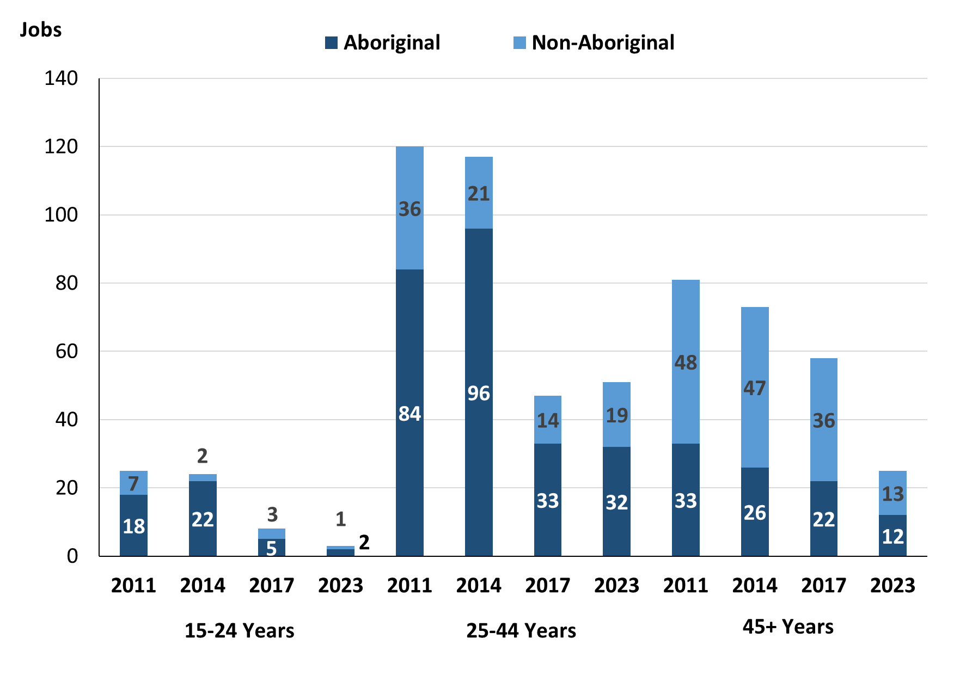

Source: Northern Territory Department of Industry, Tourism and Trade

In 2023 in Ntaria (Hermannsburg) there were:

* 3 **jobs filled** by people aged **15-24 years**, a decrease of 5 jobs from 2017 and a decrease of 21 jobs from 2014. Of these:
  + 2 jobs were filled by **Aboriginal** people, a decrease of 3 jobs from 2017 and a decrease of 20 jobs from 2014
  + 1 job was filled by a **non-Aboriginal** person, a decrease of 2 jobs from 2017 and a decrease of 1 job from 2014
* 51 **jobs filled** by people aged **25-44 years**, a decrease of 35 jobs from 2017 and a decrease of 66 jobs from 2014. Of these:
  + 32 jobs were filled by **Aboriginal** people, a decrease of 27 jobs from 2017 and a decrease of 64 jobs from 2014
  + 19 jobs were filled by **non-Aboriginal** people, a decrease of 8 jobs from 2017 and a decrease of 2 jobs from 2014
* 25 **jobs filled** by people aged **45+ years**, a decrease of 33 jobs from 2017 and a decrease of 48 jobs from 2014. Of these:
  + 12 jobs were filled by **Aboriginal** people, a decrease of 10 jobs from 2017 and a decrease of 14 jobs from 2014
  + 13 jobs were filled by **non-Aboriginal** people, a decrease of 23 jobs from 2017 and a decrease of 34 jobs from 2014.

Table 28: Count of filled jobs by age, by full-time/part-time status, by job permanency and by sector June-July 2011 (a)(b)(c)(d)(e)(i)

| **2011** | | | | | | | | | | | | | |
| --- | --- | --- | --- | --- | --- | --- | --- | --- | --- | --- | --- | --- | --- |
| **Indicator** | **15-24 years** | | | **25-44 years** | | | **45+ years** | | | **Total** | | | |
| **Aboriginal** | **Non-Aboriginal** | **Total** | **Aboriginal** | **Non-Aboriginal** | **Total** | **Aboriginal** | **Non-Aboriginal** | **Total** | **Aboriginal** | **Non-Aboriginal** | **Total** |
| Full-time | 5 | 4 | **9** | 34 | 34 | **68** | 14 | 44 | **58** | 54 | 82 | **136** |
| Part-time | 13 | 3 | **16** | 50 | 2 | **52** | 19 | 4 | **23** | 82 | 9 | **91** |
| Total | **18** | **7** | **25** | **84** | **36** | **120** | **33** | **48** | **81** | **136** | **91** | **227** |
| Permanent | 4 | 0 | **4** | 17 | 8 | **25** | 11 | 15 | **26** | 32 | 23 | **55** |
| Temporary | 14 | 7 | **21** | 67 | 28 | **95** | 22 | 33 | **55** | 104 | 68 | **172** |
| Total | **18** | **7** | **25** | **84** | **36** | **120** | **33** | **48** | **81** | **136** | **91** | **227** |
| Public Sector | 11 | 3 | **14** | 34 | 23 | **57** | 14 | 21 | **35** | 60 | 47 | **107** |
| Private Sector | 7 | 4 | **11** | 50 | 13 | **63** | 19 | 27 | **46** | 76 | 44 | **120** |
| Total | **18** | **7** | **25** | **84** | **36** | **120** | **33** | **48** | **81** | **136** | **91** | **227** |

Source: Northern Territory Department of Industry, Tourism and Trade

Table 29: Count of filled jobs by age, by full-time/part-time status, by job permanency and by sector June-July 2014 (a)(b)(c)(d)(e)(i)

| **2014** | | | | | | | | | | | | | |
| --- | --- | --- | --- | --- | --- | --- | --- | --- | --- | --- | --- | --- | --- |
| **Indicator** | **15-24 years** | | | **25-44 years** | | | **45+ years** | | | **Total** | | | |
| **Aboriginal** | **Non-Aboriginal** | **Total** | **Aboriginal** | **Non-Aboriginal** | **Total** | **Aboriginal** | **Non-Aboriginal** | **Total** | **Aboriginal** | **Non-Aboriginal** | **Total** |
| Full-time | 8 | 2 | **10** | 39 | 19 | **58** | 13 | 46 | **59** | 60 | 67 | **127** |
| Part-time | 14 | 0 | **14** | 57 | 2 | **59** | 13 | 1 | **14** | 84 | 3 | **87** |
| Total | **22** | **2** | **24** | **96** | **21** | **117** | **26** | **47** | **73** | **144** | **70** | **214** |
| Permanent | 6 | 1 | **7** | 30 | 12 | **42** | 17 | 26 | **43** | 53 | 39 | **92** |
| Temporary | 16 | 1 | **17** | 66 | 9 | **75** | 9 | 21 | **30** | 91 | 31 | **122** |
| Total | **22** | **2** | **24** | **96** | **21** | **117** | **26** | **47** | **73** | **144** | **70** | **214** |
| Public Sector | 11 | 1 | **12** | 32 | 9 | **41** | 19 | 24 | **43** | 62 | 34 | **96** |
| Private Sector | 11 | 1 | **12** | 64 | 12 | **76** | 7 | 23 | **30** | 82 | 36 | **118** |
| Total | **22** | **2** | **24** | **96** | **21** | **117** | **26** | **47** | **73** | **144** | **70** | **214** |

Source: Northern Territory Department of Industry, Tourism and Trade

Table 30: Count of filled jobs by age, by full-time/part-time status, by job permanency and by sector June-July 2017 (a)(b)(c)(d)(e)(i)

| **2017** | | | | | | | | | | | | |
| --- | --- | --- | --- | --- | --- | --- | --- | --- | --- | --- | --- | --- |
| **Indicator** | **15-24 years** | | | **25-44 years** | | | **45+ years** | | | **Total** | | |
| **Aboriginal** | **Non-Aboriginal** | **Total** | **Aboriginal** | **Non-Aboriginal** | **Total** | **Aboriginal** | **Non-Aboriginal** | **Total** | **Aboriginal** | **Non-Aboriginal** | **Total** |
| Full-time | 1 | 3 | **4** | 26 | 24 | **50** | 13 | 35 | **48** | 40 | 62 | **102** |
| Part-time | 4 | 0 | **4** | 33 | 3 | **36** | 9 | 1 | **10** | 46 | 4 | **50** |
| Total | **5** | **3** | **8** | **59** | **27** | **86** | **22** | **36** | **58** | **86** | **66** | **152** |
| Permanent | 2 | 2 | **4** | 19 | 11 | **30** | 13 | 21 | **34** | 34 | 34 | **68** |
| Temporary | 3 | 1 | **4** | 40 | 16 | **56** | 9 | 15 | **24** | 52 | 32 | **84** |
| Total | **5** | **3** | **8** | **59** | **27** | **86** | **22** | **36** | **58** | **86** | **66** | **152** |
| Public Sector | 0 | 1 | **1** | 14 | 8 | **22** | 12 | 12 | **24** | 26 | 21 | **47** |
| Private Sector | 5 | 2 | **7** | 45 | 19 | **64** | 10 | 24 | **34** | 60 | 45 | **105** |
| Total | **5** | **3** | **8** | **59** | **27** | **86** | **22** | **36** | **58** | **86** | **66** | **152** |

Source: Northern Territory Department of Industry, Tourism and Trade

Table 31: Count of filled jobs by age, by full-time/part-time status, by job permanency and by sector September 2023 (a)(b)(c)(d)(e)(i)

| **2023** | | | | | | | | | | | | |
| --- | --- | --- | --- | --- | --- | --- | --- | --- | --- | --- | --- | --- |
| **Indicator** | **15-24 years** | | | **25-44 years** | | | **45+ years** | | | **Total** | | |
| **Aboriginal** | **Non-Aboriginal** | **Total** | **Aboriginal** | **Non-Aboriginal** | **Total** | **Aboriginal** | **Non-Aboriginal** | **Total** | **Aboriginal** | **Non-Aboriginal** | **Total** |
| Full-time | 1 | 1 | **2** | 20 | 15 | **35** | 5 | 12 | **17** | 26 | 28 | **54** |
| Part-time | 1 | 0 | **1** | 12 | 4 | **16** | 7 | 1 | **8** | 20 | 5 | **25** |
| Total | **2** | **1** | **3** | **32** | **19** | **51** | **12** | **13** | **25** | **46** | **33** | **79** |
| Permanent | 0 | 1 | **1** | 13 | 10 | **23** | 6 | 8 | **14** | 19 | 19 | **38** |
| Temporary | 2 | 0 | **2** | 19 | 9 | **28** | 6 | 5 | **11** | 27 | 14 | **41** |
| Total | **2** | **1** | **3** | **32** | **19** | **51** | **12** | **13** | **25** | **46** | **33** | **79** |
| Public Sector | 1 | 0 | **1** | 17 | 12 | **29** | 5 | 8 | **13** | 23 | 20 | **43** |
| Private Sector | 1 | 1 | **2** | 15 | 7 | **22** | 7 | 5 | **12** | 23 | 13 | **36** |
| Total | **2** | **1** | **3** | **32** | **19** | **51** | **12** | **13** | **25** | **46** | **33** | **79** |

Source: Northern Territory Department of Industry, Tourism and Trade

In 2023 in Ntaria (Hermannsburg):

* of the 3 **jobs filled** by people aged **15-24 years**, there were:
  + 2 jobs filled by **Aboriginal** people, of which:
    - 1 was a full-time job, unchanged from 2017 and a decrease of 7 jobs from 2014
    - 1 was a part-time job, a decrease of 3 jobs from 2017 and a decrease of 13 jobs from 2014
    - none were permanent jobs, a decrease of 2 jobs from 2017 and a decrease of 6 jobs from 2014
    - 2 were temporary jobs, a decrease of 1 job from 2017 and a decrease of 14 jobs from 2014
    - 1 was a Public Sector job, an increase of 1 job from 2017 and a decrease of 10 jobs from 2014
    - 1 was a Private Sector job, a decrease of 4 jobs from 2017 and a decrease of 10 jobs from 2014
  + 1 job was filled by a **non-Aboriginal** person, of which:
    - 1 was a full-time job, a decrease of 2 jobs from 2017 and a decrease of 1 job from 2014
    - none were part-time jobs, unchanged from 2017 and 2014
    - 1 was a permanent job, a decrease of 1 job from 2017 and unchanged from 2014
    - none were temporary jobs, a decrease of 1 job from 2017 and a decrease of 1 job from 2014
    - none were Public Sector jobs, a decrease of 1 job from 2017 and a decrease of 1 job from 2014
    - 1 was a Private Sector job, a decrease of 1 job from 2017 and unchanged from 2014
* of the 51 **jobs filled** by people aged **25-44 years**, there were:
  + 32 jobs filled by **Aboriginal** people, of which:
    - 20 were full-time jobs, a decrease of 6 jobs from 2017 and a decrease of 19 jobs from 2014
    - 12 were part-time jobs, a decrease of 21 jobs from 2017 and a decrease of 45 jobs from 2014
    - 13 were permanent jobs, a decrease of 6 jobs from 2017 and a decrease of 17 jobs from 2014
    - 19 were temporary jobs, a decrease of 21 jobs from 2017 and a decrease of 47 jobs from 2014
    - 17 were Public Sector jobs, an increase of 3 jobs from 2017 and a decrease of 15 jobs from 2014
    - 15 were Private Sector jobs, a decrease of 30 jobs from 2017 and a decrease of 49 jobs from 2014
  + 19 jobs filled by **non-Aboriginal** people, of which:
    - 15 were full-time jobs, a decrease of 9 jobs from 2017 and a decrease of 4 jobs from 2014
    - 4 were part-time jobs, an increase of 1 job from 2017 and an increase of 2 jobs from 2014
    - 10 were permanent jobs, a decrease of 1 job from 2017 and a decrease of 2 jobs from 2014
    - 9 were temporary jobs, a decrease of 7 jobs from 2017 and unchanged from 2014
    - 12 were Public Sector jobs, an increase of 4 jobs from 2017 and an increase of 3 jobs from 2014
    - 7 were Private Sector jobs, a decrease of 12 jobs from 2017 and a decrease of 5 jobs from 2014
* of the 25 **jobs** **filled** by people aged **45+ years**, there were:
  + 12 jobs filled by **Aboriginal** people, of which:
    - 5 were full-time jobs, a decrease of 8 jobs from 2017 and a decrease of 8 jobs from 2014
    - 7 were part-time jobs, a decrease of 2 jobs from 2017 and a decrease of 6 jobs from 2014
    - 6 were permanent jobs, a decrease of 7 jobs from 2017 and a decrease of 11 jobs from 2014
    - 6 were temporary jobs, a decrease of 3 jobs from 2017 and a decrease of 3 jobs from 2014
    - 5 were Public Sector jobs, a decrease of 7 jobs from 2017 and a decrease of 14 jobs from 2014
    - 7 were Private Sector jobs, a decrease of 3 jobs from 2017 and unchanged from 2014
  + 13 jobs filled by **non-Aboriginal** people, of which:
    - 12 were full-time jobs, a decrease of 23 jobs from 2017 and a decrease of 34 jobs from 2014
    - 1 was a part-time job, unchanged from 2017 and 2014
    - 8 were permanent jobs, a decrease of 13 jobs from 2017 and a decrease of 18 jobs from 2014
    - 5 were temporary jobs, a decrease of 10 jobs from 2017 and a decrease of 16 jobs from 2014
    - 8 were Public Sector jobs, a decrease of 4 jobs from 2017 and a decrease of 16 jobs from 2014
    - 5 were Private Sector jobs, a decrease of 19 jobs from 2017 and a decrease of 18 jobs from 2014.

# Vocational Education and Training

Note: *The 2010 data is in accordance with the new, standardised reporting procedures that focus on all training activities conducted in the remote town, irrespective of funding source, as compared to earlier publications. As a result, the 2010 VET data values in this publication might not match those in earlier publications.*

*The impact of the Remote Jobs and Communities Program (RJCP), established in 2013, has played a significant role in the reduction of accredited training in many remote towns across the Territory.*

Table 32a: Northern Territory Vocational Education and Training (VET) students, 2010, 2013, 2016 & 2023 (k)

| **VET Funding Group** | **2010** | | **2013** | | **2016** | | **2023** | |
| --- | --- | --- | --- | --- | --- | --- | --- | --- |
| **No.** | **% of Total** | **No.** | **% of Total** | **No.** | **% of Total** | **No.** | **% of Total** |
| Arts, Entertainment, Sports and Rec. | 2 | 1% | 31 | 22% | 0 | 0% | 14 | 10% |
| Automotive | 0 | 0% | 12 | 8% | 0 | 0% | 0 | 0% |
| Building and Construction | 36 | 24% | 21 | 15% | 15 | 16% | 13 | 10% |
| Business and Clerical | 12 | 8% | 0 | 0% | 11 | 12% | 34 | 25% |
| Community Serv., Health and Education | 7 | 5% | 46 | 32% | 26 | 27% | 16 | 12% |
| Engineering and Mining | 9 | 6% | 8 | 6% | 11 | 12% | 0 | 0% |
| Food Processing | 0 | 0% | 0 | 0% | 12 | 13% | 0 | 0% |
| General Education and Training | 6 | 4% | 0 | 0% | 0 | 0% | 5 | 4% |
| Primary Industry | 31 | 21% | 19 | 13% | 6 | 6% | 10 | 7% |
| Process Manufacturing | 0 | 0% | 0 | 0% | 5 | 5% | 0 | 0% |
| Sales and Personal Service | 7 | 5% | 0 | 0% | 9 | 9% | 11 | 8% |
| Tourism and Hospitality | 22 | 15% | 7 | 5% | 0 | 0% | 31 | 23% |
| Transport and Storage | 15 | 10% | 0 | 0% | 0 | 0% | 0 | 0% |
| Total | **147** | **100%** | **144** | **100%** | **95** | **100%** | **134** | **100%** |

Source: Northern Territory Department of Industry, Tourism and Trade

Table 32b: Northern Territory Vocational Education and Training (VET) students, 2010-2013, 2013-2016 and 2016-2023 (k)

| **VET Funding Group** | **Change** | | |
| --- | --- | --- | --- |
| **2010-2013** | **2013-2016** | **2016-2023** |
| Arts, Entertainment, Sports and Recreation | 29 | - 31 | 14 |
| Automotive | 12 | - 12 | 0 |
| Building and Construction | - 15 | - 6 | -2 |
| Business and Clerical | - 12 | 11 | 23 |
| Community Services, Health and Education | 39 | - 20 | -10 |
| Engineering and Mining | - 1 | 3 | -11 |
| Food Processing | 0 | 12 | -12 |
| General Education and Training | - 6 | 0 | 5 |
| Primary Industry | - 12 | - 13 | 4 |
| Process Manufacturing | 0 | 5 | -5 |
| Sales and Personal Service | - 7 | 9 | 2 |
| Tourism and Hospitality | - 15 | - 7 | 31 |
| Transport and Storage | - 15 | 0 | 0 |
| Total | **- 3** | **- 49** | **39** |

Source: Northern Territory Department of Industry, Tourism and Trade

In 2023 in Ntaria (Hermannsburg):

* there were 134 **VET students**, an increase of 39 students from 2016 and a decrease of 10 students from 2013,
* VET activity with the most students were Business and Clerical with 34 students,
* Tourism and Hospitality had 31 students,
* Community Services, Health and Education had 16 students,
* Tourism and Hospitality reported the largest increase in students with an increase of 31 students,
* Food Processing reported the largest decrease in students with 12 less students over the same period.

Table 33a: Northern Territory Vocational Education and Training (VET) unit enrolments, 2010, 2013, 2016 & 2023 (l)

| **VET Funding Group** | **2010** | | **2013** | | **2016** | | **2023** | |
| --- | --- | --- | --- | --- | --- | --- | --- | --- |
| **No.** | **% of Total** | **No.** | **% of Total** | **No.** | **% of Total** | **No.** | **% of Total** |
| Arts, Entertainment, Sports and Recreation | 28 | 4% | 136 | 22% | 0 | 0% | 55 | 6% |
| Automotive | 0 | 0% | 53 | 9% | 0 | 0% | 0 | 0% |
| Building and Construction | 101 | 14% | 123 | 20% | 15 | 4% | 112 | 12% |
| Business and Clerical | 34 | 5% | 0 | 0% | 46 | 11% | 273 | 29% |
| Community Services, Health and Education | 20 | 3% | 162 | 26% | 40 | 10% | 169 | 18% |
| Engineering and Mining | 72 | 10% | 42 | 7% | 12 | 3% | 0 | 0% |
| Food Processing | 0 | 0% | 0 | 0% | 228 | 55% | 0 | 0% |
| General Education and Training | 15 | 2% | 0 | 0% | 0 | 0% | 8 | 1% |
| Primary Industry | 306 | 41% | 37 | 6% | 25 | 6% | 49 | 5% |
| Process Manufacturing | 0 | 0% | 0 | 0% | 5 | 1% | 0 | 0% |
| Sales and Personal Services | 27 | 4% | 0 | 0% | 45 | 11% | 101 | 11% |
| Tourism and Hospitality | 122 | 16% | 70 | 11% | 0 | 0% | 161 | 17% |
| Transport and Storage | 15 | 2% | 0 | 0% | 0 | 0% | 0 | 0% |
| Total | **740** | **100%** | **623** | **100%** | **416** | **100%** | **929** | **100%** |

Source: Northern Territory Department of Industry, Tourism and Trade

Table 33b: Northern Territory Vocational Education and Training (VET) unit enrolments, 2010-2013, 2013-2016 and 2016-2023 (l)

| **VET Funding Group** | **Change** | | |
| --- | --- | --- | --- |
| **2010-2013** | **2013-2016** | **2016-2023** | |
| Arts, Entertainment, Sports and Recreation | 108 | - 136 | 55 | |
| Automotive | 53 | - 53 | 0 | |
| Building and Construction | 22 | - 108 | 97 | |
| Business and Clerical | - 34 | 46 | 227 | |
| Community Services, Health and Education | 142 | - 122 | 129 | |
| Engineering and Mining | - 30 | - 30 | -12 | |
| Food Processing | 0 | 228 | -228 | |
| General Education and Training | - 15 | 0 | 8 | |
| Primary Industry | - 269 | - 12 | 24 | |
| Process Manufacturing | 0 | 5 | -5 | |
| Sales and Personal Services | - 27 | 45 | 56 | |
| Tourism and Hospitality | - 52 | - 70 | 161 | |
| Transport and Storage | - 15 | 0 | 0 | |
| Total | **- 117** | **- 207** | **512** | |

Source: Northern Territory Department of Industry, Tourism and Trade

In 2023 in Ntaria (Hermannsburg):

* there were 929 **VET unit enrolments**, an increase of 512-unit enrolments from 2016 and an increase of 306-unit enrolments from 2013,
* VET activity with the most unit enrolments were Business and Clerical with 273-unit enrolments,
* Community Services, Health and Education had 169-unit enrolments,
* Tourism and Hospitality had 161-unit enrolments,
* Business and Clerical reported the largest increase in unit enrolments with 227 more-unit enrolments compared to 2016,
* Food Processing reported the largest decrease in unit enrolments with 228 less unit enrolments over the same period.

Table 34a: Northern Territory Vocational Education and Training (VET) nominal hours, 2010, 2013, 2016 & 2023 (m)

| **VET Funding Group** | **2010** | | **2013** | | **2016** | | **2023** | |
| --- | --- | --- | --- | --- | --- | --- | --- | --- |
| **No.** | **% of Total** | **No.** | **% of Total** | **No.** | **% of Total** | **No.** | **% of Total** |
| Arts, Entertainment, Sports and Recreation | 454 | 2% | 5,240 | 26% | 0 | 0% | 2,490 | 7% |
| Automotive | 0 | 0% | 1,185 | 6% | 0 | 0% | 0 | 0% |
| Building and Construction | 2,953 | 12% | 3,604 | 18% | 400 | 3% | 3,042 | 8% |
| Business and Clerical | 1,185 | 5% | 0 | 0% | 1,165 | 10% | 10,090 | 28% |
| Community Services, Health and Education | 790 | 3% | 5,273 | 27% | 785 | 7% | 9,980 | 28% |
| Engineering and Mining | 1,170 | 5% | 1,416 | 7% | 250 | 2% | 0 | 0% |
| Food Processing | 0 | 0% | 0 | 0% | 7,200 | 61% | 0 | 0% |
| General Education and Training | 250 | 1% | 0 | 0% | 0 | 0% | 290 | 1% |
| Primary Industry | 8,875 | 35% | 1,110 | 6% | 640 | 5% | 1,700 | 5% |
| Sales and Personal Services | 745 | 3% | 0 | 0% | 1,305 | 11% | 3,115 | 9% |
| Tourism and Hospitality | 8,040 | 32% | 2,020 | 10% | 0 | 0% | 5,171 | 14% |
| Transport and Storage | 600 | 2% | 0 | 0% | 0 | 0% | 0 | 0% |
| Not Set | 0 | 0% | 0 | 0% | 0 | 0% | 50 | 0% |
| Total | **25,062** | **100%** | **19,848** | **100%** | **11,745** | **100%** | **35,928** | **100%** |

Source: Northern Territory Department of Industry, Tourism and Trade

Table 34b: Northern Territory Vocational Education and Training (VET) nominal hours, 2010-2013, 2013-2016 and 2016-2023 (m)

| **VET Funding Group** | **Change** | | |
| --- | --- | --- | --- |
| **2010-2013** | **2013-2016** | **2016-2023** |
| Arts, Entertainment, Sports and Recreation | 4,786 | -5,240 | 2,490 |
| Automotive | 1,185 | -1,185 | 0 |
| Building and Construction | 651 | -3,204 | 2,642 |
| Business and Clerical | -1,185 | 1,165 | 8,925 |
| Community Services, Health and Education | 4,483 | -4,488 | 9,195 |
| Engineering and Mining | 246 | -1,166 | -250 |
| Food Processing | 0 | 7,200 | -7,200 |
| General Education and Training | - 250 | 0 | 290 |
| Primary Industry | -7,765 | - 470 | 1,060 |
| Sales and Personal Services | - 745 | 1,305 | 1,810 |
| Tourism and Hospitality | -6,020 | -2,020 | 5,171 |
| Transport and Storage | - 600 | 0 | 0 |
| Not Set | - | - | 50 |
| Total | **-5,214** | **-8,103** | **24,183** |

Source: Northern Territory Department of Industry, Tourism and Trade

In 2023 in Ntaria (Hermannsburg):

* there were 35,928 **VET nominal hours** delivered, an increase of 24,183 nominal hours delivered from 2016 and an increase of 16,080 nominal hours delivered from 2013,
* VET activity with the most nominal hours delivered were Business and Clerical with 10,090 nominal hours,
* Community Services, Health and Education had 9,980 nominal hours,
* Tourism and Hospitality had 5,171 nominal hours,
* Community Services, Health and Education reported the largest increase in nominal hours delivered with 9,195 nominal hours compared to 2016,
* Food Processing reported the largest decrease in nominal hours delivered with 7,200 less nominal hours over the same period.

Caveat: *Nominal hours are based on the hours funded through Northern Territory Government contracts and fee for service. Students and units include delivery that may have been funded in a previous year. Because of these factors, a direct match cannot be made between hours and student/units.*

Table 35a: Northern Territory Vocational Education and Training (VET) unit completions, 2010, 2013, 2016 & 2023 (n)

| **VET Funding Group** | **2010** | | **2013** | | **2016** | | **2023** | |
| --- | --- | --- | --- | --- | --- | --- | --- | --- |
| **No.** | **% of Total** | **No.** | **% of Total** | **No.** | **% of Total** | **No.** | **% of Total** | |
| Arts, Entertainment, Sports and Recreation | 28 | 6% | 70 | 19% | 0 | 0% | 27 | 6% | |
| Automotive | 0 | 0% | 41 | 11% | 0 | 0% | 0 | 0% | |
| Building and Construction | 86 | 19% | 117 | 31% | 15 | 4% | 112 | 24% | |
| Business and Clerical | 27 | 6% | 0 | 0% | 15 | 4% | 100 | 21% | |
| Community Services, Health and Education | 5 | 1% | 56 | 15% | 36 | 10% | 55 | 12% | |
| Engineering and Mining | 3 | 1% | 0 | 0% | 12 | 3% | 0 | 0% | |
| Food Processing | 0 | 0% | 0 | 0% | 228 | 63% | 0 | 0% | |
| General Education and Training | 15 | 3% | 0 | 0% | 0 | 0% | 0 | 0% | |
| Primary Industry | 255 | 55% | 28 | 7% | 25 | 7% | 49 | 11% | |
| Process Manufacturing | 0 | 0% | 0 | 0% | 5 | 1% | 0 | 0% | |
| Sales and Personal Services | 27 | 6% | 0 | 0% | 25 | 7% | 18 | 4% | |
| Tourism and Hospitality | 0 | 0% | 65 | 17% | 0 | 0% | 105 | 23% | |
| Transport and Storage | 14 | 3% | 0 | 0% | 0 | 0% | 0 | 0% | |
| Total | **460** | **100%** | **377** | **100%** | **361** | **100%** | **467** | **100%** | |

Source: Northern Territory Department of Industry, Tourism and Trade

Table 35b: Northern Territory Vocational Education and Training (VET) unit completions, 2010-2013, 2013-2016 and 2016-2023 (n)

| **VET Funding Group** | **Change** | | |
| --- | --- | --- | --- |
| **2010-2013** | **2013-2016** | **2016-2023** |
| Arts, Entertainment, Sports and Recreation | 42 | - 70 | 27 |
| Automotive | 41 | - 41 | 0 |
| Building and Construction | 31 | - 102 | 97 |
| Business and Clerical | - 27 | 15 | 85 |
| Community Services, Health and Education | 51 | - 20 | 19 |
| Engineering and Mining | - 3 | 12 | -12 |
| Food Processing | 0 | 228 | -228 |
| General Education and Training | - 15 | 0 | 0 |
| Primary Industry | - 227 | - 3 | 24 |
| Process Manufacturing | 0 | 5 | -5 |
| Sales and Personal Services | - 27 | 25 | -7 |
| Tourism and Hospitality | 65 | - 65 | 105 |
| Transport and Storage | - 14 | 0 | 0 |
| Total | **- 83** | **- 16** | **106** |

Source: Northern Territory Department of Industry, Tourism and Trade

In 2023 in Ntaria (Hermannsburg):

* there were 467 **VET unit completions**, an increase of 106-unit completions from 2016 and an increase of 90-unit completions from 2013,
* VET activity with the most unit completions were Building and Construction with 112-unit completions,
* Tourism and Hospitality had 105-unit completions,
* Business and Clerical had 100-unit completions,
* Tourism and Hospitality reported the largest increase in unit completions with 105 more-unit completions compared to 2016,
* Food Processing reported the largest decrease in unit completions with 228 less unit completions over the same period.

# Population

Table 36: Population distribution by gender and age (p)(r)

|  |  |  |  |  |  |  |  |  |  |
| --- | --- | --- | --- | --- | --- | --- | --- | --- | --- |
| **Indicator** | **2011** | | | **2021** | | | **Change (2011-2021)** | | |
| **Male** | **Female** | **Total** | **Male** | **Female** | **Total** | **Male** | **Female** | **Total** |
| **0-4 years** | 34 | 25 | **59** | 28 | 32 | **60** | -6 | 7 | **1** |
| **5-14 years** | 69 | 71 | **140** | 42 | 48 | **90** | -27 | -23 | **-50** |
| **15-24 years** | 56 | 62 | **118** | 47 | 53 | **100** | -9 | -9 | **-18** |
| **25-44 years** | 73 | 101 | **174** | 67 | 96 | **163** | -6 | -5 | **-11** |
| **45-64 years** | 52 | 60 | **112** | 48 | 72 | **120** | -4 | 12 | **8** |
| **65+ years** | 4 | 21 | **25** | 5 | 6 | **11** | 1 | -15 | **-14** |
| **Total** | **284** | **343** | **627** | **245** | **312** | **557** | **-39** | **-31** | **-70** |

Source: Australian Bureau of Statistics

In 2021 in Ntaria (Hermannsburg):

* there were an estimated 557 people, of which:
  + 245 (44%) were male
  + 312 (56%) were female
* between 2011 and 2021, the **overall population** in Ntaria (Hermannsburg) decreased by 70 people from 2011, or an average of -1.1% per year compared to -0.5% across the 28 remote towns and 1.0% Territory wide
* the **male population** decreased by 39 people from 2011
* the **female population** decreased by 31 people from 2011
* in 2021, the **working age population** (15 years and over) in Ntaria (Hermannsburg) was an estimated 403 people (70.7% of the total population) compared with 429 people (68.4% of the total population) in 2011. Of these:
  + 100 (18.0%) were between 15 and 24 years of age
  + 163 (29.3%) were between 25 and 44 years of age
  + 120 (21.5%) were between 45 and 64 years of age
  + 11 (2.0%) were over 65 years of age
* of the 394 people of **working age**:
  + 167 (42.4%) were male
  + 227 (57.6%) were female.

There were 0.3 jobs in Ntaria (Hermannsburg) per working age person compared to 0.3 jobs per working age person across the 28 remote towns in the Northern Territory.

Chart 13: Population comparison (p)(q)

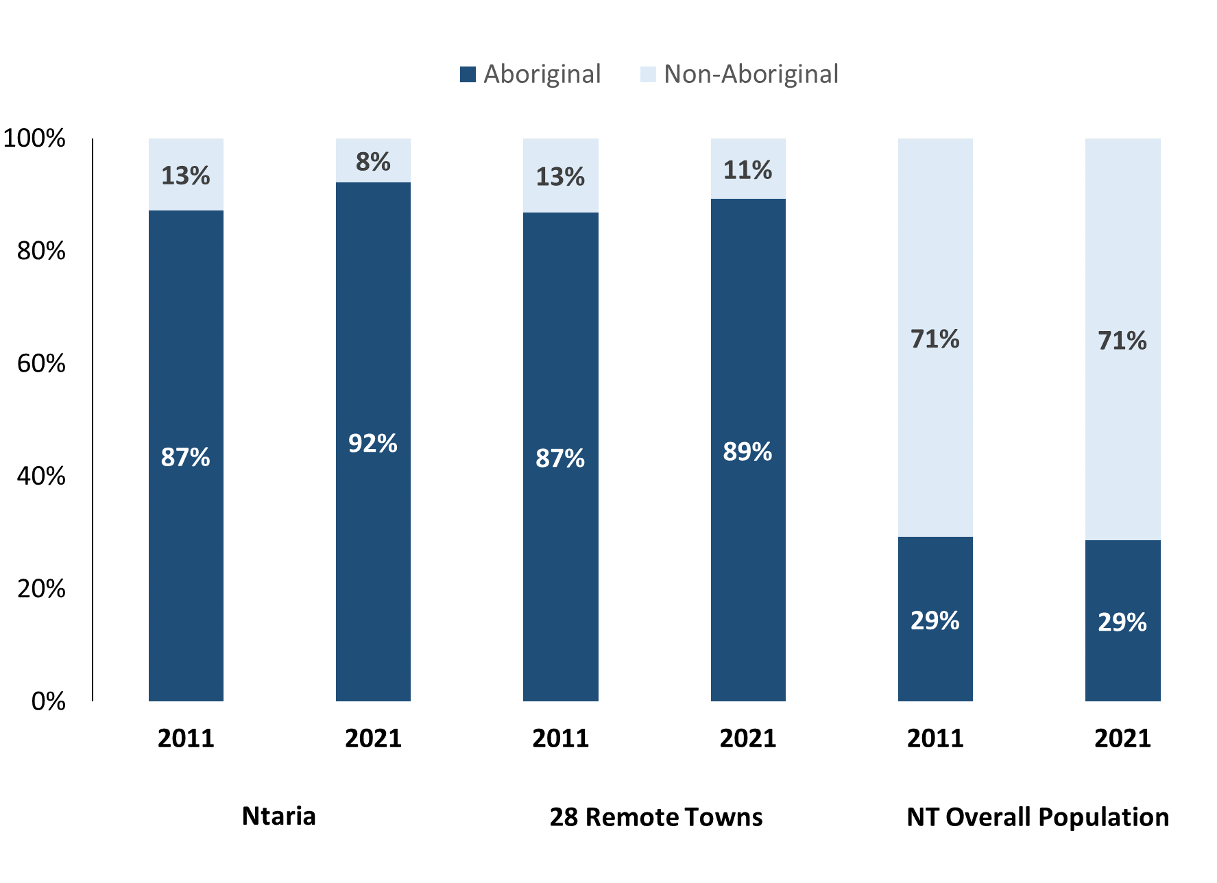

Source: Australian Bureau of Statistics

In 2021 in Ntaria (Hermannsburg):

* 92% of the population in Ntaria (Hermannsburg) were **Aboriginal**, compared to 87% in 2011
* 89% of the population across all 28 remote towns were **Aboriginal**
* 29% of the NT population were **Aboriginal**.

Table 37: Unemployment and Aboriginal participation rates (q)

|  |  |  |  |  |  |  |
| --- | --- | --- | --- | --- | --- | --- |
|  | **Ntaria (Hermannsburg)** | | | **Northern Territory** | | |
| **Aboriginal** | **Non-Aboriginal** | **Total** | **Aboriginal** | **Non-Aboriginal** | **Total** |
| **Unemployment rate** | 39.8% | 0.0% | 26.7% | 20.8% | 3.2% | 5.6% |
| **Participation rate** | 25.7% | 100.0% | 41.2% | 35.4% | 78.3% | 64.9% |

Source: Australian Bureau of Statistics

In 2021 in Ntaria (Hermannsburg) the:

* **total unemployment rate** was 26.7% compared to 5.6% for the total Northern Territory
* **Aboriginal** **unemployment rate** was 39.8% compared to 20.8% for the total Northern Territory
* **non-Aboriginal unemployment rate** was 0.0% compared to 3.2% for the total Northern Territory
* **total participation rate** was 41.2% compared to 64.9% for the total Northern Territory
* **Aboriginal participation rate** was 25.7% compared to 35.4% for the total Northern Territory
* **non-Aboriginal participation rate** was 100.0% compared to 78.3% for the total Northern Territory.

# Community Development Program

Table 38: Community Development Program Aboriginal Job Seekers, 31 Dec 2023 (o)

|  |  |  |
| --- | --- | --- |
| **Indicator** | **Aboriginal** | |
| **No.** | **%** |
| **Total Aboriginal Job Seekers** | **232** | **N/A** |
| **Age (years)** | | |
| 15-24 | 70 | 30% |
| 25-44 | 104 | 45% |
| 45+ | 58 | 25% |
| **Total** | **232** | **100%** |
| **Gender** | | |
| Male | 118 | 51% |
| Female | 114 | 49% |
| **Total** | **232** | **100%** |
| **Employment Outcome - 1 January 2023 to 31 December 2023** | | |
| 13 Weeks | 26 | N/A |
| 26 Weeks | <20 | N/A |

*Source: Department of Prime Minister and Cabinet*

Chart 14: Community Development Program Aboriginal Job Seekers by Gender and Age Group, 31 December 2023 (o)

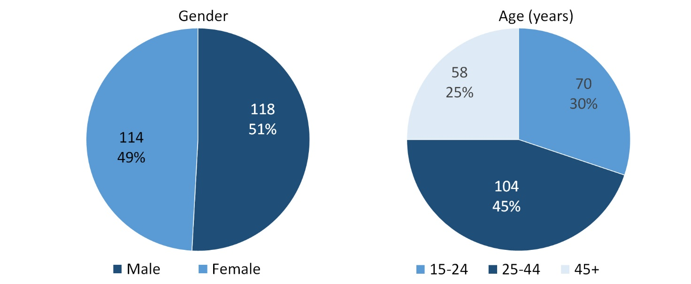

*Source: Department of Prime Minister and Cabinet*

As of 31 December 2023, in Ntaria (Hermannsburg) there were 232 CDP **Aboriginal** job seekers, of these:

* 118 (51%) were male and 114 (49%) were female
* 70 (30%) were aged 15-24 years, 104 (45%) were aged 25-44 years, and 58 (25%) were aged 45+ years
* between 1 January 2023 to 31 December 2023, 26 had reached the 13-week reporting milestone and less than 20 had reached the 26-week reporting milestone.

# Businesses

Table 39: Businesses by sector (d)(s)

| **Business Name** | **Reported on in 2011** | **Reported on in 2014** | **Reported on in 2017** | **Reported on in 2023** |
| --- | --- | --- | --- | --- |
| Public Sector | | | | |
| Batchelor Institute of Aboriginal Tertiary Education (BIITE) | Yes | No | No | No |
| **Department of Education** | Yes | Yes | Yes | **Yes** |
| **Department of Health** | Yes | Yes | Yes | **Yes** |
| Department of Human Services trading as Centrelink | Yes | Yes | Yes | No |
| Department of Justice (DoJ) | Yes | No | No | No |
| Department of the Prime Minister and Cabinet | Yes | Yes | Yes | No |
| MacDonnell Regional Council | Yes | Yes | Yes | No |
| **National Indigenous Australians Agency** | No | No | No | **Yes** |
| Ntaria School Council | Yes | No | No | No |
| **Northern Territory Police, Fire Emergency Services** | Yes | Yes | Yes | **Yes** |
| **Territory Families** | Yes | Yes | Yes | **Yes** |
| Private Sector | | | | |
| Australian Regional and Remote Community Services Ltd | No | Yes | Yes | No |
| Bethlehem Lutheran Church Hermannsburg | Yes | No | No | No |
| **Central Land Council** | Yes | Yes | Yes | **Yes** |
| **Finke River Mission** (including stores and services) | Yes | Yes | No | **Yes** |
| Finke River Mission of Lutheran Church of Australia - Finke River Mission Store | No | Yes | Yes | No |
| FRM Services Limited | No | Yes | Yes | No |
| **Hermannsburg Potters Aboriginal Inc** | Yes | Yes | Yes | **Yes** |
| **Ntaria Supermarket** | Yes | Yes | Yes | **Yes** |
| Into the Blue | Yes | No | No | No |
| Kata-Anga Tearooms | Yes | No | No | No |
| Lutheran Community Care | Yes | Yes | No | No |
| Ngurratjuta Aboriginal Corporation | No | Yes | No | No |
| Ninti One Ltd | Yes | No | No | No |
| Ntaria Cleaning Services | Yes | No | No | No |
| Ntaria Women's Safe Place | Yes | Yes | No | No |
| Steps Group Australia Limited | No | Yes | Yes | No |
| Tjuwanpa Outstation Resource Centre Aboriginal Corporation | Yes | Yes | Yes | No |
| Uniting Church of Australia Frontier Services | Yes | No | No | No |
| **WANTA Aboriginal Corporation** | No | No | No | **Yes** |
| Western Aranda Health Aboriginal Corporation | Yes | Yes | Yes | No |
| Western Desert Dialysis | No | No | Yes | No |

*Source: Northern Territory Department of Industry, Tourism and Trade*

*Note: Business names captured across the four survey periods have been identified by the current Australian Business Number name listed as of 2023.*

In 2023 in Ntaria (Hermannsburg):

* there were 10 businesses reported on, of which:
  + 5 businesses were from the Public Sector (50%)
  + 5 businesses were from the Private Sector (50%)
* there were 2 businesses operating that were not operating in 2017.

# Notes

1. These counts represent numbers of filled jobs and not the number of people. As such the totals represent the total number of filled jobs, not the total number of employees. This count is not directly comparable to the total number of employed people as a person may have several jobs or one job may be shared by more than one person.
2. Full-time is defined as a job usually requiring 35 hours or more per week or that required 35 hours or more work during the reference week. Part-time is defined as a job usually requiring less than 35 hours per week or that required less than 35 hours work during the reference week. The reference week refers to the period that respondents were asked to provide information about. In most instances it would be the week prior to the week the questionnaire was completed. Questionnaires were predominantly conducted in June and July.
3. Care needs to be taken when analysing the counts of filled jobs by Aboriginal people. Aboriginality was reported by the business representative completing the questionnaire.
4. Sector was classified using the Standard Economic Sector of Classifications of Australia (SESCA), 2008.
5. Job permanency is classified according to what the business believes the level of job permanency is based on guidelines provided by data collectors. Those guidelines state a permanent job has paid annual and/or sick leave entitlements while a temporary job includes casual and fixed-term contract jobs.
6. Classified according to the Australian and New Zealand Standard Classification of Occupations (ANZSCO), 2006, major occupation level.
7. Other Occupations include jobs where occupation was not stated, not known or inadequately described.
8. Classified using the Australian and New Zealand Standard Industrial Classification (ANZSIC), 2006, division level.
9. Care needs to be taken when analysing the counts of filled jobs by the gender of people in the jobs. The gender of the person employed in a job is reported by the business representative completing the questionnaire.
10. Care needs to be taken when analysing the counts of filled jobs by the age of people in the jobs. The age of the person employed in a job is reported by the business representative completing the questionnaire.
11. Students represent the number of individual clients that enrolled in a Vocational Education and Training unit during the calendar year.
12. Unit enrolments represent the count of individual units that students enrolled in during the calendar year.
13. Nominal hours delivered is the sum of the nominal hours of the units commenced during the calendar year regardless of when the course enrolment commenced.
14. Unit completions are the count of all successfully completed units reported in the calendar year regardless of the year of commencement of the units.
15. The Community Development Program (CDP) supports job seekers in remote Australia to build skills, address barriers and contribute to their communities through a range of flexible activities. Under the CDP, job seekers with activity requirements are expected to do up to 25 hours per week of work-like activities that benefit their community. It should be noted that some CDP participants may be reported on within the profile if they are attached to a filled position with an employer captured in the survey. Due to confidentiality issues, data below 20 people is not published.
16. Population estimates for both 2011 and 2021 are taken from the estimated resident population (ERP) data produced by the Australian Bureau of Statistics (ABS) and based on Australian Statistical Geography Standard (ASGS) Statistical Area Level 1 (SA1) regions. ERP are official estimates of the Australian population, which link people to a place of usual residence with Australia. All ERP data sources, including the Census of Population and Housing (Census), are subject to error (including inaccuracies in collection, recording and processing data) and should be used with caution.
17. Indigenous population proportions, unemployment and workforce participation rates are based on ABS Census counts at ASGS Indigenous Locations (ILOCs) for each remote town.
18. Working-age population includes all residents aged 15 years and over (commonly referred to as the civilian population) and consists of people that are employed, unemployed or not in the labour force.
19. A ‘business’ has been defined as any organisation that has undertaken productive activities in the last year, including companies, non-profit organisations, government departments and enterprises operating within the designated remote geography (town), and has one or more employees in paid employment and an Australian Business Number (ABN).

# Abbreviations and Acronyms

ABN Australian Business Number

ABS Australian Bureau of Statistics

ANZSCO Australian and New Zealand Standard Classification of Occupations

ANZSIC Australian and New Zealand Standard Industrial Classification

ASGS Australian Statistical Geography Standard

CDP Community Development Program

ERP Estimated Resident Population

ILOC Indigenous Locations

nec Not Elsewhere Classified

No. Number

Perm Permanent

ppt Percentage point

RJCP Remote Jobs and Communities Program

Temp Temporary

SA1 Statistical Area Level 1

VET Vocational Education and Training

1. The number of filled jobs does not represent numbers of people as a person may have several jobs or one job may be shared by more than one person.