Mineral Titles Act
NOTICE OF GRANT OF A MINERAL TITLE
Title Type and Number: | Exploration Licence 25384
Granted: | 04 February 2025, for a period of 6 Years
Area: | 94 Blocks, 266.01 km²
Locality: | WELLINGTON RANGE
Name of Holder/s: | 100% G E RESOURCES PTY LTD [ACN. 096 473 737]
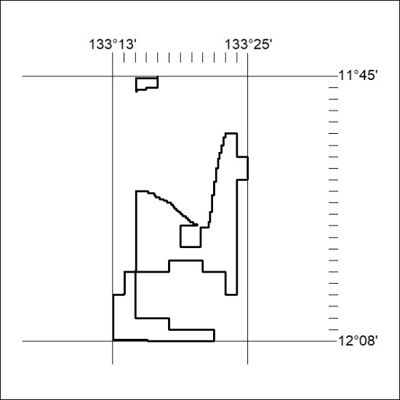
Area granted is indicated above. The titleholder is not permitted to exercise occupational rights on any land that is subject to a development title, or an application for a development title. Any land the subject of a Reserved Land gazettal under the Mineral Titles Act and all land vested in the Commonwealth of Australia is also excluded by description but not excised from the grant area.
49/25

Mineral Titles Act
NOTICE OF GRANT OF A MINERAL TITLE
Title Type and Number: | Exploration Licence 29897
Granted: | 04 February 2025, for a period of 6 Years
Area: | 16 Blocks, 24.96 km²
Locality: | WELLINGTON RANGE
Name of Holder/s: | 100% G E RESOURCES PTY LTD [ACN. 096 473 737]
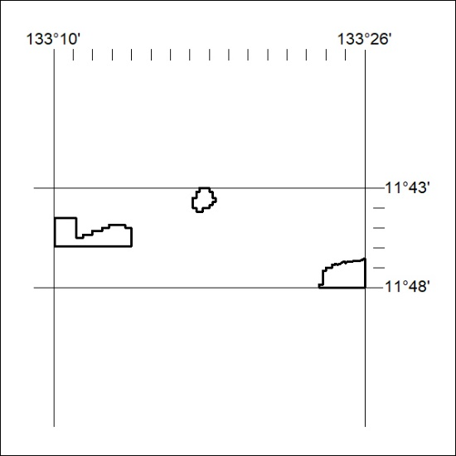
Area granted is indicated above. The titleholder is not permitted to exercise occupational rights on any land that is subject to a development title, or an application for a development title. Any land the subject of a Reserved Land gazettal under the Mineral Titles Act and all land vested in the Commonwealth of Australia is also excluded by description but not excised from the grant area.
50/25

