Mineral Titles Act 2010
NOTICE OF LAND CEASING TO BE A MINERAL TITLE AREA
Title Type and Number: | Exploration Licence 25194
Area Ceased on: | 21 January 2025
Area: | 34 Blocks, 107.46 km²
Locality: | McFARLANE
Name of Applicant(s)/Holder(s): | 100% PRODIGY GOLD NL* [ACN. 009 127 020]
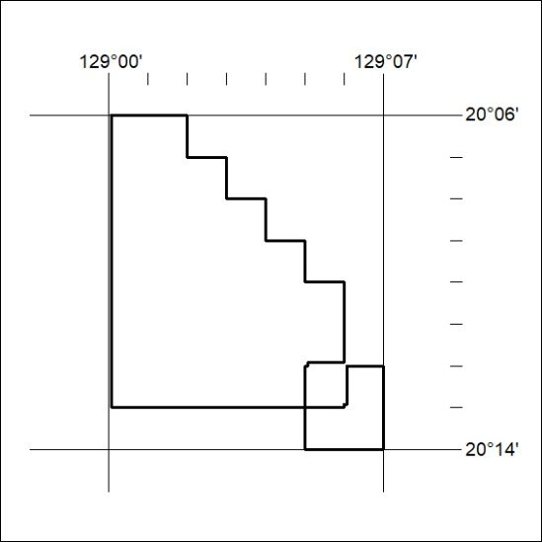

32/25

Mineral Titles Act 2010
NOTICE OF LAND CEASING TO BE A MINERAL TITLE AREA
Title Type and Number: | Exploration Licence 26608
Area Ceased on: | 21 January 2025
Area: | 1 Block, 3.23 km²
Locality: | PARGEE
Name of Applicant(s)/Holder(s): | 100% PRODIGY GOLD NL* [ACN. 009 127 020]
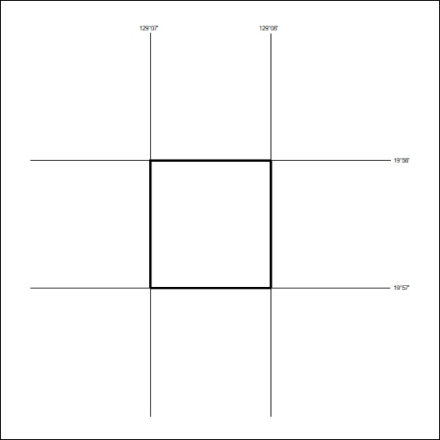

33/25

Mineral Titles Act 2010
NOTICE OF LAND CEASING TO BE A MINERAL TITLE AREA
Title Type and Number: | Exploration Licence 26610
Area Ceased on: | 21 January 2025
Area: | 1 Block, 3.23 km²
Locality: | PARGEE
Name of Applicant(s)/Holder(s): | 100% PRODIGY GOLD NL* [ACN. 009 127 020]
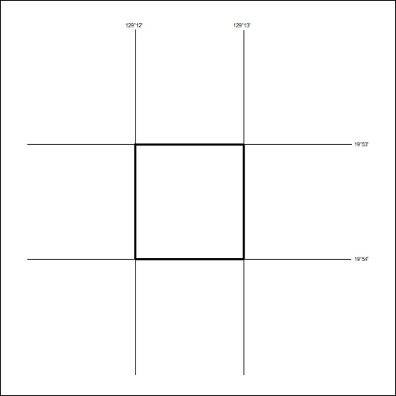

34/25

Mineral Titles Act 2010
NOTICE OF LAND CEASING TO BE A MINERAL TITLE AREA
Title Type and Number: | Exploration Licence 27378
Area Ceased on: | 21 January 2025
Area: | 21 Blocks, 67.01 km²
Locality: | McFARLANE
Name of Applicant(s)/Holder(s): | 100% PRODIGY GOLD NL* [ACN. 009 127 020]
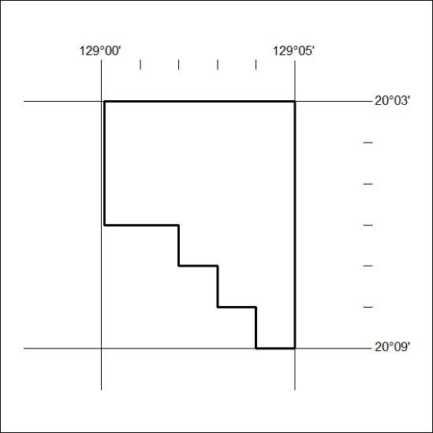

35/25

Mineral Titles Act 2010
NOTICE OF LAND CEASING TO BE A MINERAL TITLE AREA
Title Type and Number: | Exploration Licence 28324
Area Ceased on: | 21 January 2025
Area: | 18 Blocks, 58.00 km²
Locality: | McFARLANE
Name of Applicant(s)/Holder(s): | 100% PRODIGY GOLD NL* [ACN. 009 127 020]
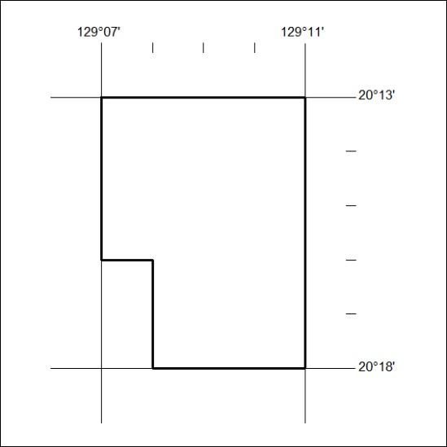
36/25

Mineral Titles Act 2010
NOTICE OF LAND CEASING TO BE A MINERAL TITLE AREA
Title Type and Number: | Exploration Licence 28328
Area Ceased on: | 21 January 2025
Area: | 33 Blocks, 104.19 km²
Locality: | PARGEE
Name of Applicant(s)/Holder(s): | 100% PRODIGY GOLD NL* [ACN. 009 127 020]
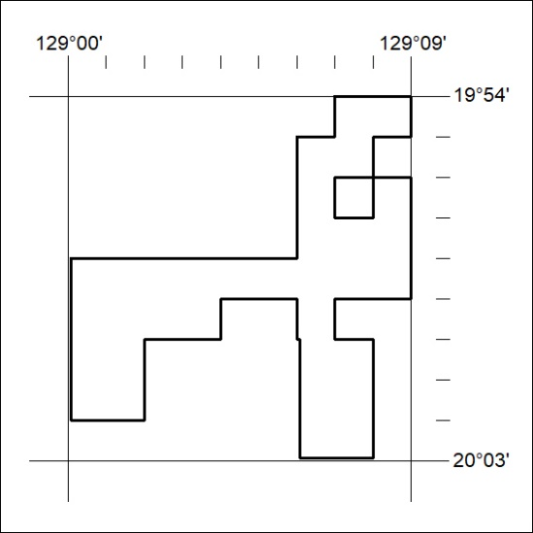
37/25

