Mineral Titles Act 2010
NOTICE OF LAND CEASING TO BE A MINERAL TITLE AREA
Title Type and Number: | Exploration Licence 33188
Area Ceased on: | 13 January 2025
Area: | 12 Blocks, 32.74 km²
Locality: | BATCHELOR
Name of Applicant(s)/Holder(s): | 100% MANGUSTA MINERALS PTY LTD [ACN. 653 950 522]
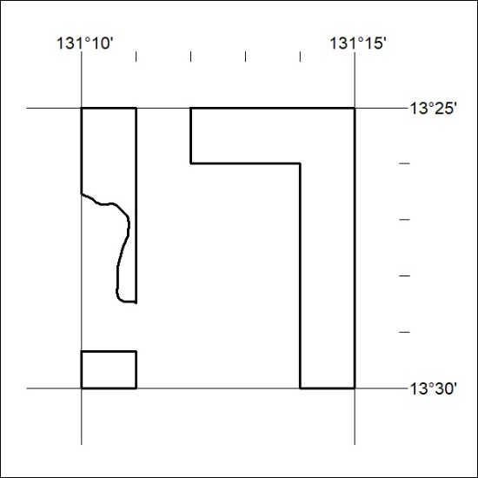
23/25

Mineral Titles Act 2010
NOTICE OF LAND CEASING TO BE A MINERAL TITLE AREA
Title Type and Number: | Mineral Lease (Northern) 1135
Area ceased on: | 19 December 2024
Area: | 240.00 Hectares
Locality: | BATCHELOR
Name of Applicants(s)Holder(s): | 100% NT MINING OPERATIONS PTY LTD* [ACN. 136 525 990]
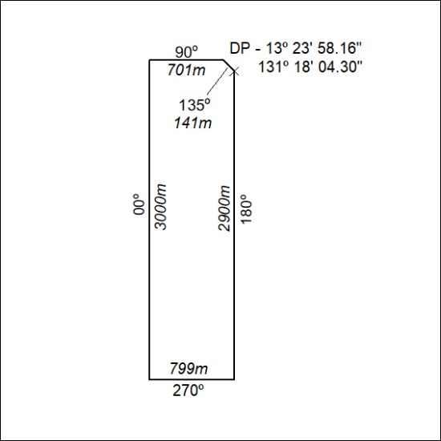
(Area now amalgamated into Mineral Lease 34046 under s102)
24/25

Mineral Titles Act 2010
NOTICE OF LAND CEASING TO BE A MINERAL TITLE AREA
Title Type and Number: | Mineral Lease (Northern) 1144
Area ceased on: | 19 December 2024
Area: | 190.00 Hectares
Locality: | BATCHELOR
Name of Applicants(s)Holder(s): | 100% NT MINING OPERATIONS PTY LTD* [ACN. 136 525 990]
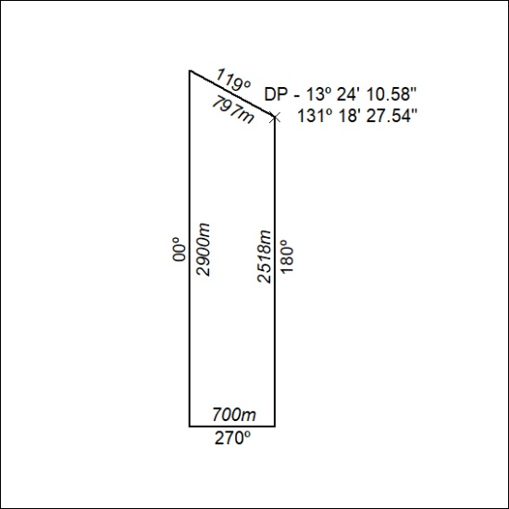
(Area now amalgamated into Mineral Lease 34046 under s102)
25/25

