Mineral Titles Act
NOTICE OF GRANT OF A MINERAL TITLE
Title Type and Number: | Extractive Mineral Permit 31293
Granted: | 22 November 2024, for a period of Years
Area: | 76.00 Hectares
Locality: | NEWRY
Name of Holder/s: | 100% DUNCAN Ruth Ann
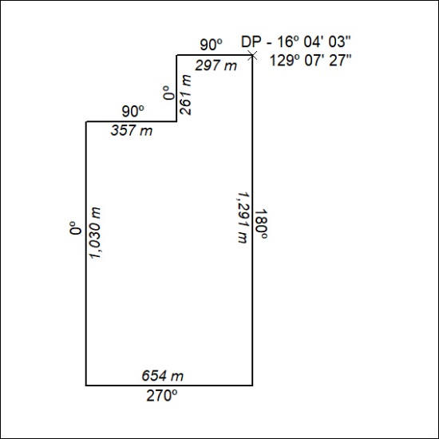

451/24

