Mineral Titles Act 2010
NOTICE OF LAND CEASING TO BE A MINERAL TITLE APPLICATION AREA
Title Type and Number: | Exploration Licence 32724
Area Ceased on: | 01 May 2024
Area: | 250 Blocks, 821.54 km²
Locality: | DUNMARRA
Name of Applicant(s)/Holder(s): | 100% BAUDIN RESOURCES PTY LTD [ACN. 618 455 593]
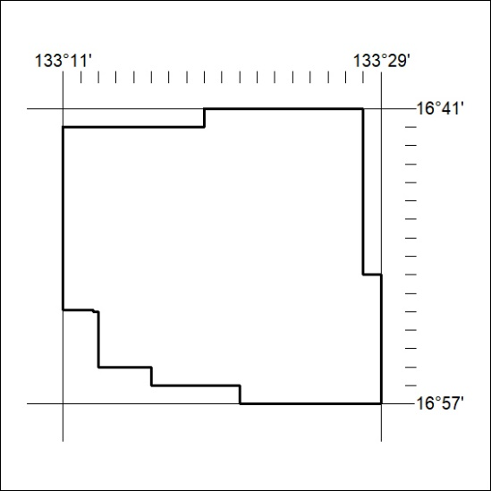
178/24

Mineral Titles Act 2010
NOTICE OF LAND CEASING TO BE A MINERAL TITLE APPLICATION AREA
Title Type and Number: | Exploration Licence 33330
Area Ceased on: | 01 May 2024
Area: | 247 Blocks, 805.76 km²
Locality: | CORELLA CREEK
Name of Applicant(s)/Holder(s): | 100% BAUDIN RESOURCES PTY LTD [ACN. 618 455 593]
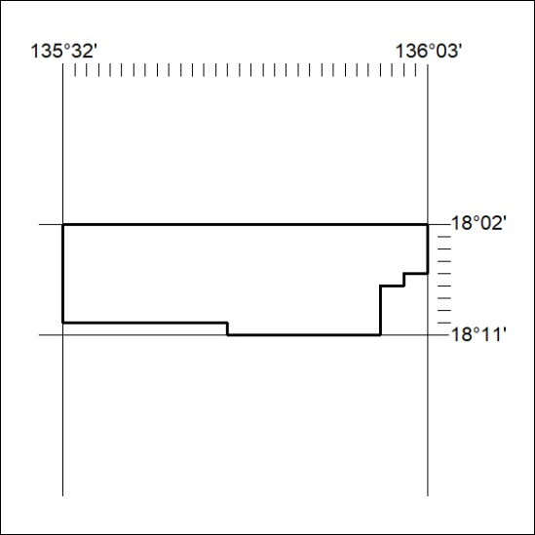
179/24

