Mineral Titles Act 2010
NOTICE OF LAND CEASING TO BE A MINERAL TITLE AREA
Title Type and Number: | Authorised Holdings (Southern) 1
Area ceased on: | 08 April 2024
Area: | 4.00 Hectare
Locality: | JAMES
Name of Applicants(s)Holder(s): | 100% GOODLUCK Joyce
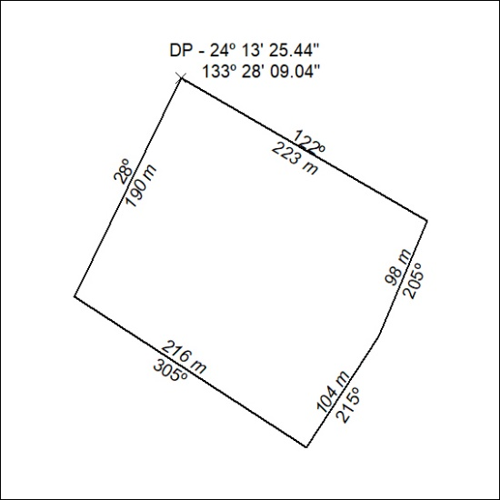

97/24

Mineral Titles Act 2010
NOTICE OF LAND CEASING TO BE A MINERAL TITLE AREA
Title Type and Number: | Exploration Licence 32117
Area Ceased on: | 08 April 2024
Area: | 100 Blocks, 317.88 km²
Locality: | ALGAMBA
Name of Applicant(s)/Holder(s): | 100% ELEMENTZONE PTY LTD [ACN. 633 108 906]
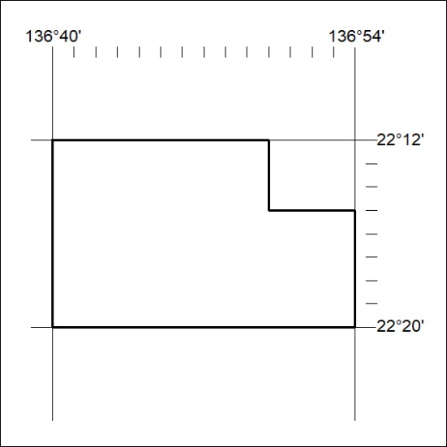

98/24

Mineral Titles Act
NOTICE OF GRANT OF A MINERAL TITLE
Title Type and Number: | Extractive Mineral Exploration Licence 33647
Granted: | 21 March 2024, for a period of 2 Years
Area: | 4 Blocks, 11.41 km²
Locality: | BYNOE
Name of Holder/s: | 100% TERRITORY QUARTZ PTY LTD [ACN. 671 474 409]
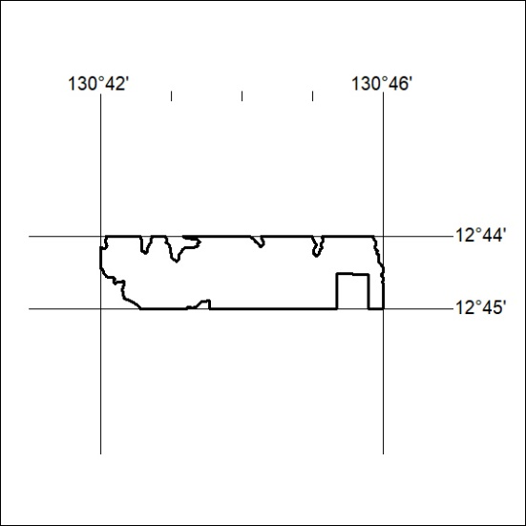
Area granted is indicated above. The titleholder is not permitted to exercise occupational rights on any land that is subject to a development title, or an application for a development title. Any land the subject of a Reserved Land gazettal under the Mineral Titles Act and all land vested in the Commonwealth of Australia is also excluded by description but not excised from the grant area.

99/24

