Mineral Titles Act 2010
NOTICE OF LAND CEASING TO BE A MINERAL TITLE APPLICATION AREA
Title Type and Number: | Mineral Lease 32093
Area ceased on: | 11 March 2024
Area: | 3.00 Hectare
Locality: | PINE CREEK
Name of Applicants(s)Holder(s): | 100% GMG MINING (NT) PTY LTD [ACN. 634 618 410]
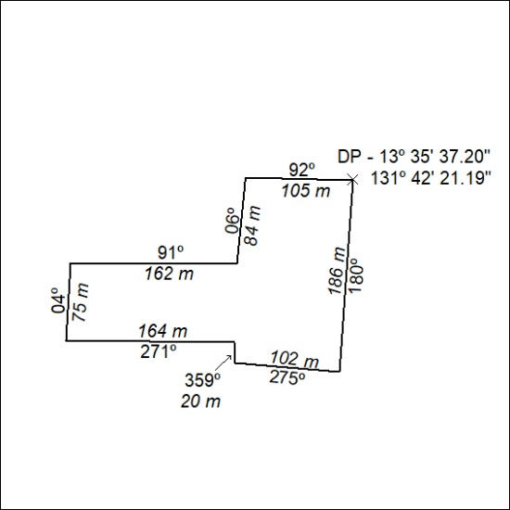

58/24

