Mineral Titles Act 2010
NOTICE OF LAND CEASING TO BE A MINERAL TITLE AREA
Title Type and Number: | Exploration Licence 32039
Area Ceased on: | 06 March 2024
Area: | 180 Blocks, 592.11 km²
Locality: | WARRAMBAN
Name of Applicant(s)/Holder(s): | 100% PENNANT RESOURCES PTY LTD [ACN. 150 501 492]
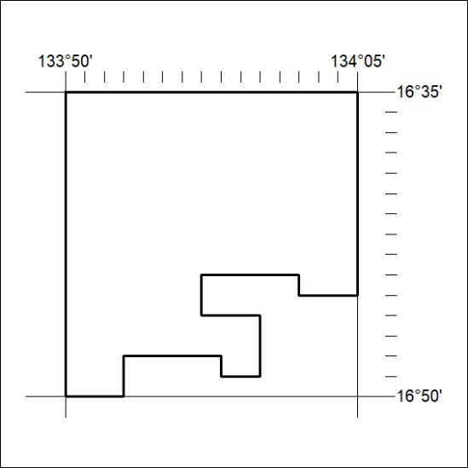

51/24

Mineral Titles Act 2010
NOTICE OF LAND CEASING TO BE A MINERAL TITLE AREA
Title Type and Number: | Exploration Licence 33394
Area Ceased on: | 28 February 2024
Area: | 16 Blocks, 50.55 km²
Locality: | RIDDOCH
Name of Applicant(s)/Holder(s): | 100% IGO NEWSEARCH PTY LTD [ACN. 142 192 701]
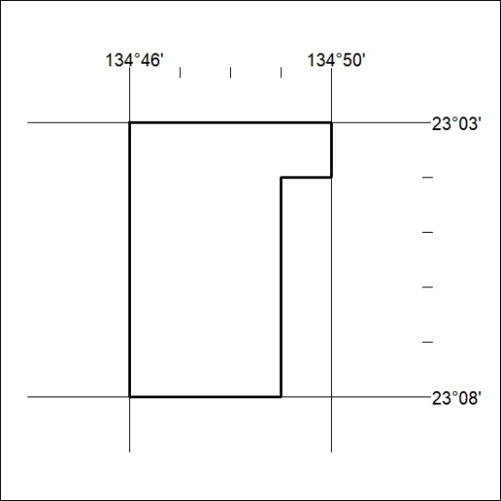
(Area now amalgamated into Exploration Licence 33694 under s102 – EL moratorium period does not apply)

52/24
Mineral Titles Act 2010
NOTICE OF LAND CEASING TO BE A MINERAL TITLE AREA
Title Type and Number: | Exploration Licence 33469
Area Ceased on: | 28 February 2024
Area: | 175 Blocks, 510.13 km²
Locality: | DELNY
Name of Applicant(s)/Holder(s): | 100% IGO NEWSEARCH PTY LTD [ACN. 142 192 701]
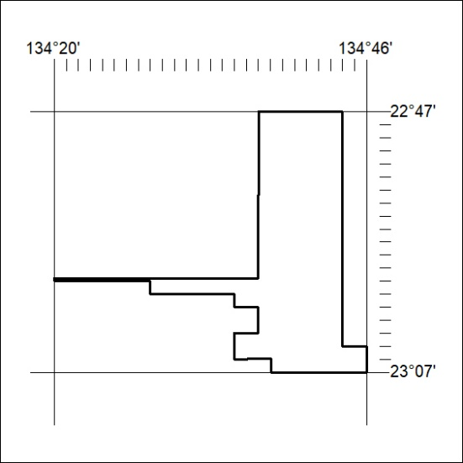
(Area now amalgamated into Exploration Licence 33694 under s102 – EL moratorium period does not apply)

53/24

