Mineral Titles Act 2010
NOTICE OF LAND CEASING TO BE A MINERAL TITLE AREA
Title Type and Number: | Exploration Licence 25748
Area Ceased on: | 16 January 2024
Area: | 179 Blocks, 584.45 km²
Locality: | BATCHELOR
Name of Applicant(s)/Holder(s): | 90% PNX METALS LIMITED* [ACN. 127 446 271], 10% NT MINING OPERATIONS PTY LTD* [ACN. 136 525 990]
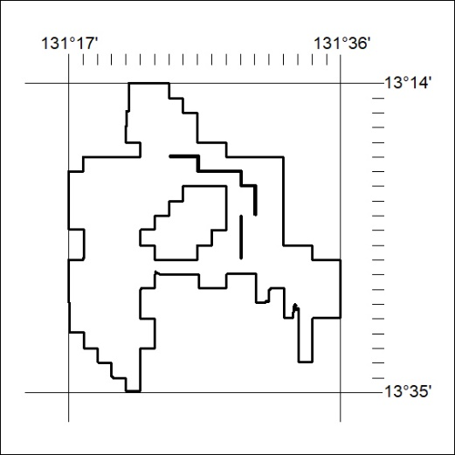
(Area now amalgamated into Exploration Licence 33713 under s102 – EL moratorium period does not apply)

13/24

Mineral Titles Act 2010
NOTICE OF LAND CEASING TO BE A MINERAL TITLE AREA
Title Type and Number: | Exploration Licence 33502
Area Ceased on: | 16 January 2024
Area: | 12 Blocks, 3.00 km²
Locality: | McKINLAY RIVER
Name of Applicant(s)/Holder(s): | 90% PNX METALS LIMITED* [ACN. 127 446 271], 10% NT MINING OPERATIONS PTY LTD* [ACN. 136 525 990]
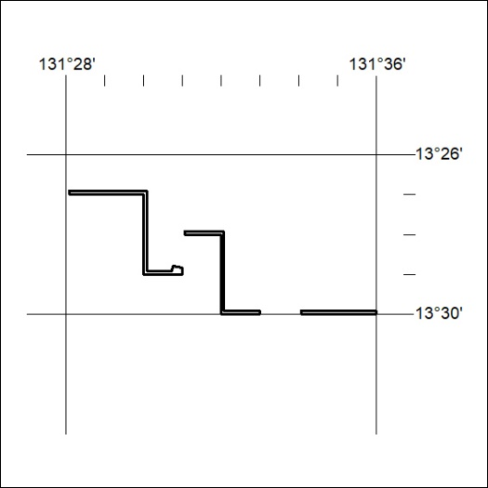
(Area now amalgamated into Exploration Licence 33713 under s102 – EL moratorium period does not apply)

14/24
Mineral Titles Act 2010
NOTICE OF LAND CEASING TO BE A MINERAL TITLE AREA
Title Type and Number: | Exploration Licence 33503
Area Ceased on: | 16 January 2024
Area: | 19 Blocks, 4.39 km²
Locality: | BATCHELOR
Name of Applicant(s)/Holder(s): | 90% PNX METALS LIMITED* [ACN. 127 446 271], 10% NT MINING OPERATIONS PTY LTD* [ACN. 136 525 990]
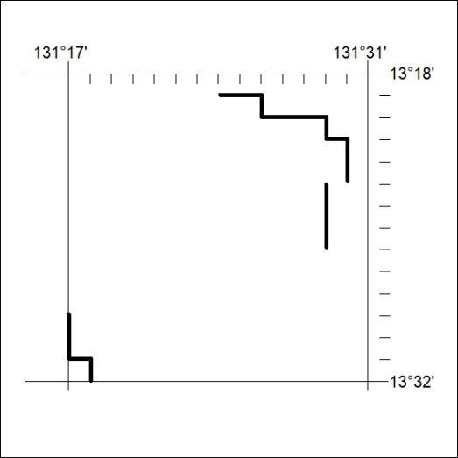
(Area now amalgamated into Exploration Licence 33713 under s102 – EL moratorium period does not apply)

15/24

