Mineral Titles Act 2010
NOTICE OF LAND CEASING TO BE A MINERAL TITLE AREA
Title Type and Number: | Exploration Licence 32709
Area Ceased on: | 27 October 2023
Area: | 127 Blocks, 412.95 km²
Locality: | BRUNETTE
Name of Applicant(s)/Holder(s): | 100% RED METAL LIMITED [ACN. 103 367 684]
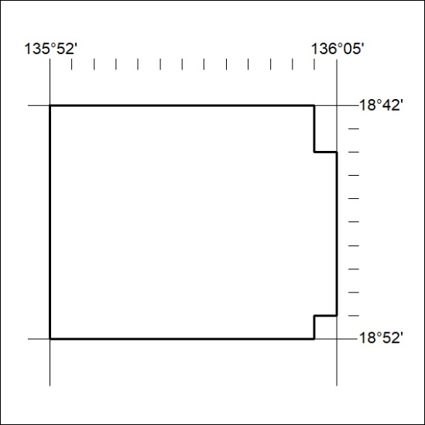

448/23

Mineral Titles Act 2010
NOTICE OF LAND CEASING TO BE A MINERAL TITLE AREA
Title Type and Number: | Exploration Licence 32710
Area Ceased on: | 27 October 2023
Area: | 180 Blocks, 577.70 km²
Locality: | BRUNETTE
Name of Applicant(s)/Holder(s): | 100% RED METAL LIMITED [ACN. 103 367 684]
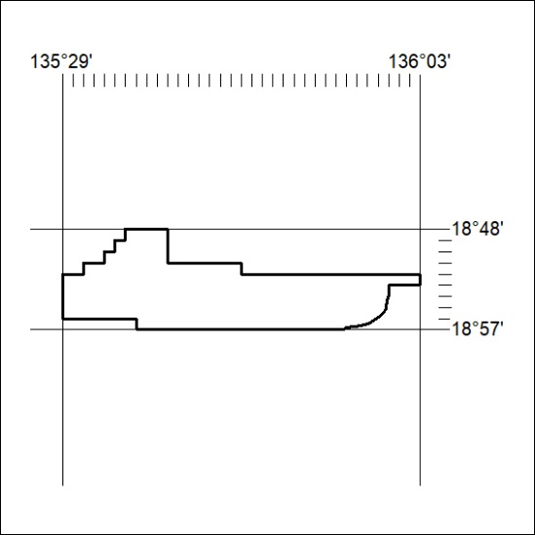

449/23
Mineral Titles Act 2010
NOTICE OF LAND CEASING TO BE A MINERAL TITLE AREA
Title Type and Number: | Exploration Licence 32714
Area Ceased on: | 27 October 2023
Area: | 86 Blocks, 279.49 km²
Locality: | ROCKHAMPTON DOWNS
Name of Applicant(s)/Holder(s): | 100% RED METAL LIMITED [ACN. 103 367 684]
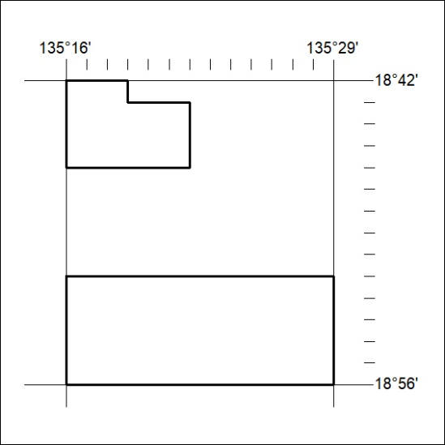

450/23

