Mineral Titles Act 2010
NOTICE OF LAND CEASING TO BE A MINERAL TITLE AREA
Title Type and Number: | Exploration Licence 26592
Area Ceased on: | 05 October 2023
Area: | 4 Blocks, 12.87 km²
Locality: | GRANITES
Name of Applicant(s)/Holder(s): | 100% PRODIGY GOLD NL* [ACN. 009 127 020]
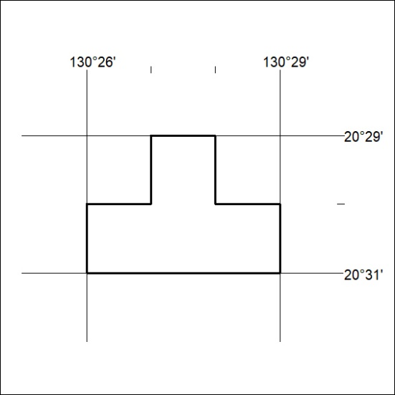

411/23

Mineral Titles Act 2010
NOTICE OF LAND CEASING TO BE A MINERAL TITLE AREA
Title Type and Number: | Exploration Licence 26593
Area Ceased on: | 05 October 2023
Area: | 27 Blocks, 86.97 km²
Locality: | DAVIDSON
Name of Applicant(s)/Holder(s): | 100% PRODIGY GOLD NL* [ACN. 009 127 020]
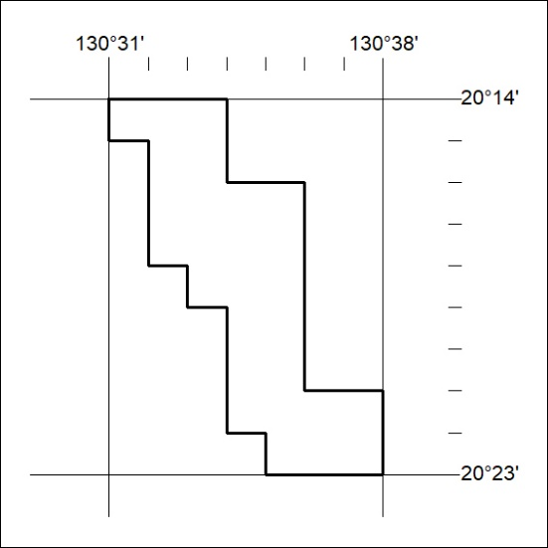

412/23
Mineral Titles Act 2010
NOTICE OF LAND CEASING TO BE A MINERAL TITLE AREA
Title Type and Number: | Exploration Licence 26621
Area Ceased on: | 05 October 2023
Area: | 10 Blocks, 32.16 km²
Locality: | GRANITES
Name of Applicant(s)/Holder(s): | 100% PRODIGY GOLD NL* [ACN. 009 127 020]
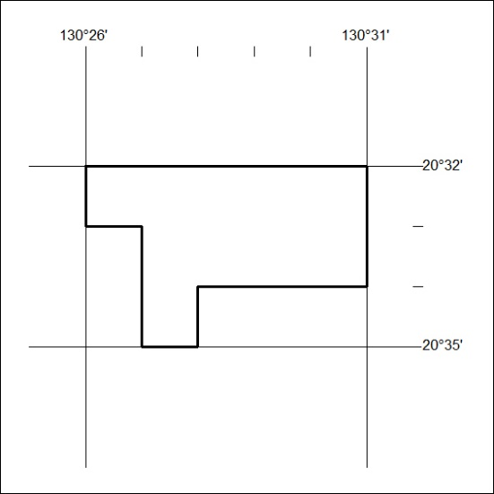

413/23

Mineral Titles Act 2010
NOTICE OF LAND CEASING TO BE A MINERAL TITLE AREA
Title Type and Number: | Exploration Licence 26622
Area Ceased on: | 05 October 2023
Area: | 6 Blocks, 19.31 km²
Locality: | DAVIDSON
Name of Applicant(s)/Holder(s): | 100% PRODIGY GOLD NL* [ACN. 009 127 020]
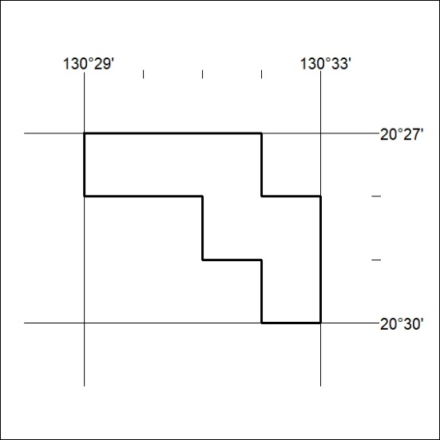

414/23
Mineral Titles Act 2010
NOTICE OF LAND CEASING TO BE A MINERAL TITLE AREA
Title Type and Number: | Exploration Licence 27604
Area Ceased on: | 05 October 2023
Area: | 14 Blocks, 45.02 km²
Locality: | GRANITES
Name of Applicant(s)/Holder(s): | 100% PRODIGY GOLD NL* [ACN. 009 127 020]
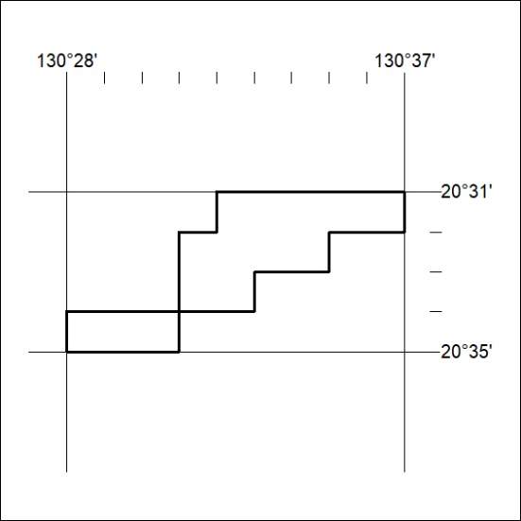

415/23

Mineral Titles Act 2010
NOTICE OF LAND CEASING TO BE A MINERAL TITLE APPLICATION AREA
Title Type and Number: | Exploration Licence 33481
Area Ceased on: | 05 October 2023
Area: | 185 Blocks, 592.88 km²
Locality: | ELKEDRA
Name of Applicant(s)/Holder(s): | 100% WESTURA ENERGY PTY LTD [ACN. 662 539 200]
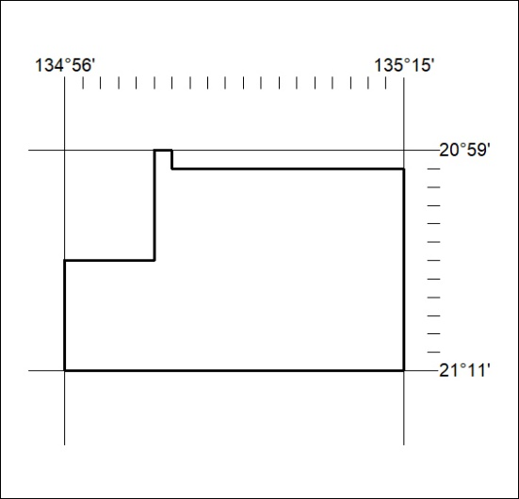

416/23

