Mineral Titles Act 2010
NOTICE OF LAND CEASING TO BE A MINERAL TITLE AREA
Title Type and Number: | Exploration Licence 32299
Area Ceased on: | 02 October 2023
Area: | 60 Blocks, 194.43 km²
Locality: | ALROY
Name of Applicant(s)/Holder(s): | 100% NEWCREST OPERATIONS LIMITED [ACN. 009 221 505]
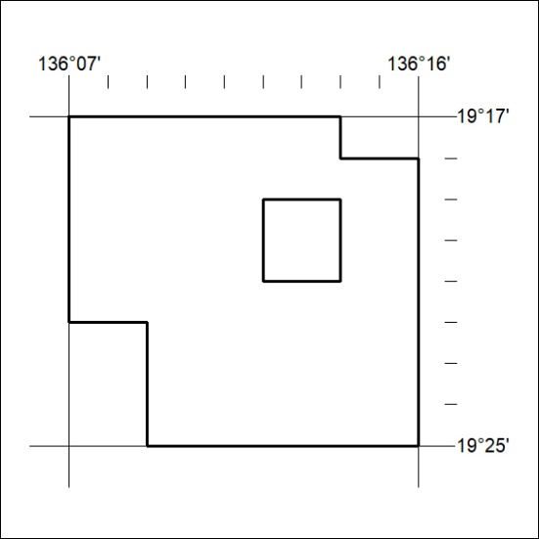
(Area now amalgamated into Exploration Licence 33591 under s102 – EL moratorium period does not apply)

396/23

Mineral Titles Act 2010
NOTICE OF LAND CEASING TO BE A MINERAL TITLE AREA
Title Type and Number: | Exploration Licence 32300
Area Ceased on: | 02 October 2023
Area: | 80 Blocks, 259.44 km²
Locality: | ALROY
Name of Applicant(s)/Holder(s): | 100% NEWCREST OPERATIONS LIMITED [ACN. 009 221 505]
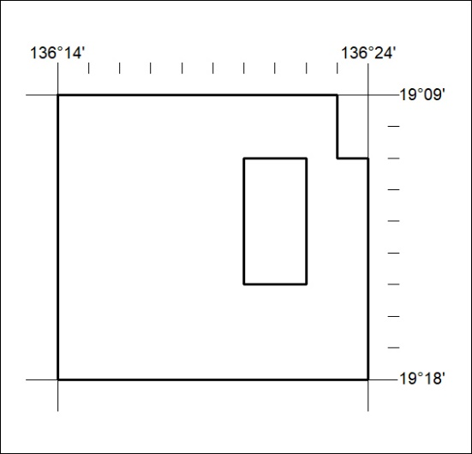
(Area now amalgamated into Exploration Licence 33591 under s102 – EL moratorium period does not apply)

397/23
Mineral Titles Act 2010
NOTICE OF LAND CEASING TO BE A MINERAL TITLE AREA
Title Type and Number: | Exploration Licence 32303
Area Ceased on: | 02 October 2023
Area: | 151 Blocks, 488.70 km²
Locality: | DALMORE
Name of Applicant(s)/Holder(s): | 100% NEWCREST OPERATIONS LIMITED [ACN. 009 221 505]
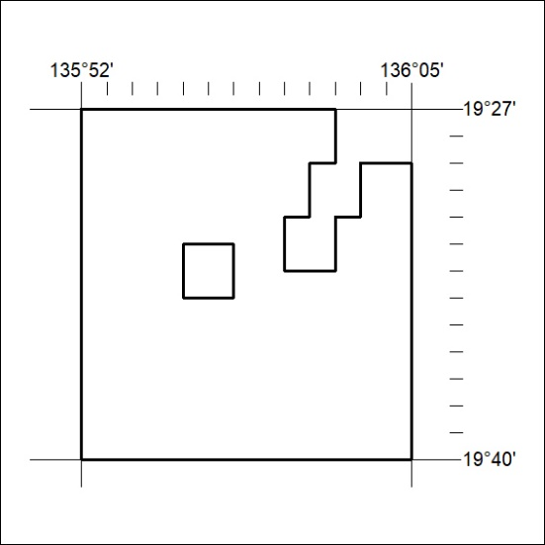
(Area now amalgamated into Exploration Licence 33592 under s102 – EL moratorium period does not apply)

398/23

Mineral Titles Act 2010
NOTICE OF LAND CEASING TO BE A MINERAL TITLE AREA
Title Type and Number: | Exploration Licence 32810
Area Ceased on: | 02 October 2023
Area: | 8 Blocks, 25.89 km²
Locality: | WONARAH
Name of Applicant(s)/Holder(s): | 100% NEWCREST OPERATIONS LIMITED [ACN. 009 221 505]
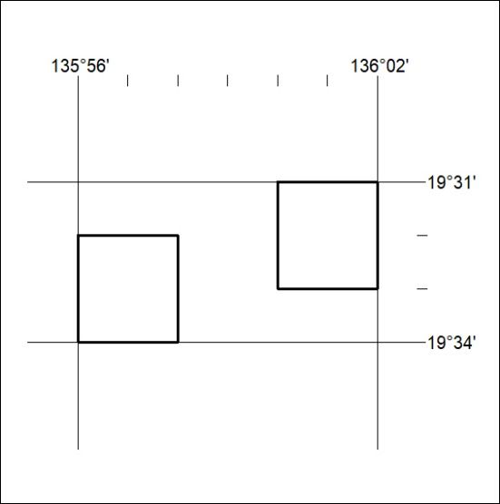
(Area now amalgamated into Exploration Licence 33592 under s102 – EL moratorium period does not apply)

399/23
Mineral Titles Act 2010
NOTICE OF LAND CEASING TO BE A MINERAL TITLE AREA
Title Type and Number: | Exploration Licence 32811
Area Ceased on: | 02 October 2023
Area: | 12 Blocks, 38.91 km²
Locality: | ALROY
Name of Applicant(s)/Holder(s): | 100% NEWCREST OPERATIONS LIMITED [ACN. 009 221 505]
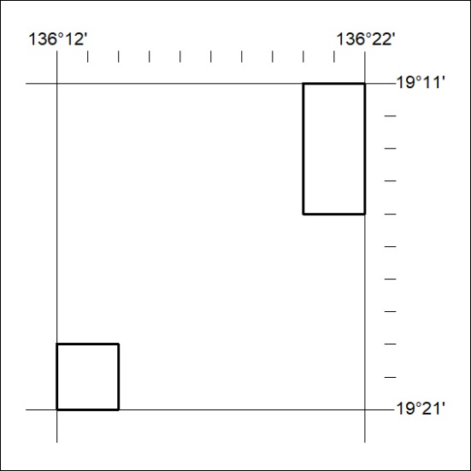
(Area now amalgamated into Exploration Licence 33591 under s102 – EL moratorium period does not apply)

400/23

Mineral Titles Act 2010
NOTICE OF LAND CEASING TO BE A MINERAL TITLE APPLICATION AREA
Title Type and Number: | Exploration Licence 33578
Area Ceased on: | 28 September 2023
Area: | 16 Blocks, 53.37 km²
Locality: | PINE CREEK
Name of Applicant(s)/Holder(s): | 100% CONSTRUCTION 101 PTY LTD [ACN. 622 542 045]
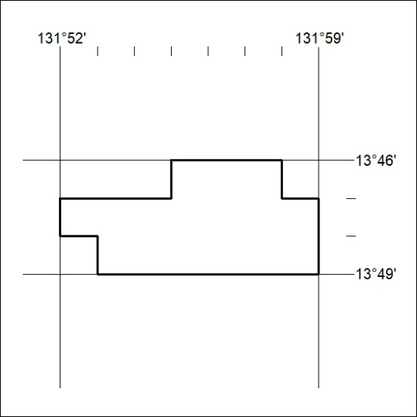

401/23
Mineral Titles Act 2010
NOTICE OF LAND CEASING TO BE A MINERAL TITLE APPLICATION AREA
Title Type and Number: | Exploration Licence 33583
Area Ceased on: | 28 September 2023
Area: | 16 Blocks, 53.37 km²
Locality: | PINE CREEK
Name of Applicant(s)/Holder(s): | 100% GMG MINING (NT) PTY LTD [ACN. 634 618 410]

402/23

Mineral Titles Act
NOTICE OF GRANT OF A MINERAL TITLE
Title Type and Number: | Extractive Mineral Permit 31670
Granted: | 29 September 2023, for a period of 5 Years
Area: | 85.00 Hectares
Locality: | NOONAMAH
Name of Holder/s: | 100% YEBNA SANDS PTY LTD [ACN. 606 114 603]
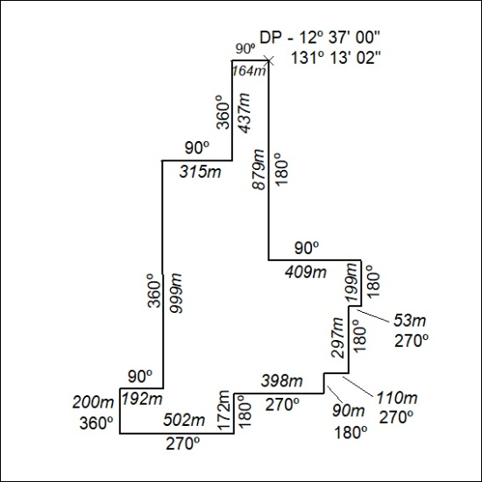

403/23

Mineral Titles Act
NOTICE OF GRANT OF A MINERAL TITLE
Title Type and Number: | Extractive Mineral Permit 31674
Granted: | 29 September 2023, for a period of 5 Years
Area: | 87.00 Hectares
Locality: | NOONAMAH
Name of Holder/s: | 100% YEBNA SANDS PTY LTD [ACN. 606 114 603]
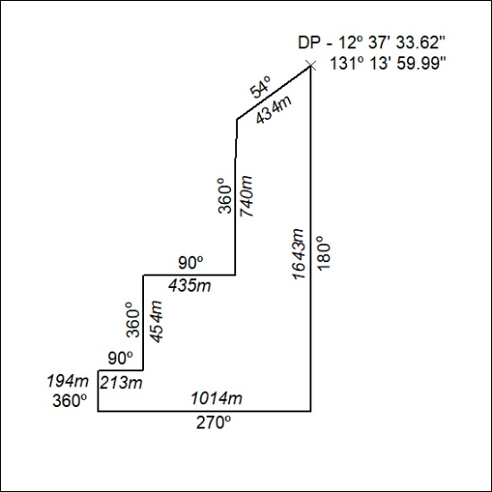

404/23

Mineral Titles Act
NOTICE OF GRANT OF A MINERAL TITLE
Title Type and Number: | Extractive Mineral Permit 31675
Granted: | 29 September 2023, for a period of 5 Years
Area: | 98.00 Hectares
Locality: | NOONAMAH
Name of Holder/s: | 100% YEBNA SANDS PTY LTD [ACN. 606 114 603]
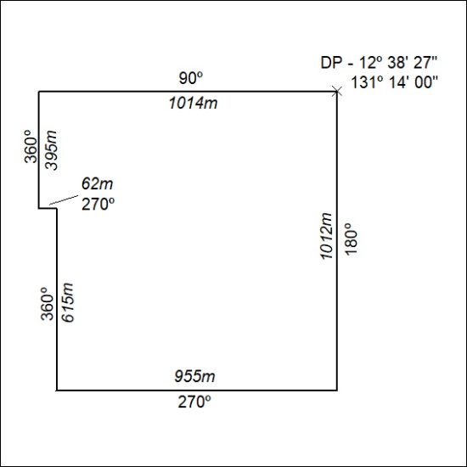

405/23

Mineral Titles Act
NOTICE OF GRANT OF A MINERAL TITLE
Title Type and Number: | Extractive Mineral Exploration Licence 33523
Granted: | 29 September 2023, for a period of 2 Years
Area: | 4 Blocks, 13.18 km²
Locality: | BAUHINIA DOWNS
Name of Holder/s: | 100% EAST ARM CIVIL PTY LTD [ACN. 073 382 251]
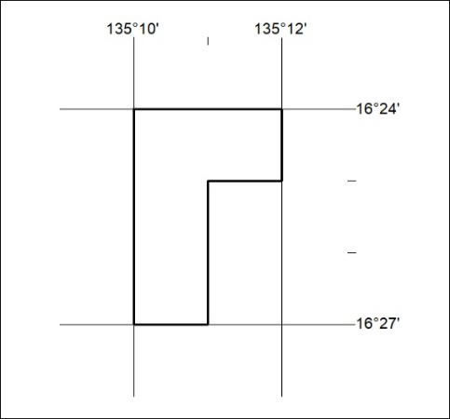
Area granted is indicated above. The titleholder is not permitted to exercise occupational rights on any land that is subject to a development title, or an application for a development title. Any land the subject of a Reserved Land gazettal under the Mineral Titles Act and all land vested in the Commonwealth of Australia is also excluded by description but not excised from the grant area.

406/23

Mineral Titles Act
NOTICE OF GRANT OF A MINERAL TITLE
Title Type and Number: | Extractive Mineral Exploration Licence 33523
Granted: | 29 September 2023, for a period of 2 Years
Area: | 4 Blocks, 13.18 km²
Locality: | BAUHINIA DOWNS
Name of Holder/s: | 100% EAST ARM CIVIL PTY LTD [ACN. 073 382 251]
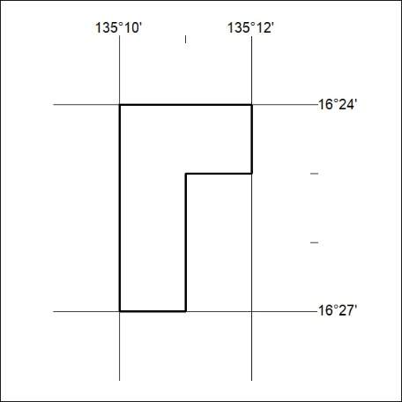
Area granted is indicated above. The titleholder is not permitted to exercise occupational rights on any land that is subject to a development title, or an application for a development title. Any land the subject of a Reserved Land gazettal under the Mineral Titles Act and all land vested in the Commonwealth of Australia is also excluded by description but not excised from the grant area.

407/23

Mineral Titles Act
NOTICE OF GRANT OF A MINERAL TITLE
Title Type and Number: | Extractive Mineral Exploration Licence 33524
Granted: | 29 September 2023, for a period of 2 Years
Area: | 4 Blocks, 13.18 km²
Locality: | BAUHINIA DOWNS
Name of Holder/s: | 100% EAST ARM CIVIL PTY LTD [ACN. 073 382 251]
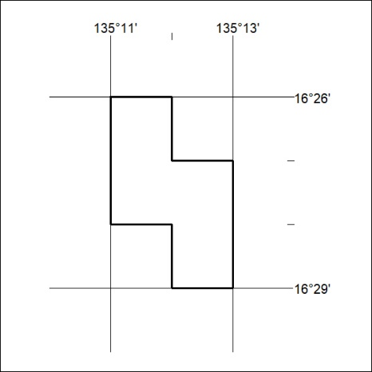
Area granted is indicated above. The titleholder is not permitted to exercise occupational rights on any land that is subject to a development title, or an application for a development title. Any land the subject of a Reserved Land gazettal under the Mineral Titles Act and all land vested in the Commonwealth of Australia is also excluded by description but not excised from the grant area.

408/23

Mineral Titles Act
NOTICE OF GRANT OF A MINERAL TITLE
Title Type and Number: | Extractive Mineral Exploration Licence 33525
Granted: | 29 September 2023, for a period of 2 Years
Area: | 4 Blocks, 13.17 km²
Locality: | BAUHINIA DOWNS
Name of Holder/s: | 100% EAST ARM CIVIL PTY LTD [ACN. 073 382 251]
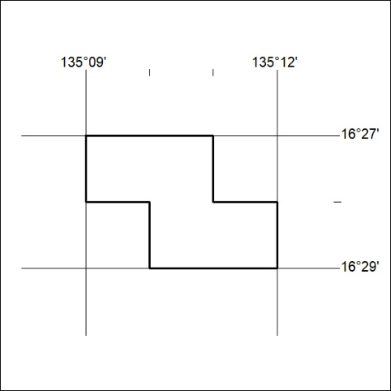
Area granted is indicated above. The titleholder is not permitted to exercise occupational rights on any land that is subject to a development title, or an application for a development title. Any land the subject of a Reserved Land gazettal under the Mineral Titles Act and all land vested in the Commonwealth of Australia is also excluded by description but not excised from the grant area.

409/23

