Mineral Titles Act 2010
NOTICE OF LAND CEASING TO BE A MINERAL TITLE AREA
Title Type and Number: | Mineral Lease 30411
Area ceased on: | 07 July 2023
Area: | 11.00 Hectare
Locality: | HATCHES
Name of Applicants(s)Holder(s): | 50% MONCKTON Robert James, 50% REINELT THE ESTATE OF Horst Rudolf
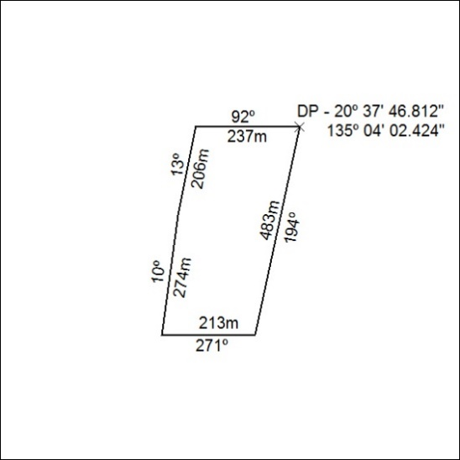

263/23

Mineral Titles Act 2010
NOTICE OF LAND CEASING TO BE A MINERAL TITLE APPLICATION AREA
Title Type and Number: | Exploration Licence 33494
Area Ceased on: | 10 July 2023
Area: | 10 Blocks, 29.99 km²
Locality: | QUARTZ
Name of Applicant(s)/Holder(s): | 100% IGO NEWSEARCH PTY LTD [ACN. 142 192 701]
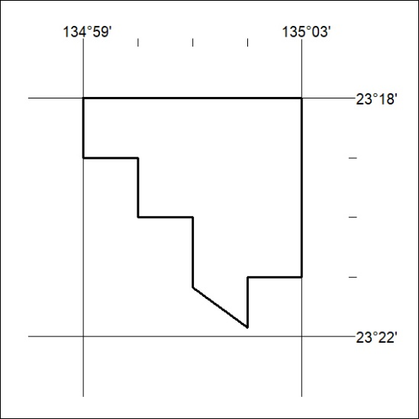

264/23

