Mineral Titles Act 2010
NOTICE OF LAND CEASING TO BE A MINERAL TITLE AREA
Title Type and Number: | Exploration Licence 32002
Area Ceased on: | 23 June 2023
Area: | 35 Blocks, 115.26 km²
Locality: | OCTOBER
Name of Applicant(s)/Holder(s): | 100% PENNANT RESOURCES PTY LTD [ACN. 150 501 492]
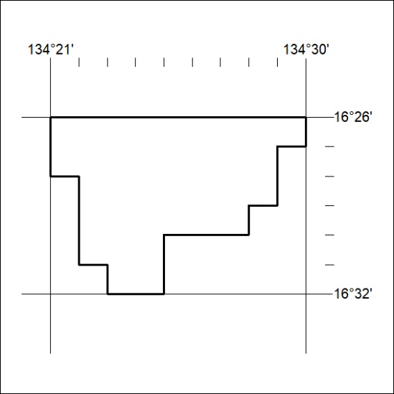

224/23

Mineral Titles Act 2010
NOTICE OF LAND CEASING TO BE A MINERAL TITLE AREA
Title Type and Number: | Exploration Licence 32009
Area Ceased on: | 23 June 2023
Area: | 97 Blocks, 319.70 km²
Locality: | ARNOLD RIVER
Name of Applicant(s)/Holder(s): | 100% PENNANT RESOURCES PTY LTD [ACN. 150 501 492]
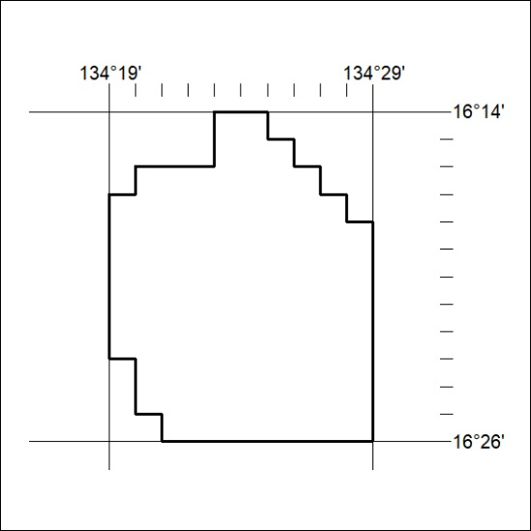

225/23
Mineral Titles Act 2010
NOTICE OF LAND CEASING TO BE A MINERAL TITLE AREA
Title Type and Number: | Exploration Licence 32010
Area Ceased on: | 23 June 2023
Area: | 6 Blocks, 19.77 km²
Locality: | TANUMBIRINI
Name of Applicant(s)/Holder(s): | 100% PENNANT RESOURCES PTY LTD [ACN. 150 501 492]
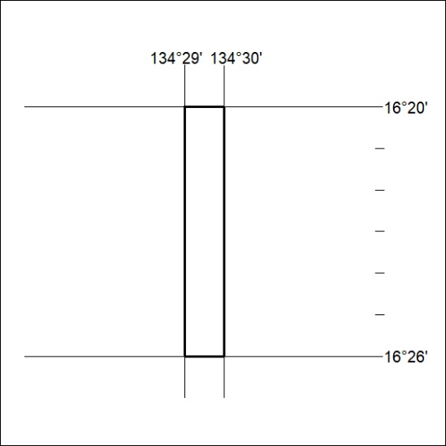

226/23

Mineral Titles Act 2010
NOTICE OF LAND CEASING TO BE A MINERAL TITLE AREA
Title Type and Number: | Exploration Licence 32011
Area Ceased on: | 23 June 2023
Area: | 8 Blocks, 26.35 km²
Locality: | TANUMBIRINI
Name of Applicant(s)/Holder(s): | 100% PENNANT RESOURCES PTY LTD [ACN. 150 501 492]
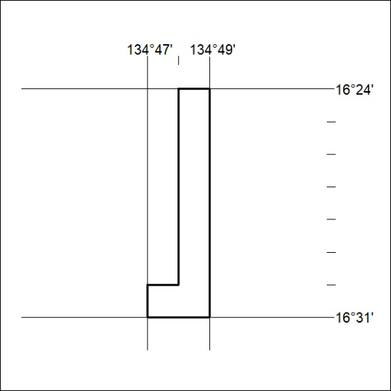

227/23

Mineral Titles Act 2010
NOTICE OF LAND CEASING TO BE A MINERAL TITLE AREA
Title Type and Number: | Exploration Licence 32012
Area Ceased on: | 23 June 2023
Area: | 42 Blocks, 138.32 km²
Locality: | TANUMBIRINI
Name of Applicant(s)/Holder(s): | 100% PENNANT RESOURCES PTY LTD [ACN. 150 501 492]
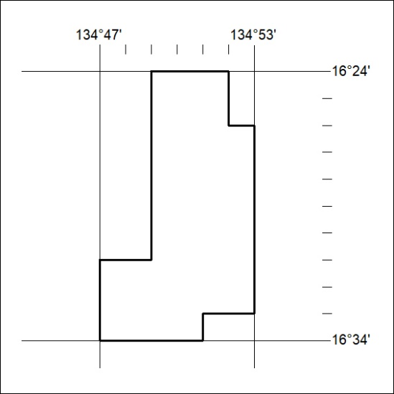

228/23

Mineral Titles Act 2010
NOTICE OF LAND CEASING TO BE A MINERAL TITLE AREA
Title Type and Number: | Exploration Licence 32417
Area Ceased on: | 23 June 2023
Area: | 16 Blocks, 53.37 km²
Locality: | PINE CREEK
Name of Applicant(s)/Holder(s): | 33.34% TEELOW Leslie John, 33.33% FRANCIS Jason Ross, 33.33% TEELOW Michael Daniel
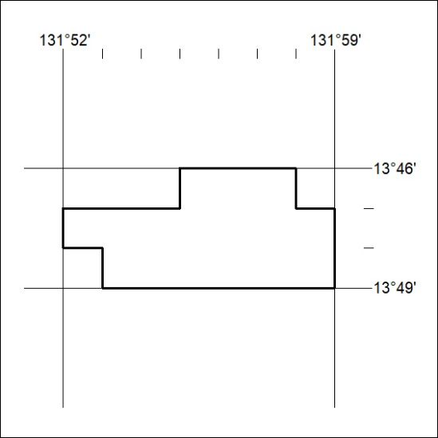

229/23

