Mineral Titles Act 2010
NOTICE OF LAND CEASING TO BE A MINERAL TITLE AREA
Title Type and Number: | Exploration Licence 32507
Area Ceased on: | 15 June 2023
Area: | 249 Blocks, 824.01 km²
Locality: | WILLEROO
Name of Applicant(s)/Holder(s): | 100% TRANSITION MINERALS LIMITED* [ACN. 641 565 139]
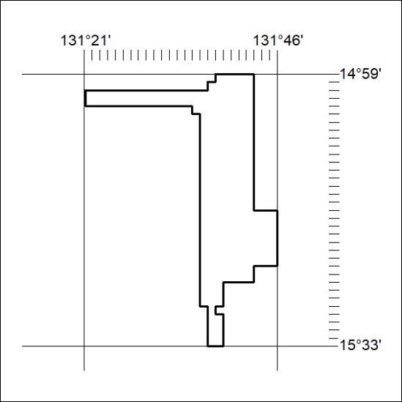

200/23

Mineral Titles Act 2010
NOTICE OF LAND CEASING TO BE A MINERAL TITLE AREA
Title Type and Number: | Exploration Licence 32508
Area Ceased on: | 15 June 2023
Area: | 249 Blocks, 789.41 km²
Locality: | FLORA
Name of Applicant(s)/Holder(s): | 100% TRANSITION MINERALS LIMITED* [ACN. 641 565 139]
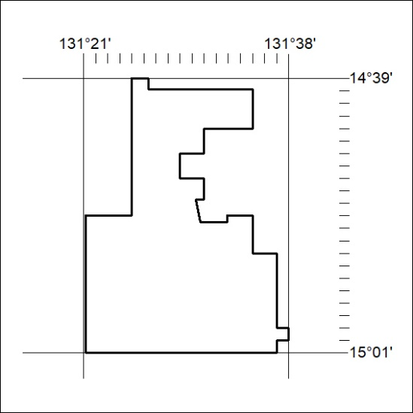

201/23
Mineral Titles Act 2010
NOTICE OF LAND CEASING TO BE A MINERAL TITLE AREA
Title Type and Number: | Exploration Licence 32509
Area Ceased on: | 15 June 2023
Area: | 245 Blocks, 766.23 km²
Locality: | FLORA
Name of Applicant(s)/Holder(s): | 100% TRANSITION MINERALS LIMITED* [ACN. 641 565 139]
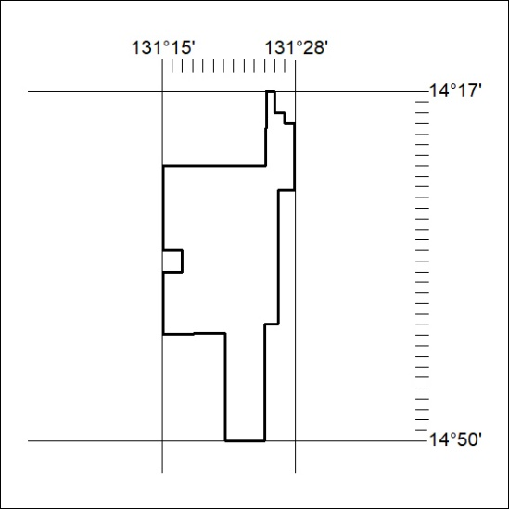

202/23

Mineral Titles Act 2010
NOTICE OF LAND CEASING TO BE A MINERAL TITLE AREA
Title Type and Number: | Exploration Licence 32925
Area Ceased on: | 15 June 2023
Area: | 47 Blocks, 149.39 km²
Locality: | DOREEN
Name of Applicant(s)/Holder(s): | 100% PET FC PTY LTD [ACN. 602 050 117]
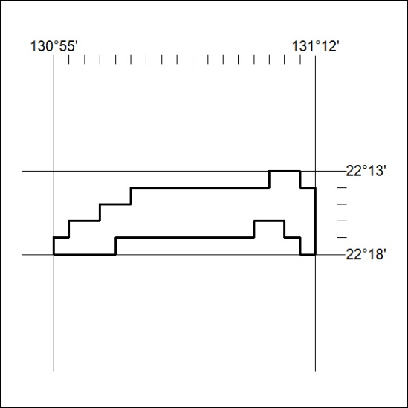

203/23
Mineral Titles Act 2010
NOTICE OF LAND CEASING TO BE A MINERAL TITLE AREA
Title Type and Number: | Exploration Licence 32927
Area Ceased on: | 15 June 2023
Area: | 24 Blocks, 76.10 km²
Locality: | NAPPERBY
Name of Applicant(s)/Holder(s): | 100% PET FC PTY LTD [ACN. 602 050 117]
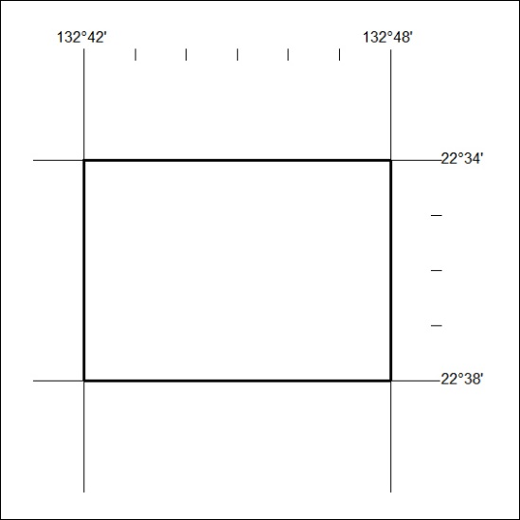

204/23

Mineral Titles Act 2010
NOTICE OF LAND CEASING TO BE A MINERAL TITLE AREA
Title Type and Number: | Exploration Licence 32928
Area Ceased on: | 15 June 2023
Area: | 44 Blocks, 139.32 km²
Locality: | NAPPERBY
Name of Applicant(s)/Holder(s): | 100% PET FC PTY LTD [ACN. 602 050 117]
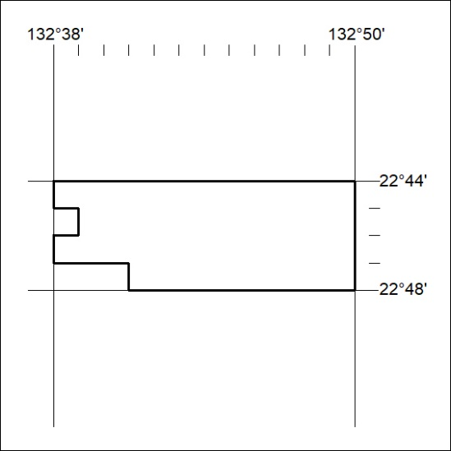

205/23
Mineral Titles Act 2010
NOTICE OF LAND CEASING TO BE A MINERAL TITLE AREA
Title Type and Number: | Exploration Licence 32930
Area Ceased on: | 15 June 2023
Area: | 36 Blocks, 108.29 km²
Locality: | DOREEN
Name of Applicant(s)/Holder(s): | 100% PET FC PTY LTD [ACN. 602 050 117]
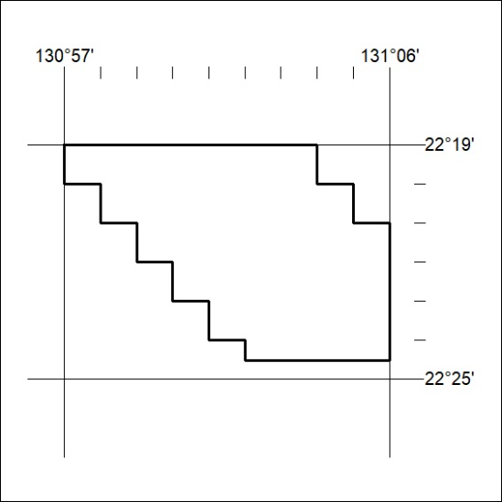

206/23

Mineral Titles Act 2010
NOTICE OF LAND CEASING TO BE A MINERAL TITLE AREA
Title Type and Number: | Exploration Licence 32931
Area Ceased on: | 15 June 2023
Area: | 16 Blocks, 40.24 km²
Locality: | DOREEN
Name of Applicant(s)/Holder(s): | 100% PET FC PTY LTD [ACN. 602 050 117]
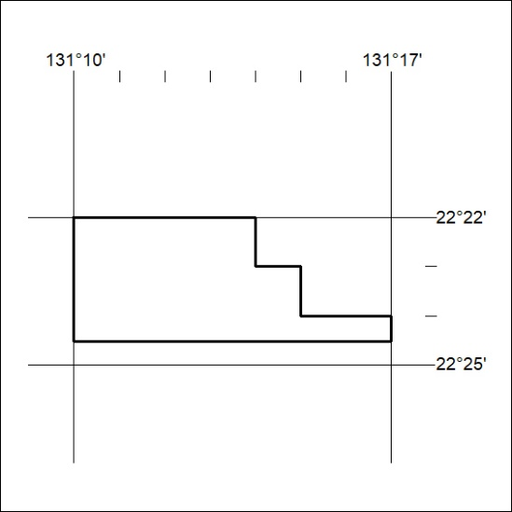

207/23
Mineral Titles Act 2010
NOTICE OF LAND CEASING TO BE A MINERAL TITLE AREA
Title Type and Number: | Extractive Mineral Exploration Licence 32610
Area Ceased on: | 15 June 2023
Area: | 4 Blocks, 8.56 km²
Locality: | MARY RIVER
Name of Applicant(s)/Holder(s): | 100% CABOT MELISSA
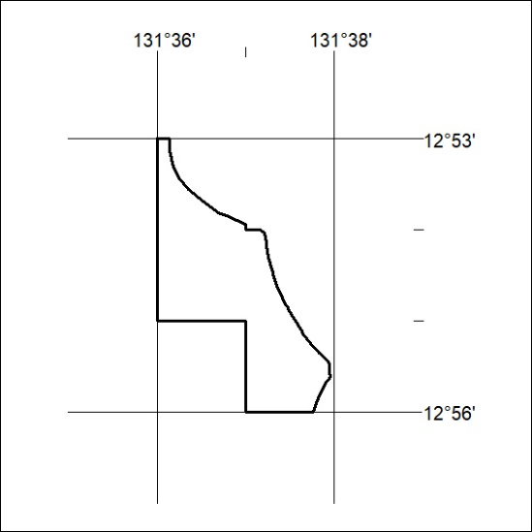

208/23

Mineral Titles Act 2010
NOTICE OF LAND CEASING TO BE A MINERAL TITLE AREA
Title Type and Number: | Extractive Mineral Exploration Licence 32611
Area Ceased on: | 15 June 2023
Area: | 4 Blocks, 13.39 km²
Locality: | MARY RIVER
Name of Applicant(s)/Holder(s): | 100% CABOT MELISSA
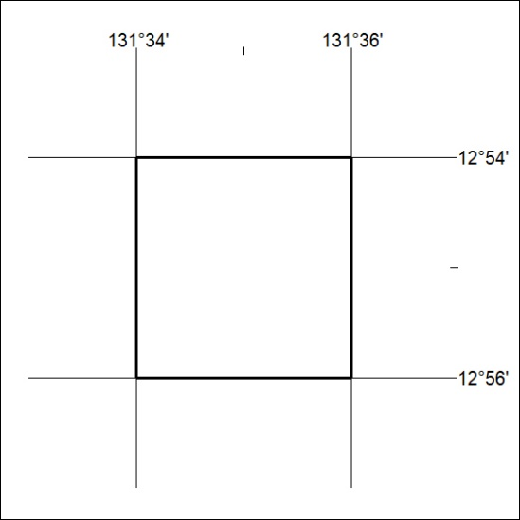

209/23
Mineral Titles Act 2010
NOTICE OF LAND CEASING TO BE A MINERAL TITLE AREA
Title Type and Number: | Extractive Mineral Exploration Licence 32612
Area Ceased on: | 15 June 2023
Area: | 4 Blocks, 12.44 km²
Locality: | MARY RIVER
Name of Applicant(s)/Holder(s): | 100% CABOT MELISSA
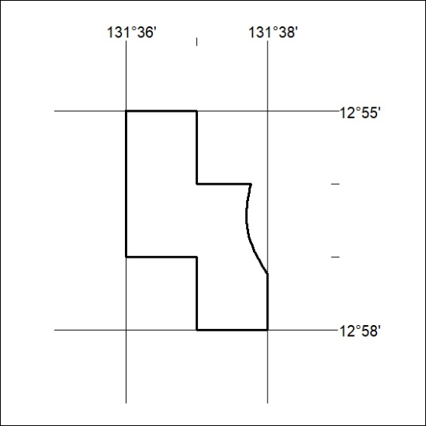

210/23

Mineral Titles Act 2010
NOTICE OF LAND CEASING TO BE A MINERAL TITLE AREA
Title Type and Number: | Extractive Mineral Exploration Licence 32613
Area Ceased on: | 15 June 2023
Area: | 4 Blocks, 13.39 km²
Locality: | MARY RIVER
Name of Applicant(s)/Holder(s): | 100% CABOT MELISSA
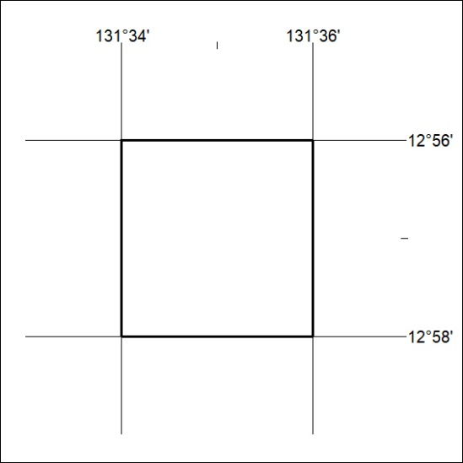

211/23

