Mineral Titles Act
NOTICE OF GRANT OF A MINERAL TITLE
Title Type and Number: | Extractive Mineral Exploration Licence 33446
Granted: | 08 June 2023, for a period of 2 Years
Area: | 3 Blocks, 10.01 km²
Locality: | PINE CREEK
Name of Holder/s: | 100% MOUSELLIS John Nick
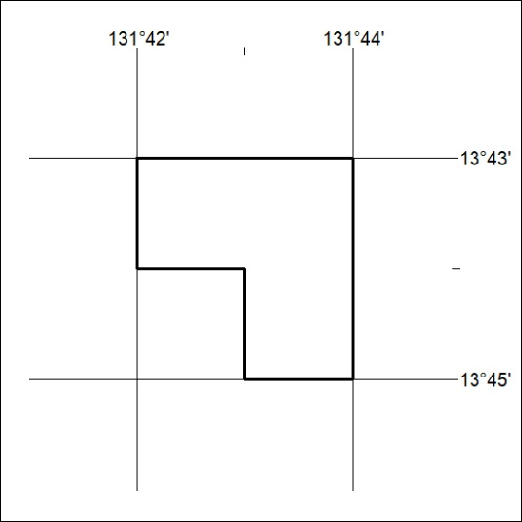
Area granted is indicated above. The titleholder is not permitted to exercise occupational rights on any land that is subject to a development title, or an application for a development title. Any land the subject of a Reserved Land gazettal under the Mineral Titles Act and all land vested in the Commonwealth of Australia is also excluded by description but not excised from the grant area.
188/23

Mineral Titles Act
NOTICE OF GRANT OF A MINERAL TITLE
Title Type and Number: | Extractive Mineral Exploration Licence 33447
Granted: | 08 June 2023, for a period of 2 Years
Area: | 4 Blocks, 13.35 km²
Locality: | PINE CREEK
Name of Holder/s: | 100% MOUSELLIS John Nick
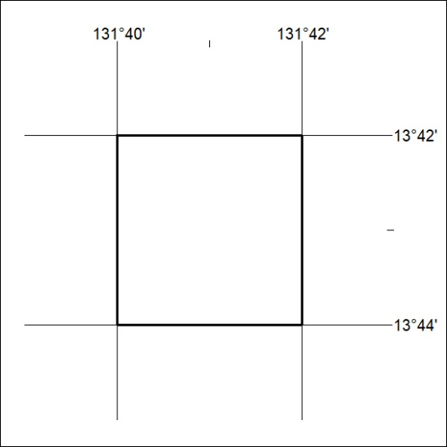
Area granted is indicated above. The titleholder is not permitted to exercise occupational rights on any land that is subject to a development title, or an application for a development title. Any land the subject of a Reserved Land gazettal under the Mineral Titles Act and all land vested in the Commonwealth of Australia is also excluded by description but not excised from the grant area.
189/23

