Mineral Titles Act 2010
NOTICE OF LAND CEASING TO BE A MINERAL TITLE AREA
Title Type and Number: | Exploration Licence 31952
Area Ceased on: | 22 May 2023
Area: | 18 Blocks, 57.58 km²
Locality: | GEORGE CREEK
Name of Applicant(s)/Holder(s): | 100% MAGNET EXPLORATION PTY LTD [ACN. 623 568 918]
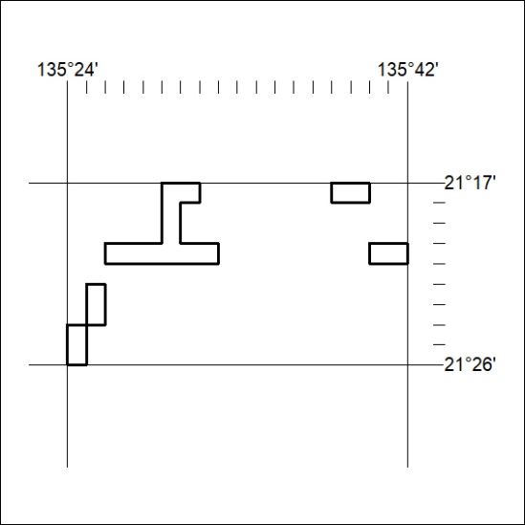

159/23

Mineral Titles Act
NOTICE OF GRANT OF A MINERAL TITLE
Title Type and Number: | Exploration Licence 33306
Granted: | 22 May 2023, for a period of 6 Years
Area: | 232 Blocks, 722.30 km²
Locality: | BURT
Name of Holder/s: | 100% GEMPART (NT) PTY LTD* [ACN. 081 859 896]
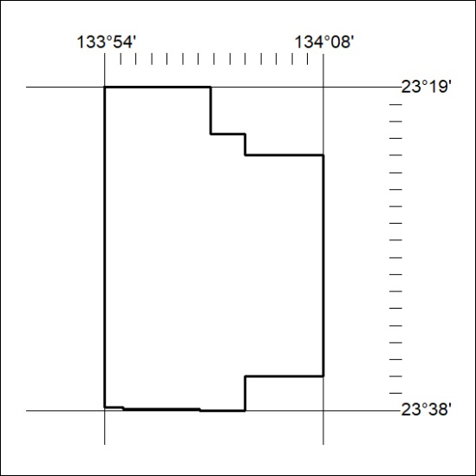
Area granted is indicated above. The titleholder is not permitted to exercise occupational rights on any land that is subject to a development title, or an application for a development title. Any land the subject of a Reserved Land gazettal under the Mineral Titles Act and all land vested in the Commonwealth of Australia is also excluded by description but not excised from the grant area.

160/23

Mineral Titles Act
NOTICE OF GRANT OF A MINERAL TITLE
Title Type and Number: | Extractive Mineral Permit 33300
Granted: | 18 May 2023, for a period of 5 Years
Area: | 3.29 Hectares
Locality: | LARRIMAH
Name of Holder/s: | 100% TERRITORY SANDS PTY LTD [ACN. 632 797 972]
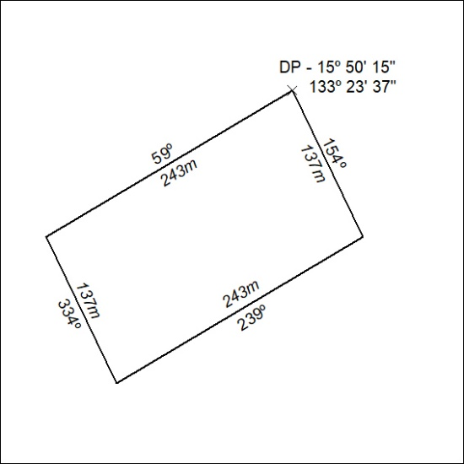

161/23

Mineral Titles Act
NOTICE OF GRANT OF A MINERAL TITLE
Title Type and Number: | Extractive Mineral Permit 33301
Granted: | 18 May 2023, for a period of 5 Years
Area: | 2.74 Hectares
Locality: | LARRIMAH
Name of Holder/s: | 100% TERRITORY SANDS PTY LTD [ACN. 632 797 972]
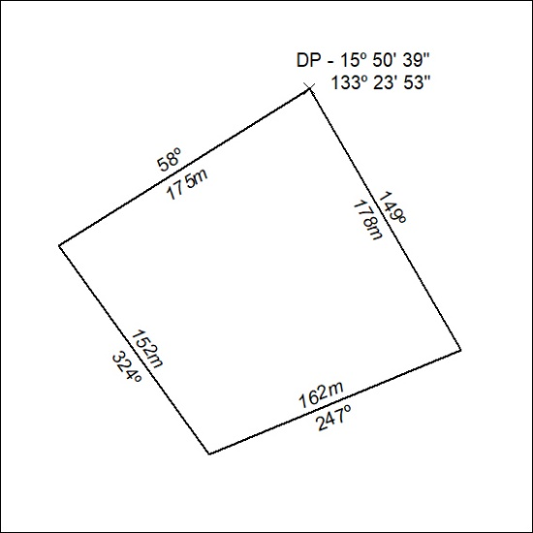

162/23

