Mineral Titles Act 2010
NOTICE OF LAND CEASING TO BE A MINERAL TITLE AREA
Title Type and Number: | Mineral Lease 31269
Area ceased on: | 19 April 2023
Area: | 449.00 Hectares
Locality: | BATCHELOR
Name of Applicants(s)Holder(s): | 100% NT MINING OPERATIONS PTY LTD* [ACN. 136 525 990]
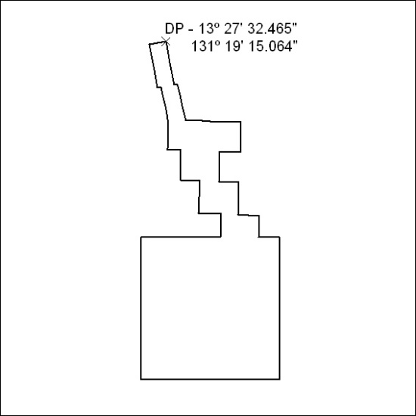

110/23

