Mineral Titles Act 2010
NOTICE OF LAND CEASING TO BE A MINERAL TITLE AREA
Title Type and Number: | Exploration Licence 32505
Area Ceased on: | 15 March 2023
Area: | 186 Blocks, 561.02 km²
Locality: | FIELD RIVER
Name of Applicant(s)/Holder(s): | 100% PLUTONIC LIMITED [ACN. 632 991 167]
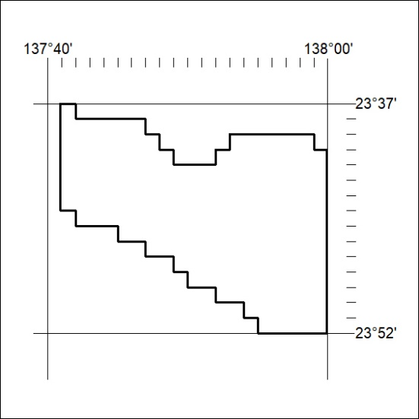

064/23

Mineral Titles Act 2010
NOTICE OF LAND CEASING TO BE A MINERAL TITLE AREA
Title Type and Number: | Extractive Mineral Exploration Licence 32564
Area Ceased on: | 15 March 2023
Area: | 4 Blocks, 10.50 km²
Locality: | MANBULLOO
Name of Applicant(s)/Holder(s): | 100% WARRIJA CONSTRUCTION AND CIVIL PTY. LTD. [ACN. 616 177 845]
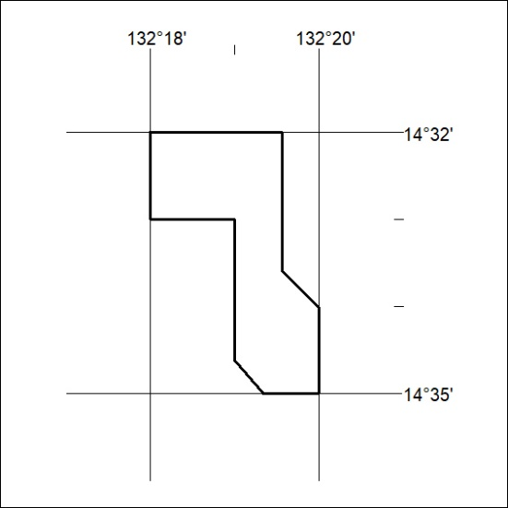

065/23

Mineral Titles Act 2010
NOTICE OF LAND CEASING TO BE A MINERAL TITLE AREA
Title Type and Number: | Mineral Lease 29795
Area ceased on: | 15 March 2023
Area: | 17.00 Hectare
Locality: | PINE CREEK
Name of Applicants(s)Holder(s): | 100% SINGLETON Robert Bruce
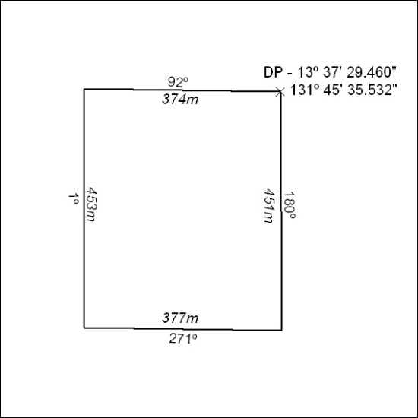

066/23

