Corrigendum
Notice Number 038/23 appearing in MN017/23 on 14 February 2023 is hereby cancelled and replaced by the following:

Mineral Titles Act 2010
NOTICE OF LAND CEASING TO BE A MINERAL TITLE AREA
Title Type and Number: | Exploration Licence 31543
Area Ceased on: | 14 February 2023
Area: | 38 Blocks, 118.23 km²
Locality: | BRAHMA
Name of Applicant(s)/Holder(s): | 100% TYPHON MINERALS PTY LTD [ACN. 614 887 464]
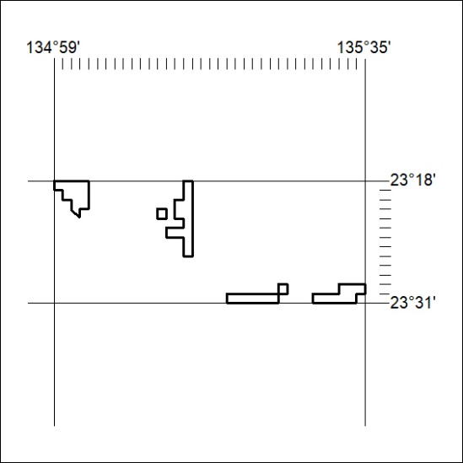

062/23

